Subscribe Past Issues
Translate
RSS

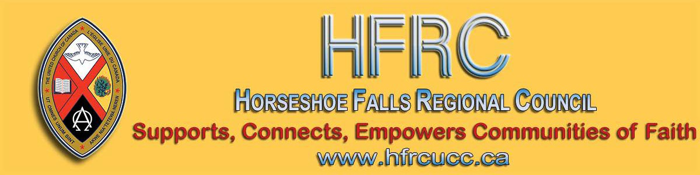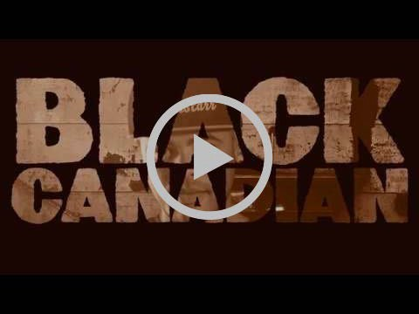

View this email in your browser

Next Deadline for submissions: February 21
Sign up for our newsletter & forward this one to friends.

BLACK HISTORY MONTH

This year is the mid-point of the
International Decade for People of African Descent

Black Canadian by Rapper D. O. Gibson
Black History Month
United Church Worship, Prayers, Resources & more
Canadian Council of Churches: Info Sheet & Resources

“During the 19th Century, thousands of slaves escaped to freedom through a secret network known as the Underground Railroad. It is believed that, along the way, spiritual songs were used as secret coded messages to escaping slaves. ‘Wade in the Water’ warned them to flee dry land for the water so that the dogs and owners
chasing them couldn’t track their scent.”

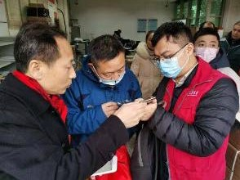United Church Responds to the Coronavirus

Please pray for the sick and those who have lost their lives, as well as the families, caregivers, medical responders, and communities affected by this outbreak around the world.

United Church Mission & Service partner, the Amity Foundation, has requested emergency medical supplies for use by
Licensed Lay Worship Committee
Needs Members - Maybe YOU!

The Human Resources Commission is looking for individuals to be part of our Licensed Lay Worship Committee. This committee will oversee Licensed Lay Worship Leaders (LLWL) in Horseshoe Falls Regional Council.

We are looking for Ministry Personnel from any stream, lay people who are not LLWL and LLWLs to be on this committee. This will be a one to three year term position with the option of renewal for one term.

The primary responsibilities for this committee will be:

Interviewing potential LLWLs and recommending licensing to the Human Resources Commission.

medical first responders and communities in Wuhan. The United Church is collaborating with the American Baptist International Ministries, which is coordinating the provision of these supplies to address the crisis.

Find out more ...

3rd Annual Inter-Youth Group
Games Day: February 9
Wellington Square UC

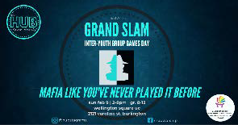

Download the full-size promo card.

Have a Heart Day
A Sunday between January 26 to
February 9

A project of the First Nations Child and Family Caring Society. Led by Dr. Cindy Blackstock, the Caring Society educates about and advocates for the rights of Indigenous kids across Canada.

Interviewing and recommending current LLWLs for relicensing every
3 years.
Ensuring LLWLs have completed mandatory workshops and have a current Police Records Check. Ensuring the recognition of a newly licensed LLWL at a service of worship.
Providing ongoing support and guidance to LLWLs.

If being on this committee is something that interests you, please complete an Expression of Interest form (also found on the Horseshoe Falls Regional Council website).

Do you want to be on the
Pulpit Supply List?

We are looking for ministry personnel
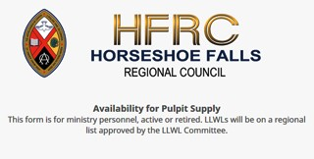who are willing to be available to do pulpit supply in our regions. Licensed Lay Worship Leaders (LLWLs) do much pulpit supply and that list is often sent out.

Click on the photo to go to the form. Right now we are gathering the names of
ministry personnel who are interested in being on a list for supply. Look under
'Pastoral Relations Toolkits' on the Horseshoe Falls website. We look forward to hearing from you!

We hope non-Indigenous kids can learn about the different experiences of kids in Canada and take action out of a sense of compassion. We also hope Indigenous kids can speak from their hearts about what they want and need.

Download the Sunday School Activities.

Rendez-Vous: Bold Faith. Brave
Space. Brazen Grace.

Rendez-vous, an M&S supported event, brings together youth (grade 9 and up to any age), young adults and their leaders from across the country (and beyond!) for a celebration of vibrant music, inspiring speakers, and dancing like there is no tomorrow.

Get involved. Find out how. Email Kathy or call her at 519-441-0656.

Help Communities of Faith with
Mission/Justice/Faith Formation

Besides helping congregations with the above, you will also help with resources, guidance and support to enable communities of faith to do the best

Racial Justice Workshops
2020 Dates

For Indigenous, Racialized, Bi-racial
People: April 25
June 20
September 19
November 14

For White People:

May 2
June 27
September 26
November 21

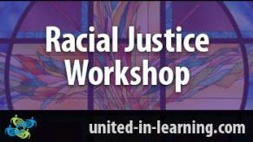

"The racial justice training is particularly commended to people serving in any leadership capacity within the church."
www.united-in-learning.com

(Not in Horseshoe Falls, but ...) An Uplifting Church Story
from TVO.org

This is a great story featured by TVO.org that lives into Eric Law's Holy Currencies principles (a webinar that may come back soon to United-in-Learning.com).

My favourite line is when Rev. Anne
Hines says, "Renting out space is nothing new for struggling churches, but Roncesvalles United’s approach goes beyond that, she says: “[The tenants] are

ministry possible in their communities and the world.

The mandate includes working in right relations with Indigenous partners, supporting Affirming ministries with LGBTQ2SIA+ members, making safe space, opening dialogue and strengthening relationships everywhere.

The Mission & Discipleship Commission could use your help. Read the letter and mandate from the Commission. Then apply through the Expression of Interest form. Hope to see you soon!

Covenant Commission
Here to Help You

We are the “go to” commission for everything from property matters, to local governance, new beginnings and endings
- dedicated to helping communities of faith live out their ministry:

Ministry discernment tools Property matters Transistions
Local governance
Education/information

At the heart of the relationship with the regional council will be a personalized covenant for each community of faith.

Read the full letter from the Covenant Commission . And ... if you're interested in becoming a Companion, you can apply through the Expression of Interest form.

Contact Lynne Allin with any questions.

Want to include something here?
not here paying to allow us to do our mission. They are our mission.”

Missional Leadership Diploma Atlantic School of Theology June 2020

Learn the keys to thriving ministry in the
21st Century. Starts in June - Apply now! Only 25 spots available. For more details on this leading edge program download this information sheet and/or contact Dr. Stephen Harper.

Discoverment for Yats
'What Will Frame You' February 21-23

Whether you are creating an Instagram profile, a resume, or a life in the Way of Jesus - the decisions we make about how we frame our experience have a lot of power to shape our future. What do we focus on? What do we crop out? What opportunities do we pursue? Which ones do we forego? Who do we listen to as we make those decisions?

What Will Frame You? for YATS is open to young adults from any and all denominations and is hosted at Pearce Williams (Fingal, Ontario). The event is sponsored and led by The Centre for Practical Theology, The Swell, Ecumenical Campus Ministry of the University of Guelph, and Western Ontario Waterways.

Come find out What Will Frame You!

Confirmation Retreat & Faith

Do you know of a region-wide event or happening that would be of interest to ministry personnel and/or lay members? To have it posted in this regional newsletter, send an email with the information to pkukadia@united- church.ca.

The next deadline is January 31.

Question & Answer Column

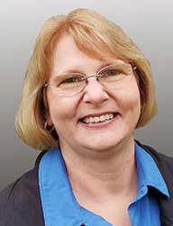Question What is surprisingly one in three in
Horseshoe Falls Regional Council?

Answer
Approximately one-third of the pastoral charges in our regional council are without ministry personnel. Each one of them needs a PASTORAL CHARGE SUPERVISOR. Please contact Lynne Allin, Minister, Congregational Support & Mission at lallin@united-church.ca if you can help with this important work. Training is available and travel costs are reimbursed.

From your friendly Regional Council
Covenant Commission. :)

Canada Summer Jobs is Open

Have a new idea but need help to get it off the ground?

New ways of communicating? A Vacation Bible School?
A community garden?
Refresher 'What Will Find You' February 21-23

Confirmation PLUS is designed to prepare United Church teens for confirmation but is open to any and all teens in grades 7-12 regardless of whether or not they are confirmed or ever intend to be.

Confirmation PLUS is open to Region 7,
8, 9 and beyond and is hosted at Pearce- Williams (Fingal, Ontario). It is sponsored and led by The Centre for Practical Theology, The Swell, Ecumenical
Campus Ministry of the University of
Guelph and Western Ontario Waterways.

Adults/Ministers are encouraged to attend this event with their teens.

Come and find out What Will Find You!

Hamilton Presbytery Reunion
Tuesday, February 25
Emmanuel United Church

The former Hamilton Presbytery is having a meeting at Emmanuel United Church,
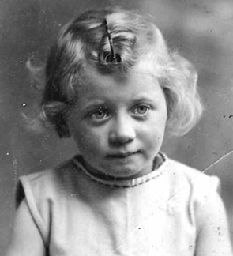871 Upper Ottawa Street in Hamilton.

Maybe to bring in new ideas?

If you want to hire someone under 30 to work at your community of faith now is the time to apply for Canada Summer Jobs through the Federal Government!

Strengthening Youth Ministry
United-in-Learning
February 11 at 7:00 pm

Concerns about mental health among young people in our churches are on the rise. Young people who are dealing with mental health challenges need specific support, as do their families.

This webinar in the series is about Creating Sex Positive Spaces: Many young people struggle with issues of sexual and gender identity, which can lead to struggles with mental health and
wellness. Sue Browning provides practical tips and tools for creating welcoming sex- positive environments.

Register here .

Bridges Out of Poverty United-in-Learning February 19 at 1:00 pm

Make a difference in your community. Challenge your assumptions about poverty, economic class and community sustainability. Bridges Out of Poverty is a highly successful initiative that is transforming communities. This program is successful because it puts the under-
resourced people it seeks to assist, in 'the
driver’s seat'.

Guest Speaker: Suzanne Berliner Weiss, Survivor, Activist and Author.
Suzanne will talk about the mass initiatives that saved three-quarters of the Jews under Nazi rule in her native France and discuss how the principle of solidarity that saved her life can help us face the world’s challenges today.

Email Hamilton Presbytery Resource Centre or call 905-318-5289 for tickets. RSVP by February 20. Download flyer for more information.

Youth Rally 2020: Escape! April 23 - April 26
Pearce-Williams Christian Camp

High-School aged youth: Do you love to be inspired, challenged to think, meet new people & hang out with good
friends ??? Do you enjoy being in an open
& welcoming community where you are free to be completely yourself ? Well, faith, fellowship and connection is what Youth Rally is all about.

Come join us for Youth Rally 2020: Escape! Registration closes when full.

There is limited space! Register Early. Deadline for registration: April 9.

For more information email Shannon.

The Grandmothers Tea
Mount Pleasant United Church
February 26 at Noon

Register here .

Liaison Training for Free! Almost ...

The Human Resources Commission is looking for people wanting to train as liaisons. Liaisons help support and equip congregations during search and in times of transition. If you are interested or if you would like more information please
contact Allison Playfair or apply through the Expression of Interest form.

Show Me the $$$ Regional Office, Hamilton Tuesday, March 3

Finding, Writing, Getting Grant$

RSVP required by February 19. Email Ruthanna Mack or call 1-833-236-0280 ext. 0. Time: 12:00 - 2:30 pm (light lunch provided-donation).

Lent is coming! give, Give, GIVE

What if we not only give up something, but GIVE something for Lent?

Find ideas here on what to give ... and download the flyer from Dave Jagger.

Confirmation Retreat
Five Oaks, April 3 - 5

Colour Outside the Lines, Unravel Faith,
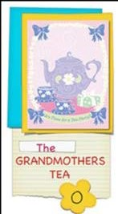

Download Grandmother's Tea flyer from
Nations Uniting.

Nations Uniting Programs for the month of February

Come and explore The Seven Grandfather Teachings at Nations Uniting in Ohsweken through Bible Study,
Sharing Circle, Film Showings and
Parallel Path with Renee Thomas Hill.

Download the flyer, or check out the website.

Ministry with Children & Youth Monday, March 2, 5:30 -7:00 pm Carlisle United Church, Carlisle

Share your struggles and celebrations in children and youth ministry. Connect with other Christian Education leaders and meet Kathy Douglas, Faith Formation Minister for the new Horseshoe Falls Regional Council.

Resurrect Hope and Create Radical Beauty on Earth with Ruth Noble, Alana Martin and Kathy Douglas.

A retreat to support & enrich the confirmation process of your congregation. For both youth & leaders. Come, share the journey!

For information email Kathy Douglas.

Sisters Together: Clergy Women's Retreat for Women in Ministry - April 20 - 24

The theme of this 5-day event is 'Voices of Hope in Challenging Times'. The event features Rabbi Elyse Goldstein, Rev. Dr. HyeRan Kim-Cragg and Diamond
Fotiadis. The Blanket Exercise with Kairos
Canada will also be presented.

Download the poster for information, go to the Facebook page, send an email to sistersandministers@gmail.com, or go directly to the registration form.

Limited to the first 50 participants.

Please Share this Newsletter

Please share this newsletter widely. It is especially helpful for people involved in leadership roles in your community of faith to know what upcoming events are planned that they might find helpful.

Invite people to subscribe for themselves by including the following with the announcements: Stay in touch with the wider church: subscribe to the regional council newsletter.

This event is for anyone who leads or supports programming with children and families in Horseshoe Falls Regional Council.

For details and to RSVP (for donation supper) email or call 905-689-8630.

Congratulations, Kellie McComb

Reverend Kellie McComb has been appointed to the Office of Vocation serving Canadian Shield and Shining Waters regional councils beginning May.

We wish you all the best!

Crossan is coming to Westdale
United Church, Hamilton
April 3 and 4

Contemporary Spiritual Voices present: A
weekend with John Dominic Crossan.
The foremost historical Jesus scholar will be at Westdale UC from a Friday evening talk through all day Saturday.

Register online or download the flyer and get all the details and information.

SW Ontario Candidacy Board

The SW Ontario Candidacy Board is looking for new members; we meet monthly and the 2020 dates are set.

Learning Fund Applications
Hello, HELLO!
The 2020 Horseshoe Falls Regional Welcome to Jung-Hyun Shin . He is Council budget includes $30,000 for joining us at Burkholder United Church in learning grants this year, in the following Hamilton until the end of July. categories:

Professional Development Individual Learning Grants Event Sponsorship
Student Bursaries

Download the information and application sheet.
Supports, Connects, Empowers
Communities of Faith

Horseshoe Falls Regional Council
The United Church of Canada
Sign up for our newsletters.

Copyright © 2020 Horseshoe Falls Regional Council, UCC, All rights reserved.

Want to change how you receive these emails?
You can update your preferences or unsubscribe from this list.

