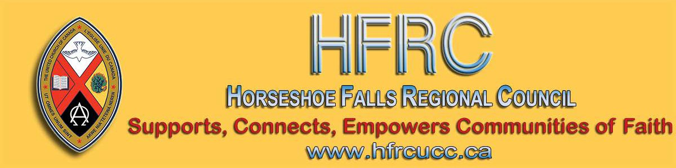
Subscribe |  | Past Issues |  | Translate |  | RSS
View this email in your browser

Next Deadline for submissions: January 31
Sign up for our newsletter & forward this one to friends.
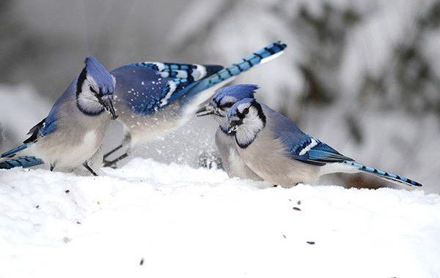

giftswithvision Covenanting Service
Sunday, January 19 @ 2:00 pm
Looking for inspiring new gift ideas or Melrose United Church
perhaps would rather not give family and
friends the same old The congregation of Melrose United
clothes/toys/chocolates, Gifts with Vision Church is covenanting with Sonia Ireson. presents a better way to celebrate special Come and celebrate with us on Sunday, occasions. A gift that can help change January 19 at 2:00 pm as we start this
lives! new ministry.

Feel free to send greetings to melrose@melroseunited.ca if you can't

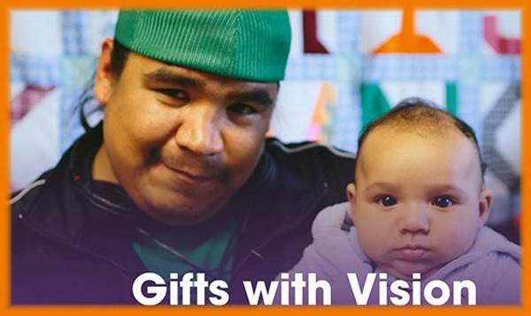

Everyone will find something in Gifts with Vision worth sharing with the special people in their lives. Gifts are available in a range of dollar amounts, as well as for many areas of need — hunger, shelter, education, health, safety, and more...

Worshiplude in Ottawa!!! January 31 - February 3

Click to go to the registration form. Skate on the Rideau Canal, ride ice
slides, see amazing ice sculptures and more, as part of Ottawa's Winterlude.

Contemporary worship, dinner and the Alt Space Event with other youth and young adults. For more information email Dana Ducette.

Go directly to the registration form.

attend. We are at 86 Homewood Avenue in Hamilton.

Covenanting Service
Sunday, January 26 @ 3:00 pm
Mount Pleasant United Church

The congregation of Mount Pleasant United Church is covenanting with Jeff Learmonth. Come and celebrate with us on Sunday, January 26 at 3:00 pm as we start this new ministry.

Send greetings to mtpleasantunitedchurch@gmail.com if
you can't be there yourself. We are at 669
Mt Pleasant Road near Brantford.

Covenanting Service
Sunday, January 26 @ 10:00 am
Central UC, Port Colborne

The congregation of Central United Church is covenanting with Alison Nicholson. Come and celebrate with us on Sunday, January 26 at 3:00 pm as we start this new ministry.

Feel free to send greetings to centralchurchpc@gmail.com if you can't be there. We are located at 30 Delhi Street in Port Colborne.

Do you want to be on the
Pulpit Supply List?

We are looking for ministry personnel
who are willing to be available to do pulpit supply in our regions. Licensed Lay

Intro to Contemplative Prayer
Saturday, February 1, Ancaster
9:00 am - 3:30 pm

Learn how to pray in silence following the Christian contemplative tradition of The Cloud of Unknowing, St. John of the Cross, Father Thomas Merton, Father Thomas Keating. All are welcome – whatever your faith, church/religious affiliation or none.

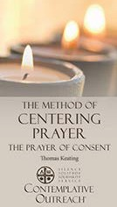Download the
Registration
Form, Brochure & Poster.

Contact James Bell by email or phone for info at
905-407-1919.

Rendez-Vous: Bold Faith. Brave
Space. Brazen Grace.

Rendez-vous, an M&S supported event, brings together youth (grade 9 and up to any age), young adults and their leaders from across the country (and beyond!) for a celebration of vibrant music, inspiring speakers, and dancing like there is no
Worship Leaders (LLWLs) do much pulpit supply and that list is often sent out.

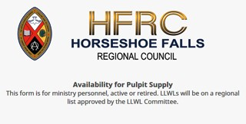Click on the photo to go to the form. Right now we are gathering the names of
ministry personnel who are interested in being on a list for supply. Look under
'Pastoral Relations Toolkits' on the Horseshoe Falls website. We look forward to hearing from you!

Toronto United Church Council
2 Upcoming Opportunities
& Property and Mission Review

Communities of Faith and Social Enterprise: An Afternoon with Shaun Loney
Turn your underused church space into meaningful, problem-solving space! Sunday, January 19, 1:00 – 4:30 pm Trinity United Church, 461 Park Avenue, Newmarket.
$25 per person (free for Living Presence
Ministry congregations).

Read the TUCC newsletter for complete information and registration.

Racial Justice Workshops
2020 Dates

tomorrow.

Get involved. Find out how. Email Kathy or call her at 519-441-0656.

Help Communities of Faith with
Mission/Justice/Faith Formation

Besides helping congregations with the above, you will also help with resources, guidance and support to enable communities of faith to do the best
ministry possible in their communities and the world.

The mandate includes working in right relations with Indigenous partners, supporting Affirming ministries with LGBTQ2SIA+ members, making safe space, open dialogue and strengthening relationships everywhere.

The Mission & Discipleship Commission could use your help. Read the letter and mandate from the Commission. Then apply through the Expression of Interest form. Hope to see you soon!

Covenant Commission
Here to Help You

We are the “go to” commission for everything from property matters, to local governance, new beginnings and endings
- dedicated to helping communities of faith live out their ministry:

Ministry discernment tools Property matters Transistions
Local governance
Education/information

At the heart of the relationship with the

For Indigenous, Racialized, Bi-racial
People: January 25
April 25
June 20
September 19
November 14

For White People:

February 1
May 2
June 27
September 26
November 21

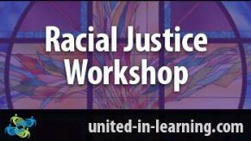

"The racial justice training is particularly commended to people serving in any leadership capacity within the church."
www.united-in-learning.com

Curriculum Workshop Saturday, January 25 10-3pm Emmanuel UC, Waterloo

Curricula that engages children but it's yours on a shoe-string budget: Free!! It's
home -grown, tried and true, and best of all, it's free for those who attend. Ministers and lay leaders will be introduced to three curricula and how to

regional council will be a personalized covenant for each community of faith.

Read the full letter from the Covenant Commission . And ... if you're interested in becoming a Companion, you can apply through the Expression of Interest form.

Contact Lynne Allin with any questions.

Want to include something here?

Do you know of a region-wide event or happening that would be of interest to ministry personnel and/or lay members? To have it posted in this regional newsletter, send an email with the information to pkukadia@united- church.ca.

The next deadline is January 31.

Another Great Year for The
Healing Fund - 2019

In 2019, The Healing Fund provided more than $300,000 to support Indigenous communities in language and culture programs. Read More ...
implement them in your ministry context.

Three workshops with presenters Alana
Martin and Pat Morrison.

Find out more: Curriculum Workshop

Discoverment for Yats
'What Will Frame You' February 21-23

Whether you are creating an Instagram profile, a resume, or a life in the Way of Jesus - the decisions we make about how we frame our experience have a lot of power to shape our future. What do we focus on? What do we crop out? What opportunities do we pursue? Which ones do we forego? Who do we listen to as we make those decisions?

What Will Frame You? for YATS is open to young adults from any and all denominations and is hosted at Pearce Williams (Fingal, Ontario). The event is sponsored and led by The Centre for Practical Theology, The Swell, Ecumenical Campus Ministry of the University of Guelph, and Western Ontario Waterways.

Come find out What Will Frame You!

Confirmation Retreat & Faith Refresher 'What Will Find You' February 21-23

Confirmation PLUS is designed to prepare United Church teens for confirmation but is open to any and all teens in grades 7-12 regardless of

Songs for the Holy Other

A new resource from the Hymn Society of the United States and Canada , Hymns Affirming The LGBTQIA2S+ Community! Hymns for the Holy Other is an online hymnal that emerged from a desire to make queer hymns — hymns by, for, or about the LGBTQIA2S+ community — accessible to a wider range of congregations.

We celebrate the contributions of those who have paved the way for this collection, and hope to create a dynamic resource of additional resources that are available to congregations in the near future.

Question & Answer Column

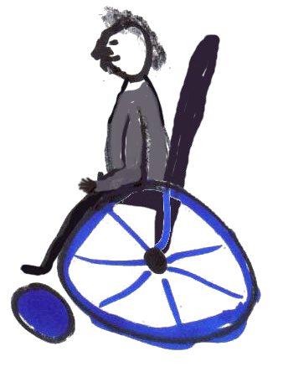Question
Does our church have to be physically accessible by
2025?

Answer
A Community of Faith is a non-profit with usually under 20 employees and does not need to make their building physically accessible by 2025. Under Ontario's Building Code, it is grandfathered. The exception is if you do a new construction or redevelopment (renovation).

For more information see: Accessing Accessibility Under the Building Code, the AODA and the OHRC.

From your friendly Regional Council
Covenant Commission. :)
whether or not they are confirmed or ever intend to be.

Confirmation PLUS is open to Region 7,
8, 9 and beyond and is hosted at Pearce Williams (Fingal, Ontario). It is sponsored and led by The Centre for Practical Theology, The Swell, Ecumenical
Campus Ministry of the University of
Guelph and Western Ontario Waterways.

This retreat weekend playfully engages teens in the exploration of A New Creed, energetic worship, and lots of recreation, all lead by seasoned adult ministry personnel with decades of experience in youth ministry.

Adults/Ministers are encouraged to attend this event with their teens.

Come and find out What Will Find You!

Become a Youth Ministry Friend on Facebook - Friends4ever

Follow Regions 7-
8-9 Youth Ministry Network on Facebook and always be in the know.

There is so much coming up, it's hard to stay on top of it! Here is a peek of what you'll find on Facebook:

Interfaith Event for Young Adult Women. Feb 14-17 @ Five Oaks Show me the $. March 3-5 @ the Regional Office
Youth Rally. April 23-26 @ Pearce- Williams Camp

Nominations: General Council
Positions

Please check the General Council Nominations page regularly. General Council is inviting Expressions of Interest:

Committees of the National Indigenous Organization Indigenous Candidacy Board National Indigenous Committees

Deadline for all of the above: January 23.

Marketing/Animation and Funding
Development Subcommittee, Sing
2025
Web Content Development
Subcommittee, Sing 2025

Deadline: February 10.

Liaison Training for Free! Almost ...

The Human Resources Commission is looking for people wanting to train as liaisons. Liaisons help support and equip congregations during search and in times of transition. If you are interested or if you would like more information please
contact Allison Playfair or apply through the Expression of Interest form.

Show Me the $$$ Regional Office, Hamilton Tuesday, March 3

Finding, Writing, Getting Grant$

RSVP required by February 19. Email
The Grandmothers Tea (dates!)

Download Grandmother's Tea dates.

Stewardship Updates
M&S Deadline: January 31

If you are looking for encouragement, new ways to think about stewardship, resources, help to implement Congregational Giving, Mission & Service, Planned Legacy Giving, United Church Foundation and investing opportunities
for your congregation, and personalised support to help grow strong generous thankful disciples, then contact Dave Jagger and let’s talk. January News !

SW Ontario Candidacy Board

The SW Ontario Candidacy Board is looking for new members; we meet monthly and the 2020 dates are set.

Week of Guided Prayer

A Unique and Meaningful Opportunity for
Deepening your Relationship with God.

Ruthanna Mack or call 1-833-236-0280 ext. 0. Two opportunities: 12:00 - 2:30 pm (light lunch provided-donation) or 6:00 -
8:30 pm (light supper provided-donation).

Hello, HELLO!

Welcome to Horseshoe Falls Regional Council, Paul Shepherd. He is joining us at Sydenham-Heritage United Church in Brantford as of February 1.

Encourage your Congregation to Hold a Week of Guided Prayer. A Retreat Guided by the Holy Spirit in the Midst of Daily Life.

Find out more through the website. Purchase the 94-page manual and materials with this form and start your congregation on your chosen Sunday.

And you say Goodbye!

Thank you, Ross Hibberd, for your service and blessings
on your retirement as of this January! You will
be missed at Burkholder United in Hamilton.

Supports, Connects, Empowers
Communities of Faith

Horseshoe Falls Regional Council
The United Church of Canada

Sign up for our newsletters.

Copyright © 2020 Horseshoe Falls Regional Council, UCC, All rights reserved.

Want to change how you receive these emails?
You can update your preferences or unsubscribe from this list.

