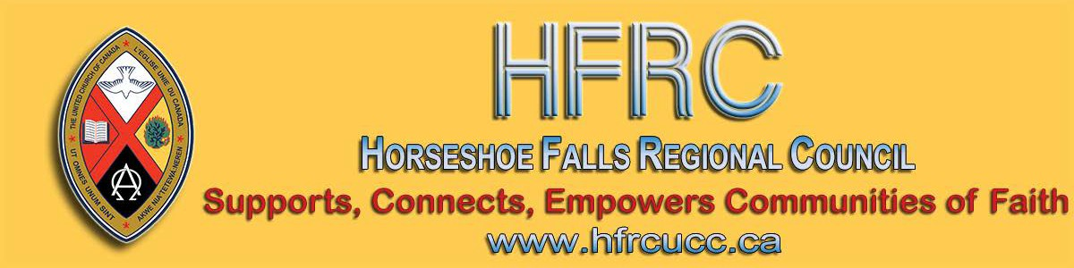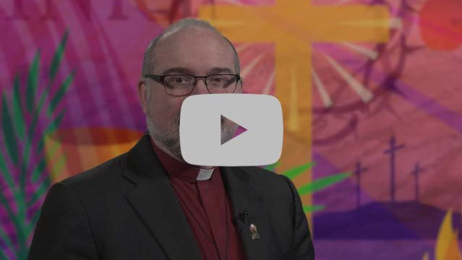
Subscribe |  | Past Issues |  | Translate |  | RSS
View this email in your browser

Next Deadline for submissions: March 13
Sign up for our newsletter & forward this one to friends.
Moderator Richard Bott's Lent message for 2020

Ash Wednesday isn’t only about lament and death—it’s also about celebrating life because the two are so deeply intertwined. For the 40 days of Lent, you are invited to join in celebrating life each day.

Visit the United Church worship page for additional Lenten resources.

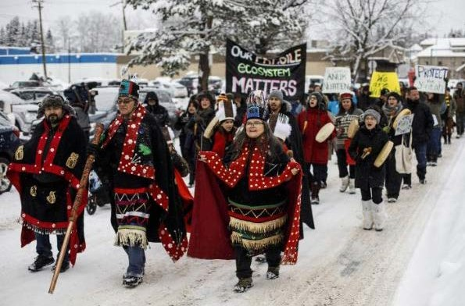

The National Indigenous Elders Council and Moderator Richard Bott have written a joint letter in support of Wet’suwet’en.

Learn how your faith community can encourage the Canadian government to embody the UN Declaration on the Rights of Indigenous Peoples in their relationships with Indigenous Peoples.
~~~~~ From the Editor's Desk ~~~~~

One year ago, the regional council staff were scrambling to assemble email lists to send newsletters. Our newsletter platform was not working for the volume of our work and our websites were a distant hope! Thank you for your patience as we have developed these communication tools.
The website and newsletter are still being reviewed and refined - we continue to make improvements.
Welcome to our newly formatted newsletter. We realize that the newsletter has a three-fold purpose:

1. to provide useful advice for communities of faith;
2. to detail upcoming events;
3. to share stories of life throughout the regional council.

We want to provide all three in a way that makes it easy to navigate the newsletter

and to skim it for selected portions if desired. This newsletter is divided into 3 sections:

For Your Community of Faith

Upcoming Events

News from Around the Regional Council

Enjoy the read!

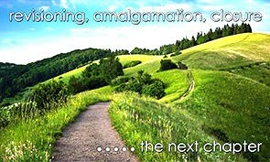
for Communities of Faith

Confirmation Retreat
Five Oaks, April 3 - 5

Colour Outside the Lines, Unravel Faith, Resurrect Hope and Create Radical Beauty on Earth with Ruth Noble, Alana Martin and Kathy Douglas.

A retreat to support & enrich the confirmation process of your congregation. For both youth & leaders. Come, share the journey!

For information email Kathy Douglas.

Please Share this Newsletter

Please share this newsletter widely. It is especially helpful for people involved in leadership roles in your community of faith to know what upcoming events are planned that they might find helpful.

Invite people to subscribe for themselves by including the following with the announcements: Stay in touch with the wider church: subscribe to the regional council newsletter.

Video Licensing Available for May 2020 to April 2021
Sisters Together: Clergy Women's Retreat for Women in Ministry - April 20 - 24

The theme of this 5-day event is 'Voices of Hope in Challenging Times'. The event features Rabbi Elyse Goldstein, Rev. Dr. HyeRan Kim-Cragg and Diamond
Fotiadis. The Blanket Exercise with Kairos
Canada will also be presented.

Download the poster for information, go to the Facebook page, send an email to sistersandministers@gmail.com, or go directly to the registration form. Limited to the first 50 participants.

Interim Ministers Spring Retreat
Five Oaks Retreat Centre
May 6 to May 7

Holy connection, worship, open space, spiritual practices, kaleidoscope Bible study, learning experience.

Registration deadline is March 30.

Video licensing information is available online at Buying United. Those who had video licenses last year should have received their invitation for this year. Please share this information as widely as you can. The deadline for applications for this round is Friday, March 27.

Contact Alexandra Belaskie or at 1-800-
268-3781 x4157 for more information.

HUB Youth Event & GO Project Climate Change & Our Faith Saturday, March 14, 2-8 pm
St. Paul's UC, Oakville

Calling all youth & groups, grades 8 & up!

Climate change. We know it’s real. We know it matters. We know it’s making all the headlines right now. So how can we go deeper than a headline or a hashtag? What are the facts and what does it all have to do with Jesus? How do we engage this issue as people of faith? If being a disciple means making a difference, how can we actually do that??

So many questions! And that's what this day is all about! Exploring those
important questions, and learning how we can make positive changes to protect this
planet God gave us.
Download the poster or go to the registration form.

reVITALize 4
SAVE-THE-DATES June 5 & 6

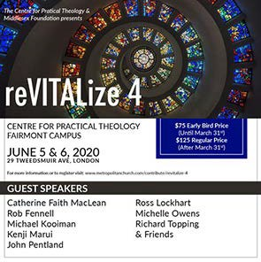

Early Bird Rate until: March 31st!

reVITALize 4: Amazing guest speakers. Presented by the Centre for Practical Theology & The Middlesex Foundation June 5 & 6. Find out more! Download the poster.

Rendez-Vous: Bold Faith. Brave
Space. Brazen Grace.

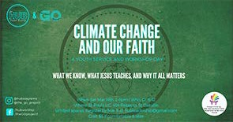Register by March 9, llimited spaces:
hubleadership@gmail.com. Find out everything here !

Want to include something here?

Do you know of a region-wide event or happening that would be of interest to ministry personnel and/or lay members? To have it posted in this regional newsletter, send an email with the information to pkukadia@united- church.ca.

The next deadline is March 13.

Lent is here! give, Give, GIVE

What if we not only give up something, but GIVE something for Lent?

Find ideas here on what to give ... and download the flyer from Dave Jagger.

Upcoming Events

Nations Uniting Parallel Paths
March 11 - 1:30 - 3:30 pm
Rendez-vous, an M&S supported event, brings together youth (grade 9 and up to any age), young adults and their leaders from across the country (and beyond!) for a celebration of vibrant music, inspiring speakers, and dancing like there is no tomorrow.

We are planning to take 10 participants. The cost of the registration will be about
$350 and the flight will be $800-$900. We're applying for funds to help cover 1/3 of the cost.

Get involved. Find out how. Email Kathy or call her at 519-441-0656.

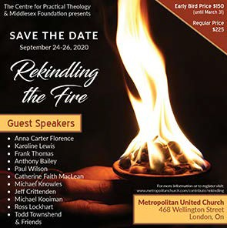Rekindling the Fire SAVE-THE-DATES September 24-26

Early Bird Rate until: March 31st! Rekindling the Fire: Many guest
speakers. Presented by the Centre for Practical Theology & The Middlesex Foundation September 24 to 26. Find out

Come and explore Parallel Paths with us: compare Traditional Culture and Stories of Spirituality to Christian Scriptures and stories that are similar with guest speaker, Renee Thomas-Hill.

At Nations Uniting, 1652 Chiefswood Rd, Ohsweken (Google map).

PIE Day Worship,
Facing Queerphobia Video from Affirm United

PIE Day happens every March 14! Affirm United/S’affirmer Ensemble and Affirming Connections have partnered to bring you tools and ideas to put on your own PIE event.

Find out about the activities happening on
March 14. Check out www.pieday.ca.

Download the February - March newsletter from Affirm United.

Centre for Christian Studies Annual General Meeting March 19 at 6 pm CT
more! Download the poster.

Regional Council Events

Youth Rally 2020: Escape! April 23 - April 26
Pearce-Williams Christian Camp

High-School aged youth: Do you love to be inspired, challenged to think, meet new people & hang out with good
friends ??? Do you enjoy being in an open
& welcoming community where you are free to be completely yourself ? Well, faith, fellowship and connection is what Youth Rally is all about.

Come join us for Youth Rally 2020: Escape! Registration closes when full.

There is limited space! Register Early. Deadline for registration: April 9.

For more information email Shannon.

Kids Across the Regions: Heroes Unite! June 6 - June 7
Camp Bimini, St. Paul's

A fun, faith filled weekend for children (grades 3 to 8) from across the three regional councils of Antler River Watershed, Western Ontario Waterways and Horseshoe Falls of The United Church of Canada! We’ll be gathering in early June after the Annual Meetings of the three regional councils to give us warmer weather and access to the beautiful pool at Camp Bimini.

Join us! Registration closes when full. Register Early. Deadline for

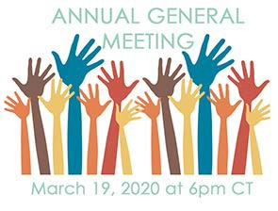

You're invited to the Centre for Christian Studies' 2020 Annual General Meeting on Thursday, March 19, from 6:00 pm to
8:00 pm Central Time. Join us in person at Woodsworth House (60 Maryland St, Winnipeg) or online via videoconferencing. (Call or email Cheryl -
204.783.4490 or office@ccsonline.ca for the link.) Agendas, reports, and documents will be posted on the CCS website soon.

Crossan is coming to Westdale
United Church, Hamilton
April 3 and 4

Contemporary Spiritual Voices present: A
weekend with John Dominic Crossan.
The foremost historical Jesus scholar will be at Westdale UC from a Friday evening talk through all day Saturday.

Register online or download the flyer and get all the details and information.

Rabbi Richard Address
Our Long and Winding Road Siloam United Church, London Saturday, April 4, 2:00 - 9:00 pm

Seeking our Path in the Longevity
Revolution: Rabbi Richard F. Address,

registration: May 22.

We are inviting youth & young adult leadership for this event. If you are a high-school aged youth or young adult interested in being leadership
for Kids Across the Regions, please contact
Kathy Douglas.

For more information email Kathy
Douglas or call 519-441-0656.

Missional Leadership Diploma Atlantic School of Theology June 2020

Learn the keys to thriving ministry in the
21st Century. Starts in June - Apply now! Only 25 spots available. For more details on this leading edge program download this information sheet and/or contact Dr. Stephen Harper.

Question & Answer Column

Question What iare Horseshoe Falls Regional Council's Learning Grants to be used for?

Answer
An opportunity to provide both ministry personnel, lay leaders and musicians with financial assistance for professional development, continuing education, event

DMin is a leading authority on Boomer and Older Adult Ministry. He hosts the weekly radio show "Boomer Generation Radio" in Philadelphia and speaks regularly on issues related to baby boomers, aging and how Judaism can impact our lives as we age.

Download the poster and registration form. Contact Siloam United Church by email or phone at 519-455-9201.

Leadership Development and Continuing Education For lay people and clergy who want to learn, explore, and question, the Centre for Christian Studies is offering two one-week learning circles: Oppression and Resistance (Apr 15-21) and Ages and Stages (April 23-29). Application deadline this month. Both will be in Winnipeg. Click on the name of the circle to find out more. If you have questions call 204-783-4490 or e-mail info@ccsonline.ca.
sponsorship and student bursaries. *The form must be submitted prior to the event for review.

Find out more, download the information and application form here .

From your friendly Horseshoe Falls
Regional Council . :)

Treasurers: Charity Returns
We Have An Answer for You

In response to the following question on the T3010 Charity Return: Was the
charity in a subordinate position to a head body?

Answer: The United Church of Canada
Bn # 108102435RR0003

Thanks for all you do at this busy time of year to help United Church communities of faith understand their financial picture and direct their assets to the service of God's mission.

Due to having had the flu, this issue has been sent out later than planned. The next deadline is still March 13. I welcome your submissions. Pretima Kukadia
- - - - - - - - - - - - - - - - - - - - - - - - - - - - - - - - - - - - - - - - - - - - - - - - - - -

The Horseshoe Falls Regional Council newsletter welcomes submissions of upcoming events, regional news and educational opportunities. This is also the place to keep up-to-date on information from the regional office.

Supports, Connects, Empowers
Communities of Faith

Horseshoe Falls Regional Council
The United Church of Canada

Sign up for our newsletter.

Copyright © 2020 Horseshoe Falls Regional Council, UCC, All rights reserved.

Want to change how you receive these emails?
You can update your preferences or unsubscribe from this list.

