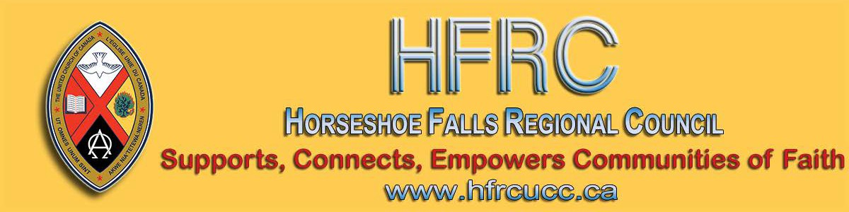
Subscribe |  | Past Issues |  | Translate |  | RSS
View this email in your browser

Next Deadline for submissions: January 31
Sign up for our newsletter & forward this one to friends.
M & P Workshop Saturday, January 25, 10-12 pm Forest Hill UC, Kitchener

A Ministry & Personnel workshop is being held Saturday, January 25 from
10:00 a.m. to noon at Forest Hill United Church,121 Westmount Rd E, Kitchener. Don't miss out on this opportunity!

Register with Ruthanna Mack to reserve your seat and/or for your group.
Supports, Connects, Empowers
Communities of Faith

Horseshoe Falls Regional Council
The United Church of Canada
Sign up for our newsletters.

Copyright © 2020 Horseshoe Falls Regional Council, UCC, All rights reserved.

Want to change how you receive these emails?
You can update your preferences or unsubscribe from this list.

