To access a link in this newsletter, please press CTRL + mouse click on the highlighted link.
View this email in your browser
Next Deadline for submissions: TBA
Forward this to a friend to sign up for this newsletter.

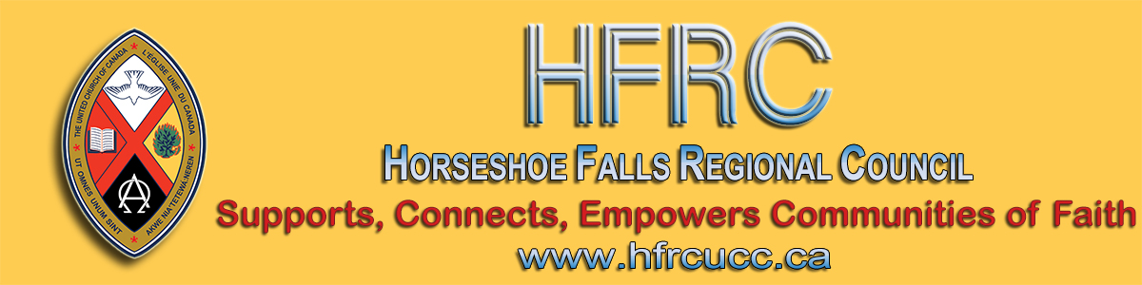

New Provincial Guidelines
- - - From news.ontario.ca - - -
Effective Friday, June 12, 2020, 12:01 a.m. the province will increase the limit on social gatherings from five to 10 people across the province, regardless of whether a region has moved to Stage 2. Additionally, all places of worship in Ontario will also be permitted to open with physical distancing in place and attendance limited to no more than 30 per cent of the building capacity to ensure the safety of worshippers.

Now each community of faith needs to decide if and when it is ready to re-open. Below are some factors to consider:

1) Is your building ready?
- Have you removed hymn books, bibles, etc. from the pews or made plans for the cleaning of them after every service?
- Have you decided how you will mark pews/chairs to ensure there is physical distancing?
- What plans are in place for a thorough cleaning of the space after every use?

2) Are your worship plans in place?
- Have you decided how you will manage people entering the building to limit the risk of spreading the virus? One person with gloves and mask at a designated door or hand sanitizer at the entrance?
- How will you track who is present, with their name and contact information, so that you are able to provide this to public health officials if one of the attendees tests positive for the virus in the next 14 days?
- If you are moving to broadcast words, have you secured the copyright licence (the grace period is now over)?
- It is not recommended to use bulletins. What other plan is in place?
- How will you handle the offering so you are not passing the plate from person to person?
- Have you determined if and how you will involve music? Congregational singing is dangerous - so will music be only instrumental or will there be a soloist far removed from others?
- What will you do to substitute greetings or passing the peace that were customarily part of the service?

3) Is the congregation ready?
- The membership of many congregations are among those who are vulnerable to the virus. People may not feel comfortable returning to church yet. What plans are in place to continue to engage those who still shelter in place?
- How will the congregation be prepared for the changes in worship and for the changes in behaviour - no lingering in the narthex to visit, no going to greet people, and so forth. How will you help people not fall into familiar but dangerous patterns?
- This is the most difficult stage yet. To date, congregations have done an amazing job of learning something totally new to them to be able to continue during lockdown. Now, as we consider reopening, we face the difficult task of adapting the familiar into something different. Over the past months, many communities have discovered benefits in their new experience. The changes that must happen once congregations return to the building are more likely to be viewed as a necessary restriction rather than a potential enhancement. Building commitment to and compliance with best practices is essential and may be challenging.

This is important work.
As the re-opening committee tackles it, please remember:

1) You are in charge of your timeline! There is always the risk that we may return to a more severe lockdown but, for now, you can choose when you open the building within this guideline.
If it makes sense to wait until September so that you can ensure that there is not a second wave and that all is ready, then wait until September.
Do not feel rushed!!!

2) What is the compelling reason to return to the building if returning to the building does not provide more contact with one another than being out of it did?
Is it worth the risk and the work?

Celebrating Communion
Please do not rush to celebrate communion in person. It is a high-risk activity while there is still community spread happening.
The Theology and Faith Committee extensively researched the option of on-line communion several years ago and United Church congregations are authorized to celebrate on-line communion provided it is happening in real time, such as a zoom service. One of the key elements of communion is the unity of the feast. That is lost if it is celebrated individually at different times. If the on-line option you are using provides for on-demand delivery rather than for a scheduled time delivery, then communion should not be celebrated.

Providing Pastoral Care
Ministry personnel have been asking about pastoral care. Reducing community spread requires social distancing and limited contacts. Every time a minister visits a person, the minister is bringing all the contacts they have had over the past 14 days with them! Although porch visits reduce the risk some, the minister is still increasing the circle of contacts for every person visited.
Best practices:
- Continue to provide pastoral care by telephone or other electronic means;
- Follow the guidelines of any health care facility being visited (hospital; long-term care);
- As much as possible, do not visit different long-term care homes within 14 days of each other;
- Ask why any pastoral care contact needs to be in person? Make as few in-person visits as possible and only when there is a compelling reason to do so (end of life, tragedy).

Rethinking Church
Our ministry personnel and buildings are key to ministry so it is hard to imagine that they are, at this point, also a risk to vulnerable people. Our most valuable resources also pose our biggest threat. We need to recognize that spaces and actions that have been comforting are now dangerous. We have to rethink how we provide ministry.

Welcoming Tenants
Ensure that any user group returning to the space has a plan for safely practicing their program in accord with public health guidelines and sector specific restrictions that apply. How will their use of the space be contained? What cleaning protocols will be put in place subsequent to their use?

Staff Expectations
If there are new duties being assigned to staff (an online service as well as an in-person one, additional cleaning, etc.), ensure that the position descriptions are adjusted to allow for these with the removal of some current duties to make this possible.

To find out more visit Ontario.ca/coronavirus

Learning from Lockdown
The three regional councils are working in partnership to offer two evenings with Cameron Trimble, last year's theme speaker.
More details will follow but, for now, reserve:

Monday, June 22, 7:00 - 8:00 p.m.
Pre-registration required. Details will follow soon with registration information.

Thursday, June 25, 7:00 - 8:00 pm
Follow Up Session addressing questions raised out the previous event.

I'm Tired of Lockdown Too ...
On a personal note, I am aware that this past week I've been experiencing "quarantine fatigue" as our local Medical Officer of Health, Dr. Klassen, calls it.
I am keen to expand my world, see my family and visit with my friends. Many of us who are in general good health are longing for this. That is understandable. How do we manage that longing and still observe public health guidelines?
We are nowhere near the end of the pandemic. Community
spread continues and, realistically, may increase as the province re-opens.
There will be an end to the pandemic.
There will be a vaccine or treatment or something that reduces the threat of it. The question for us is how we live in the in-between time - between what we knew and loved before lockdown and what what life will be after the pandemic.
We ought to be able to do that as church because in-between time is the reality for the followers of Jesus who lived 2,000 years ago and whose kin-dom we await!

Be cautious. Stay safe. Be patient. God be with you,
Cheryl-Ann, Executive Minister

The Horseshoe Falls Regional Council newsletter welcomes submissions of upcoming events, regional news and educational opportunities. This is also the place to keep up-to-date on information from the regional office.

Supports, Connects, Empowers
Communities of Faith

Horseshoe Falls Regional Council
The United Church of Canada

Sign up for our newsletter.

For information, contact Pretima: pkukadia@united-church.ca
Our phone number is: 1-833-236-0280
Our mailing address is:
Horseshoe Falls Regional Council, UCC
PO Box 100
Carlisle, On L0R 1H0
Canada
Add us to your address book
Copyright © 2020 Horseshoe Falls Regional Council, UCC, All rights reserved.

