To access a link in this newsletter, please press CTRL + mouse click on the highlighted link.

View this email in your browser
Next Deadline for submissions: April 3
Sign up for our newsletter & forward this one to friends.

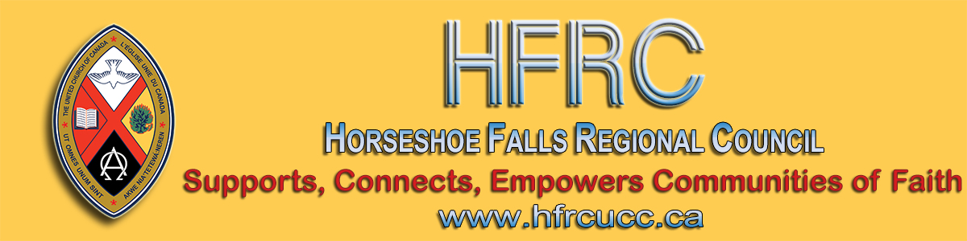

COVID-19 Update
As the COVID-19 situation changes moment by moment, our goal is to find ways to minimize the spread of the virus without maximizing the spread of fear.
Please click on any of these links to take you to the section below:
Web Resources Some Key Links Social Distancing Regional Council Office Updates
Communities of Faith On-line Options Streaming/Podcasts Donations
Protecting Staff The Vulnerable

Website Resources
United Church communities of faith are referred to this page on the Horseshoe Falls Regional Council website for emergency planning information https://arwrcucc.ca/emergency-plan/.
Some Key Links
The United Church of Canada Emergency Plan:
This is where you will find the United Church Emergency Plan with recommendations for communities of faith can be found.
Ontario Ministry of Health Coronavirus Preparation:
The latest updates from the Ministry of Health: how to protect yourself, what to do if you’re sick after travel and how to recognize possible symptoms.
Local Public Health Unit:
Public Health Units monitor this developing situation actively, in collaboration with national and provincial health agencies, as well as local stakeholders, including hospitals and community agencies.

Social Distancing
With the announcements made on Thursday, Ontario has adopted the principle of social distancing, of following practices designed to slow the spread of transmission. This has guided the following decisions for the regional council.
Communities of faith are encouraged to consider the social distancing principle when determining when to remain open or when to close.
Regional Council Office Updates
- In Person Gatherings
For the next two weeks (March 13th - 27th), there will be no in-person regional council gatherings or meetings. By March 27th, a decision will be made concerning events planned for the week of March 30th.
Though we rarely have a gathering that meets the cut-off for number of participants, our meetings involve people attached to different communities of faith. One person at this meeting who may be infected, but is not yet showing symptoms, could possibly lead to infecting several different communities of faith - that of every person present. The cut-off number would be far exceeded. The potential to spread the virus from one gathering to many communities needs to be taken seriously.
- Regional Council Staff will Not Be Visiting Communities of Faith
While few of our staff fall into high risk categories, the majority of our staff have loved ones who do. The goal is to reduce the likelihood of staff carrying the virus to a loved one whose health may be compromised by it.
- Visitors will Not Be Received at the Regional Council Office
It is open ONLY to staff.
Staff have discussed protocols to practice good hygiene and minimize risk. Staff are also free to work from home. Our current technology makes that possible and, in fact, most of our staff do this regularly.

For Communities of Faith
The United Church of Canada is a conciliar church and that means each council (community of faith, regional council and General Council) makes certain decisions. The decision whether a community of faith continues to meet for worship is made by the council of that community of faith. The community of faith needs to be guided by advice from the above listed websites and with sensitivity to the possibility of transmission.
Some communities of faith that are planning to meet have put in place new practices such as:
- not passing the peace
- not shaking hands
- dispersing the choir throughout the congregation rather than gathering them in one place
- having hand sanitizer available in many locations
- inviting one person to operate the door
- providing latex gloves for those counting the offering
- cancelling coffee hour or social times
- providing pastoral care by phone rather than a visit ...
There are, no doubt, many other helpful suggestions that would aid in minimizing the risks of transmission. We offer these few but acknowledge we are not health experts, and this is a time to follow the advice of those who are.

On-line Options
If your community decides to cancel in-person worship, consider whether you have the capacity to stream your service. That does not reach all members but might reach some, at least. If your community does not have that ability, it is likely that a nearby community of faith does and offers a streamed or broadcast service every Sunday.
Streaming/Podcast/Broadcast
One License, along with hundreds of their Member Publishers, announced that it is honoured to assist worshipping communities during this extraordinary time by providing two different gratis license options valid through April 15, 2020.
New to One License? Sign up for an account and use code 'CRVS20' at checkout. Already have an account? Email One License to add a podcast/streaming license.
Donations
Every United Church congregation can activate their Canada Helps page as a way to provide for on-line donations. Go to the website and type in your community of faith's name in the search bar. Every community of faith is already listed, with several donation options.
Your community of faith may find that these services may be useful even after this current emergency.

Protecting Your Staff
In Ontario, an employee has the right to refuse work that the employee feels is not safe. Make the safety of your staff a priority:
- Your minister might choose to lead worship, but then leave without greeting others to reduce the risk of infection.
- Custodial staff may need to be supplied with proper equipment and supplies.
- The office administrator might ask to be contacted by phone rather than visited in person.
As the supervisor for the regional council staff, my goal is to take steps to ensure that none of the staff ever have to protest that they in concern for their safety. I encourage all communities of faith to do the same.

Remember the Vulnerable
As people of faith and members of our respective communities, please remember those in need:
- A grocery store run to stock up on supplies could be followed by a stop at a local food bank.
- Stay in touch, by phone, with elderly people who may be feeling alone and anxious.
- Those with medical conditions may need extra help to minimize their risk of infection.
- And, some United Church staff, like others in our communities, may find themselves with reduced income. As employers, communities of faith are encouraged to support staff to the best of their ability.

As your regional council we will continue to provide updates as appropriate and again ask that you stay tuned to the above web pages.
Stay well!!
Shalom,
Cheryl-Ann Stadelbauer-Sampa
Executive Minister
Antler River Watershed Regional Council
Western Ontario Waterways Regional Council
Horseshoe Falls Regional Council
905-659-3343 Ext. 2
1-833-236-0280 Ext 2

The Horseshoe Falls Regional Council newsletter welcomes submissions of upcoming events, regional news and educational opportunities. This is also the place to keep up-to-date on information from the regional office.

Supports, Connects, Empowers
Communities of Faith

Horseshoe Falls Regional Council
The United Church of Canada

Sign up for our newsletter.

Copyright © 2020 Horseshoe Falls Regional Council, UCC, All rights reserved.
Want to change how you receive these emails?
You can update your preferences or unsubscribe from this list.

