To access a link in this newsletter, please press CTRL + mouse click on the highlighted link.

View this email in your browser
Next Deadline for submissions: April 3
Sign up for our newsletter & forward this one to friends.

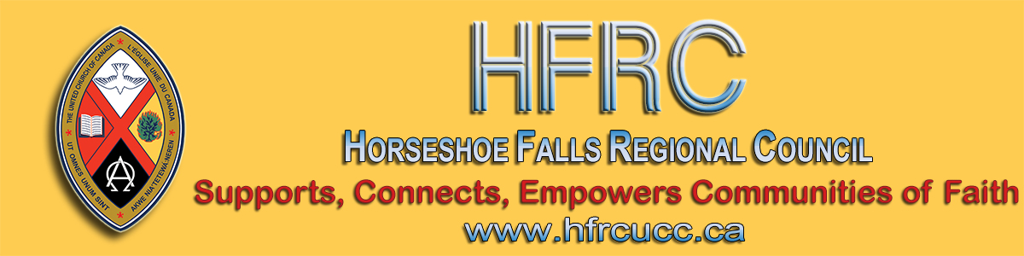

REGIONAL COUNCIL MEETING

Friday, May 29 to Sunday, May 31
Unifor Family Education Centre, Port Elgin
Registration Deadline: Midnight April 30
No meals can be provided after this date

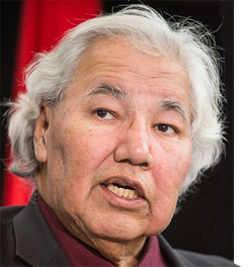
It's that time of year and the registration form for the May meeting of the regional council is open.
This year's theme speaker is Senator Murray Sinclair, one of the Commissioners and authors of the Truth and Reconciliation Commission (TRC). Senator Sinclair will be discussing the TRC's Calls to the Church.
A DRAFT agenda is attached. An agenda for your regional council's meeting will be emailed to registrants early in May. This DRAFT agenda is for planning purposes.
PLEASE NOTE: A worship service is being prepared for congregational use on Sunday, May 31. It will be posted on the Regional Meeting webpage as will other information as it becomes available.

The Horseshoe Falls Regional Council newsletter welcomes submissions of upcoming events, regional news and educational opportunities. This is also the place to keep up-to-date on information from the regional office.

Supports, Connects, Empowers
Communities of Faith

Horseshoe Falls Regional Council
The United Church of Canada

Sign up for our newsletter.

Copyright © 2020 Horseshoe Falls Regional Council, UCC, All rights reserved.
Want to change how you receive these emails?
You can update your preferences or unsubscribe from this list.

