To access a link in this newsletter, please press CTRL + mouse click on the highlighted link.

View this email in your browser
Next Deadline for submissions: TBA
Forward this to a friend to sign up for this newsletter.

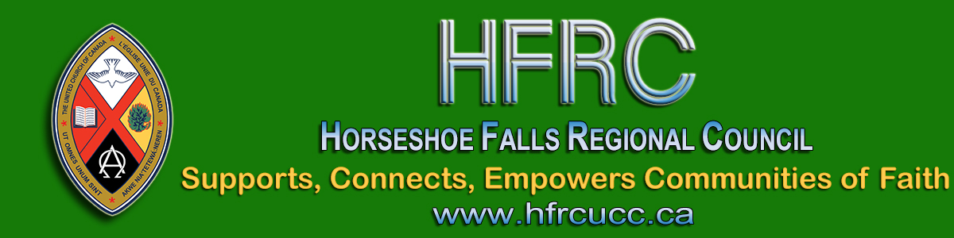

An Invitation to the Licensed Lay Worship Leaders Resource Team
- - - From Allison Playfair, Chair - - -
The Human Resources Commission is looking for individuals to be part of our Licensed Lay Worship Leaders Resource Team. This group will oversee Licensed Lay Worship Leaders (LLWL) in Horseshoe Falls Regional Council.
We are looking for Ministry Personnel from any stream, lay people who are not LLWLs and LLWLs to be on this group. This will be a one to three year term position with the option of a renewal for one term.
If being on this committee is something that interests you, please complete an Expression of Interest form (also found on the Horseshoe Falls Regional Council website under Resources).

The primary responsibilities for this committee will be:
- Interviewing potential LLWLs and recommending licensing to the Human Resources Commission.
- Interviewing and recommending current LLWLs for relicensing every 3 years.
- Ensuring LLWLs have completed mandatory workshops and have a current Police Records Check.
- Ensuring the recognition of a newly licensed LLWL at a service of worship.
- Providing ongoing support and guidance to LLWLs.

Feel free to send Allison Playfair an email if you have questions.

The Horseshoe Falls Regional Council newsletter welcomes submissions of upcoming events, regional news and educational opportunities. This is also the place to keep up-to-date on information from the regional office.

Supports, Connects, Empowers
Communities of Faith

Horseshoe Falls Regional Council
The United Church of Canada

Sign up for our newsletter.

For information, contact Pretima: pkukadia@united-church.ca
Our phone number is: 1-833-236-0280
Our mailing address is:
Horseshoe Falls Regional Council, UCC
PO Box 100
Carlisle, On L0R 1H0
Canada
Add us to your address book
Copyright © 2020 Horseshoe Falls Regional Council, UCC, All rights reserved.

