To access a link in this newsletter, please press CTRL + mouse click on the highlighted link.

View this email in your browser
Next Deadline for submissions: TBA
Forward this to a friend to sign up for this newsletter.

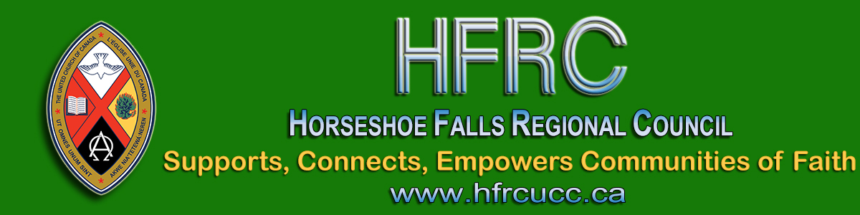

How are You Called to Be the Church?
as a member of the Horseshoe Falls Regional Council?

Supports, Connects, Empowers Communities of Faith is the Horseshoe Falls Regional Council’s (HFRC) purpose statement. HFRC fulfills this goal in part by connecting communities of faith with one another and with the United Church as a whole.
In the regional council, there are decision making bodies and resource pools. Details about the work of each can be found in the Governance Handbook.
Decision-Making
The decision-making bodies of the Executive, Covenant Commission, Human Resources Commission and Mission and Discipleship Commission meet regularly to make the decisions entrusted to the regional council.
At the 2020 fall meeting, the regional council will fill the following vacancies through the election of new members:
- Covenant Commission: maximum 5 spots
- Human Resources Commission: maximum 4 spots
- Mission & Discipleship Commission: maximum 5 spots
- Executive: 4 spots
These positions are open to anyone who is a full member in good standing in a congregation within the bounds of the regional council.
If you would be willing to let your name stand as a nominee for one of these positions, please complete the Expression of Interest Form by FRIDAY, NOVEMBER 13 at 7:00 pm. This information (minus your personal contact details) will be available to regional council members for consideration before voting.
Resource Pool
If you prefer a more time-limited involvement, please volunteer to assist in one of the resource pools. Details regarding the resource pools are also in the Governance Handbook. All resource pool volunteers will be contacted directly by the Commission selected.
Either as a member of the resource pool or one of the decision-making bodies, you will have the opportunity to learn more about the church and develop skills of benefit to your home community of faith.
If you have questions about the work of the Commissions and/or Executive, feel free to contact President Kate Young, or the Commission Chair for more details.
- President Kate Young
- Covenant Commission Chair Adrianne Robertson
- Human Resources Commission Chair Allison Playfair
- Mission & Discipleship Commission Chair Diane Viney
Thank you for your prayerful discernment of how you might serve.

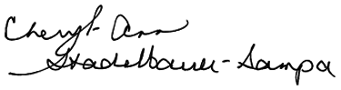
Executive Minister

The Horseshoe Falls Regional Council newsletter welcomes submissions of upcoming events, regional news and educational opportunities. This is also the place to keep up-to-date on information from the regional office.

Supports, Connects, Empowers
Communities of Faith

Horseshoe Falls Regional Council
The United Church of Canada

Sign up for our newsletter.

For information, contact Pretima: pkukadia@united-church.ca
Our phone number is: 1-833-236-0280
Our mailing address is:
Horseshoe Falls Regional Council, UCC
PO Box 100
Carlisle, On L0R 1H0
Canada
Add us to your address book
Copyright © 2020 Horseshoe Falls Regional Council, UCC, All rights reserved.

