To access a link in this newsletter, please press CTRL + mouse click on the highlighted link.

View this email in your browser
Next Deadline for submissions: TBA
Forward this to a friend to sign up for this newsletter.

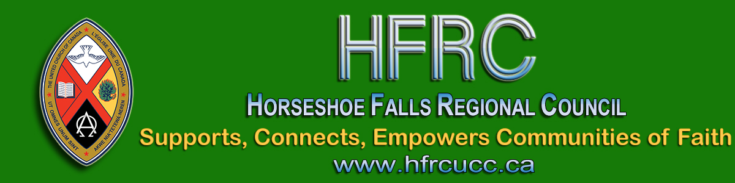

The Great Unveiling: How The World is Changing and What It Means for the Church
Join these two Zoom webinars with Cameron Trimble
Registration not required - just join us!
Monday, August 10, 7:00 - 8:00 pm
Thursday, August 13, 7:00 - 8:00 pm
(links & passcodes below)

Monday, August 10, 7:00 - 8:00 pm:
Meeting Link: Join Zoom Meeting
Meeting ID: 871 7995 3296
Passcode: 334455
Cameron will invite us to consider how this moment in time might be transforming the church. Attendees will be invited to submit questions after the event.

Thursday, August 13, 7:00 - 8:00 pm:
Meeting Link: Join Zoom Meeting
Meeting ID: 871 7995 3296
Passcode: 334455
Cameron answers our questions. (Questions will be collated according to similar themes and prioritized according to widespread applicability.)

Please join us for both sessions.
Convergence is managing the technology for these events. They are able to provide for more generous participation -- but not unlimited!

Last year Cameron Trimble energized the regional council with her invitation to catch the view from 10,000 feet (3,048 m)!
Since May 2019, much has changed. Cameron has had a bout of COVID-19. Having recovered, she has again offered to spend two evenings with us to help us catch the view now.

The Horseshoe Falls Regional Council newsletter welcomes submissions of upcoming events, regional news and educational opportunities. This is also the place to keep up-to-date on information from the regional office.

Supports, Connects, Empowers
Communities of Faith

Horseshoe Falls Regional Council
The United Church of Canada

Sign up for our newsletter.

For information, contact Pretima: pkukadia@united-church.ca
Our phone number is: 1-833-236-0280
Our mailing address is:
Horseshoe Falls Regional Council, UCC
PO Box 100
Carlisle, On L0R 1H0
Canada
Add us to your address book
Copyright © 2020 Horseshoe Falls Regional Council, UCC, All rights reserved.

