To access a link in this newsletter, please press CTRL + mouse click on the highlighted link.

View this email in your browser
Next Deadline for submissions: TBA
Forward this to a friend to sign up for this newsletter.

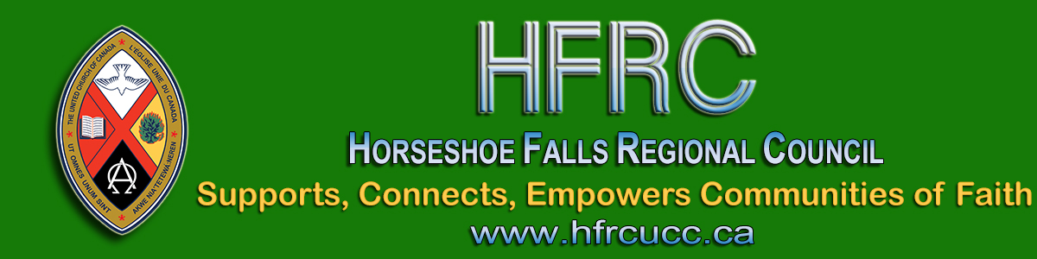

Virtual Regional Council Meeting
November 12 - November 15

Horseshoe Falls Regional Council is holding our FIRST EVER virtual regional council meeting! We will make history.
Save these dates & times!
November 12 | Thursday | 6:00 – 7:30 pm
November 13 | Friday | 4:00 – 5:30 pm
November 14 | Saturday | 9:30 – 11:00 am  1:00 - 2:30 pm
November 15 | Sunday* | 10:00 am
*Celebration of Ministries Service will be live streamed

Celebration of Ministries Service
Plan now for your congregation to join the live streamed service on Sunday morning. All communities of faith are invited to join the regional council service. Ministry Personnel are entitled to take this Sunday off for the regional council meeting. Instead of providing an alternate service for congregational worship, a link will be shared to enable us to worship as one -- a new and exciting experience!

To Prepare for the Meeting Each Community of Faith is asked
- To ensure that their representative(s) to the regional council have been selected according to the formula set out in The Manual C.1.2;
- To share the news of our joint Sunday worship service with all your members.
For Regional Council Representatives and Ministry Personnel
Information will be available in early October for you to register for the meeting. Prior registration is essential for online voting.
Information is available on the website for regional council representatives and ministry personnel
- To consider openings on the Executive and Commissions and discern how you might become involved. The work of the Executive and Commissions is detailed in the Governance Handbook;
- To consider if you are our regional council's next President (to take office in the spring of 2021).

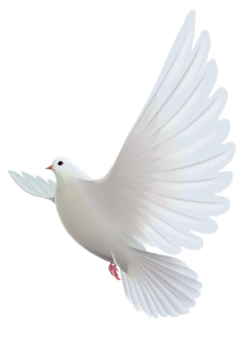
Further details, the registration form, and other information will be available early October. Watch for emailed newsletters or check the Regional Council Meeting page on the website.
This is such an exciting opportunity for us to learn to do something different together! We'll need patience and imagination and the blessing of the Spirit!

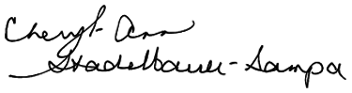
Blessings,
Executive Minister, Antler River Watershed Regional Council

The Horseshoe Falls Regional Council newsletter welcomes submissions of upcoming events, regional news and educational opportunities. This is also the place to keep up-to-date on information from the regional office.

Supports, Connects, Empowers
Communities of Faith

Horseshoe Falls Regional Council
The United Church of Canada

Sign up for our newsletter.

For information, contact Pretima: pkukadia@united-church.ca
Our phone number is: 1-833-236-0280
Our mailing address is:
Horseshoe Falls Regional Council, UCC
PO Box 100
Carlisle, On L0R 1H0
Canada
Add us to your address book
Copyright © 2020 Horseshoe Falls Regional Council, UCC, All rights reserved.

