To access a link in this newsletter, please press CTRL + mouse click on the highlighted link.

View this email in your browser
Next Deadline for submissions: TBA
Forward this to a friend to sign up for this newsletter.

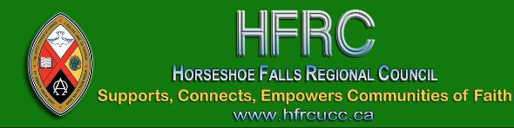

Fall Regional Council Meeting Links & Info

Our first virtual meeting for Horseshoe Falls Regional Council starts this Thursday through to Saturday, with the Celebration of Ministry service live streamed on Sunday November 15 at 10:00 a.m. from Norval United Church, Georgetown.
Please have a candle & lighting implement for opening Thursday session at 6:00 pm.

Dates & Times!
November 12 | Thursday | 5:30 *New Rep orientation  6:00 – 7:30 pm
November 13 | Friday | 4:00 – 5:30 pm
November 14 | Saturday | 9:30 – 11:30 am  1:00 – 2:30 pm
November 15 | Sunday | 10:00 am
Celebration of Ministry Service will be live streamed here on our YouTube channel
* * * * * * * * * * * * * * * * * * * * * * * * *

Information and Documents:
- Link for ALL meeting sessions: Thursday, Friday and Saturday: https://united-church.zoom.us/j/91541419776.
*** Please have a candle & lighting implement for the opening of the Thursday session.
- Workbook for the meeting with reports, agenda, background information and meeting materials.
- The detailed 2020 and 2019 Budget for more information.
- The detailed 2021 and 2020 Budget for more information.
- Please view these Nominations: Expressions of Interest. This list will be updated after the deadline for submissions: Friday, November 13, 6:00 pm, has passed.
There is still time to fill out an Expression of Interest!
Please note: Only President-Elect, Executive & Commission members are elected. Submissions for resource pools, LLWL resource team & others, will be responded to after the meeting.
- The September 22, 2020 recording of Affirming Our Communities, Affirming Our Faith is on our YouTube channel (information for Proposal #3, Workbook pg. 32).
- Recording of Pre-Meeting Financial Webinar held Monday, November 9 on our YouTube channel.
- Zoom Icons: The four icons pointed out below will help you have a successful Zoom Meeting! Download this Super Easy Zoom Guide. Pages 19 - 22 in the Workbook cover Zoom essentials for our meetings.
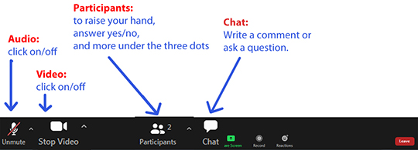
- The live-streamed Celebration of Ministry service on Sunday at 10 a.m. will be found on our YouTube Channel: https://www.youtube.com/channel/UCtNUcub3St5941GPwyu7yOA. Please share this link with your community of faith - this service is open to all.
Thank you for your patience as we get started. Looking forward to our time together!

Blessings,
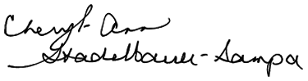
Executive Minister, Antler River Watershed Regional Council

The Horseshoe Falls Regional Council newsletter welcomes submissions of upcoming events, regional news and educational opportunities. This is also the place to keep up-to-date on information from the regional office.

Supports, Connects, Empowers
Communities of Faith

Horseshoe Falls Regional Council
The United Church of Canada

Sign up for our newsletter.

For information, contact Pretima: pkukadia@united-church.ca
Our phone number is: 1-833-236-0280
Our mailing address is:
Horseshoe Falls Regional Council, UCC
PO Box 100
Carlisle, On L0R 1H0
Canada
Add us to your address book
Copyright © 2020 Horseshoe Falls Regional Council, UCC, All rights reserved.

