To access a link in this newsletter, please press CTRL + mouse click on the highlighted link.

View this email in your browser
Next Deadline for submissions: TBA
Forward this to a friend to sign up for this newsletter.

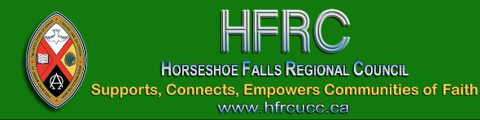

Regional Council Meeting
Information for Saturday Sessions

For Saturday's sessions please familiarize yourself with the financial documents in the Workbook, pg.35-44 and/or the detailed versions below. If you require more information, please review the Pre-Meeting Financial Webinar.

Nominations Expressions of Interest: The attached list is a revised list compiled after the deadline.
Please note: Only President-Elect, Executive & Commission
members are elected. Submissions for resource pools, LLWL
resource team & others, will be responded to after the meeting.

Dates & Times!
November 14 | Saturday Zoom Link | 9:30 – 11:30 am  1:00 – 2:30 pm
November 15 | Sunday | 10:00 am
Celebration of Ministry Service will be live streamed here on our YouTube channel
* * * * * * * * * * * * * * * * * * * * * * * * *

Information and Documents:
- The detailed 2020 and 2019 Budget.
- The detailed 2021 and 2020 Budget.
- The September 22, 2020 recording of Affirming Our Communities, Affirming Our Faith is on our YouTube channel (background for Proposal #3, Workbook pg. 32).
- 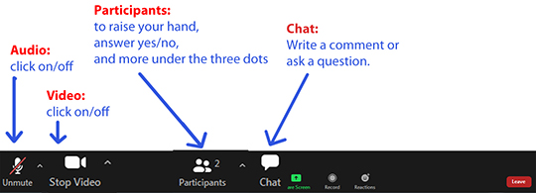
Thank you for your patience. Looking forward to our time together!

Blessings,
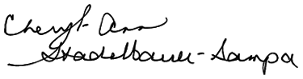
Executive Minister, Antler River Watershed Regional Council

The Horseshoe Falls Regional Council newsletter welcomes submissions of upcoming events, regional news and educational opportunities. This is also the place to keep up-to-date on information from the regional office.

Supports, Connects, Empowers
Communities of Faith

Horseshoe Falls Regional Council
The United Church of Canada

Sign up for our newsletter.

For information, contact Pretima: pkukadia@united-church.ca
Our phone number is: 1-833-236-0280
Our mailing address is:
Horseshoe Falls Regional Council, UCC
PO Box 100
Carlisle, On L0R 1H0
Canada
Add us to your address book
Copyright © 2020 Horseshoe Falls Regional Council, UCC, All rights reserved.

