To access a link in this newsletter, please press CTRL + mouse click on the highlighted link.

View this newsletter in your browser
Next Deadline for submissions: tba
Forward this to a friend to sign up for this newsletter

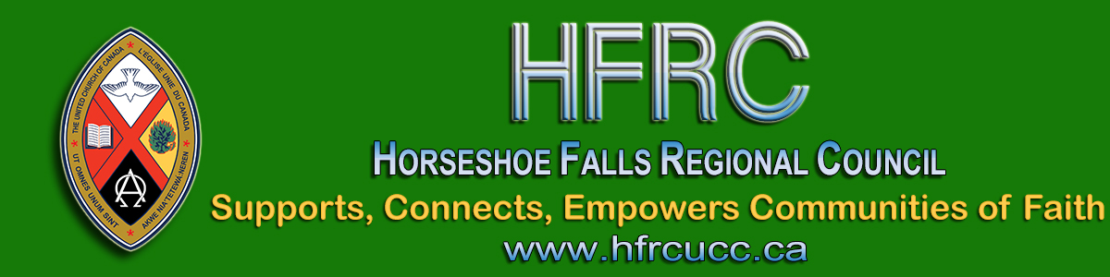

Welcome Our New Minister, Right Relations and Social Justice
Rev. Thérèse Samuel

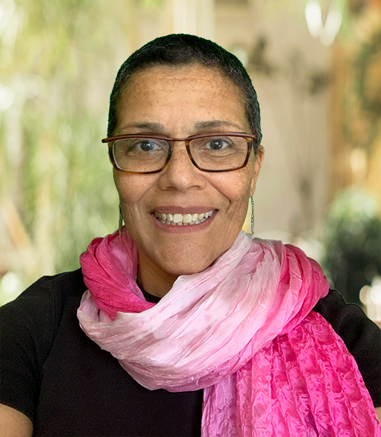
In September, the Executives of the three regional councils met together to confirm the staff complement and to authorize a search for a vacant position. A position was created: Minister, Right Relations and Social Justice.
While these two elements are related, they are also distinct. The search committee wondered if finding a candidate who could cover both was possible.

To the committee’s delight, several such individuals applied. After reviewing resumés, receiving workshop materials, conducting interviews and checking references, the Interview Team was pleased to present the name of Rev. Thérèse Samuel to the Executives on November 10th. Recently, Thérèse shared the news of her appointment with the congregation of Thornbury United Church where she currently serves.
Thérèse feels called to the ministry of justice and reconciliation. She has experience in these areas both within the church and the broader community. For example, in partnership with an elder, she has facilitated the Kairos Blanket Exercise for the local Board of Education.
Thérèse helped develop the curriculum and facilitate the Racial Justice Education program of the church. She has also helped develop material on the Doctrine of Discovery. Her involvement with the Tri-Regional Affirming Network means that many of us have already been blessed by her leadership.
Thérèse served as a physiotherapist before entering ministry making her sensitive to the culture and the church’s bias towards ableism.
As Thérèse stated in her interview, she is keen to focus her ministry on the work of anti-oppression. We look forward to having her help our regional councils to do the same.
Thérèse begins this exciting new position with us on March 1, 2021.

John Smith, Chair of Staff Support Committee and Interview Team
Cheryl-Ann Stadelbauer-Sampa, Executive Minister

The Horseshoe Falls Regional Council newsletter welcomes submissions of upcoming events, regional news and educational opportunities. This is also the place to keep up-to-date on information from the regional office.
Check out the page and the channel!

Supports, Connects, Empowers
Communities of Faith

Horseshoe Falls Regional Council
The United Church of Canada

SUBSCRIBE!

Copyright © 2020 Horseshoe Falls Regional Council, UCC, All rights reserved.

