To access a link in this newsletter, please press CTRL + mouse click on the highlighted link.

View this newsletter in your browser
Next Deadline for submissions: January 20 (January 25 issue)
Forward this to a friend to sign up for this newsletter.

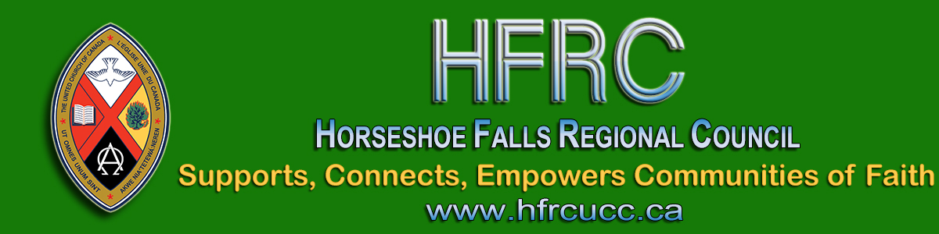

Hello Friends in Horseshoe Falls Regional Council

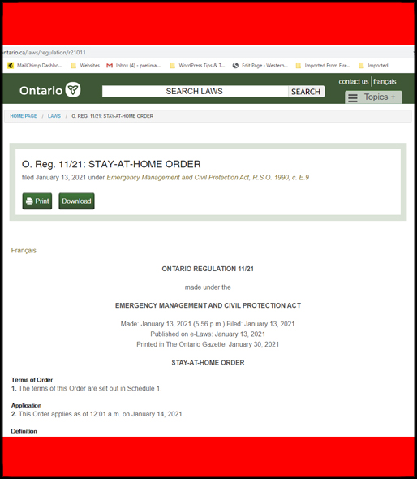
Thank you for your concern for public health and your commitment to honouring the Stay-at-Home order in Ontario. Thank you also for your patience.
The brevity of the initial document caused some confusion. It permitted worship but it was not clear that it permitted leaving home to attend worship. The Ontario Executive Ministers of the United Church consulted with legal counsel to clarify these issues.

Based on the material released yesterday,
the order specifically permits people to leave home for the purpose of “attending a gathering for the purpose of a wedding, a funeral or a religious service, rite or ceremony”.

Full details can be found at: https://www.ontario.ca/laws/regulation/r21011.
I encourage Ministry and Personnel Committees to consult with employees. The legislation requires that work be done at home if it can be. Please review details with staff.
Custodial staff may need to be on-site for snow removal, checking the building and cleaning. Following the provision of childcare, mental health and addiction services such as AA, NA or emergency response such as community meals, volunteers are permitted to travel to provide these services.
Please be sure to follow the required screening and contact tracing protocols for all entering the building.
Thank you to those who have been discussing this in our Facebook group. If you are not part of the Facebook Group, I encourage you to join. I value the wisdom shared there.
I also value the commitment to compliance. The United Church has a history of supporting medical work and, in this case, we are doing that in a new way: by taking action to reduce the strain on a stressed medical system and to support the well-being of all connected with us. What is the best way to do that? Is it better to live stream the service from the sanctuary as the music and images of the space provide strength and comfort or is it better to do this from home to model the essence of the legislation?
There is no single right answer;
there is only the right answer for each community of faith.
Holding all in prayer. United Church people care about the common good and many of them have made sacrifices for the sake of all. Thank YOU! Take care and stay safe.

Shalom,
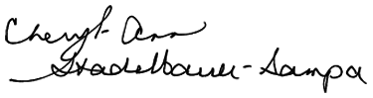
Executive Minister
Horseshoe Falls Regional Council

The Horseshoe Falls Regional Council newsletter welcomes submissions of upcoming events, regional news and educational opportunities. This is also the place to keep up-to-date on information from the regional office.
Check out the page and the channel!

Supports, Connects, Empowers
Communities of Faith

Horseshoe Falls Regional Council
The United Church of Canada

SUBSCRIBE!

Copyright © 2021 Horseshoe Falls Regional Council, UCC, All rights reserved.
Want to change how you receive these emails?
You can update your preferences or unsubscribe from this list.

