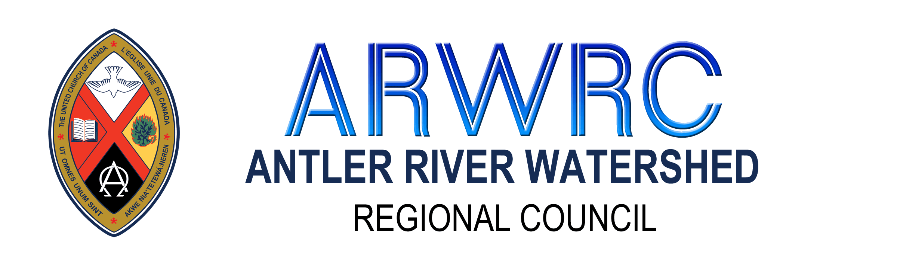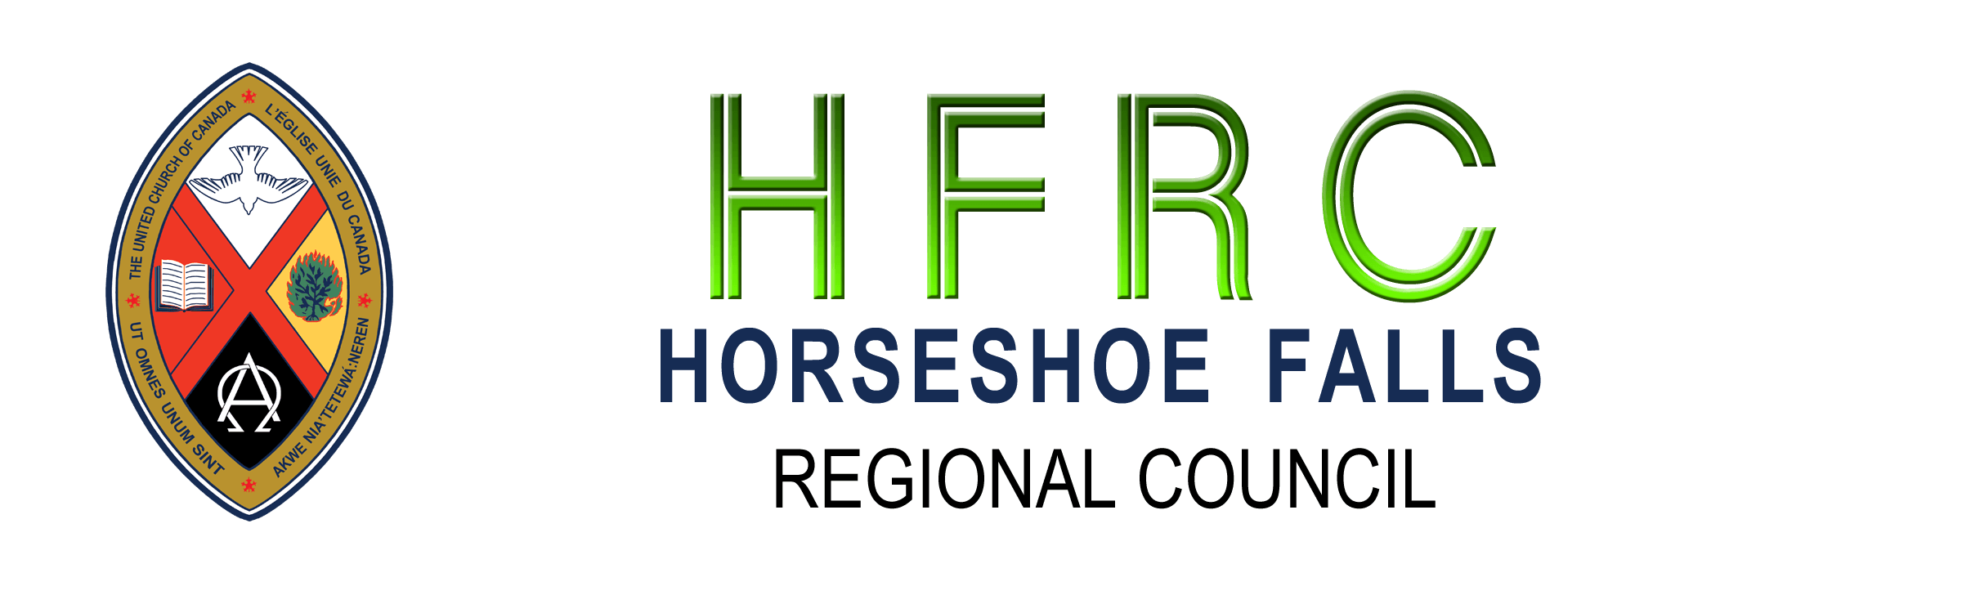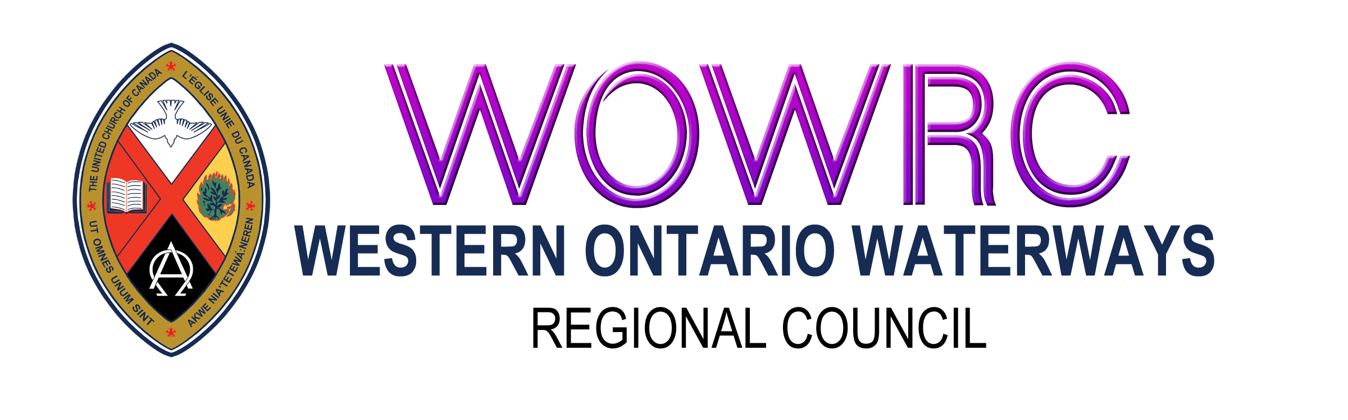
Disbanding Community of Faith: Asset Disbursement
Instructions
Completing the Form
Page 1. Contact Information
- Please provide all contact information. The Covenant Commission will set the disbanding date.
Page 2. Net Asset Calculation
- Enter the dollar amounts for net assets from all sources.
- Add up and report Total Assets available for disbursement.
Disbursement of Assets by the Community of Faith:
- List the United Church ministries that were proposed by the community of faith, and approved by the Covenant Commission, in the recipient column. Calculate the dollar amount available for recipients based on the percentage for your regional council. (ARW 33%, HF 33%, WOW 30%) Refer to the Handbook Disbanding: Steps for Closing Well for details on selecting United Church Ministries.
- Calculate the amount for each recipient. Do Not Prepare the Cheques until the disbursement form has been approved by the regional council treasurer.
Next Steps
- Copy the appropriate community of faith and Covenant Commission motions regarding approval of disbursement choices onto page 4 of the form in the Associated Motions section.
- Send all pages of the Asset Disbursement Form to the Minister, Congregational Support and Mission for your regional council to be reviewed by the regional council treasurer.
- The regional council treasurer will complete page 3 and review the form.
- Once completed and approved by the regional council treasurer, a copy of the approved Asset Distribution Form will be emailed to the community of faith and the Covenant Commission.
- Upon receipt of the approved copy, you can prepare cheques for the recipients identified on in the Disbursement of Assets by the Community of Faith section on page 2. Add cheque numbers and dates to the Asset form. The cheques can now be mailed/delivered.
- Prepare a cheque payable to the Regional Council for the Remaining Asset Total and mail it to the Regional Council Office P.O. Box 100, Carlisle, ON L0R 1H0. Please include a copy of the completed Information and Asset Distribution Form with the cheque. Consider using registered mail.

Disbanding Community of Faith: Asset Disbursement Form
(Review Instructions above before completing this form)
Regional Council Name:
Pastoral Charge Name:
Community of Faith Name:
Address:
Telephone: | Email:
Website Address:
Date of Disbanding:
Set by Regional Council on:
Address:
Telephone: | Email:
Community of Faith Governing Body, Secretary:
Community of Faith, Treasurer:
Address:
Telephone: | Email:
Trustee to be contacted:
Address:
Telephone: | Email:
Current Minister OR Pastoral Charge Supervisor:
Address:
Telephone: | Email:
Minister’s New Call or Appointment If Known:
Pastoral Charge:

Name of Community of Faith:
Net Asset Calculation
(To be completed by the community of faith)
Property | $ Amount
Cash  Including bank accounts and proceeds from investments | $
Net Income from Sale of Property | $
Other Assets | $
Total Assets for Disbursement | $

Disbursement of Assets by the Community of Faith
(To be completed by the community of faith)
Please wait for approval of this document before preparing and sending cheques
Recipient | Percentage of Total Assets | Dollar Amount | Cheque # | Date
Disbursements to UCC Ministries | 33% ARW  33% HF  30% WOW | $ | N/A | N/A
1.
2.
3.
4.
5.
6.
Remaining Asset Total (to be sent to regional council) | 67% ARW  67% HF  70% WOW | $
* Cheque for Regional Council to be sent to: [name of regional council] Regional Council, P.O Box 100, Carlisle, ON L0R 1H0, following approval of this document. Please consider using registered mail.

Name of Community of Faith:
Disbursement of Remaining Assets by Regional Council
(To be completed by regional council treasurer)
Total Assets for Disbursement (100%) | $
Amount to be Disbursed by Commuity of Faith | $

Recipient Ministry | Percentage of Total Assets | Dollar Amount
Indigenous Ministries (held at General Council) | 15% ARW  12% HF  15% WOW | $
Mission and Service (current Year) | 12.5 ARW  10% HF  12.5% WOW | $
Mission and Service Endowment Fund | 12.5% ARW  15% HF  12.5% WOW | $
United Church Archives Fund | 2% ARW  5% HF  5% WOW | $
Regional Council | 25% ARW  25% HF  25% WOW | $
Total Amount to be Disbursed by Congregation | 33% ARW  33% HF  30% WOW | $
Total Amount of Disbursements | 100% ARW  100% HF  100% WOW | $

Approval of Disbursement Allocations by Regional Council Treasurer
Regional Council Treasurer Date

Send approved copy to the Community of Faith, and the appropriate Minister, Congregational Support and Mission (LAllin@united-church.ca for ARW & HF) (JNeff@united-church.ca for WOW) and RMack@united-Church.ca

Associated Motions
Name of Community of Faith:
Motion by Community of Faith proposing disbursement to UCC Ministries (% of total)
Date:

Approval of Disbursement Proposal by Covenant Commission
Date:

Approval of Disbanding Date by Regional Council
Date:

Record of Distribution of Assets

Receipt of Funds by Regional Council for Disbursement
Date:

Funds disbursed by Regional Council
Date:

