Covenant Commission:
Pastoral Charge Supervisor Handbook

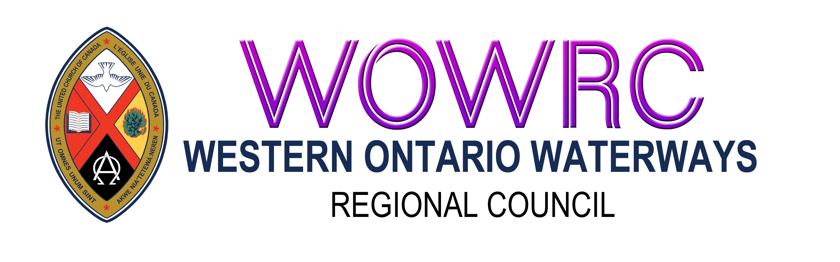

Contents
The Manual, Bylaws I. Pastoral Relations 2
General Background: 3
Situations Requiring Pastoral Charge Supervisors: 3
Responsibilities/Tasks: 4
Role 4
Meetings 4
Sacraments & Membership 5
Pastoral Care 5
Other Ministry Personnel 5
Reporting 5
Financial Considerations: 6
Expense Sheet 6
Additional Responsibilities: 7

The Manual, Bylaws I. Pastoral Relations
I.2.5.2 Pastoral Charge Supervisor
- Appointment: If a community of faith that is a pastoral charge has no called or appointed member of the order of ministry or designated lay minister who has been recognized by the regional council, the regional council is responsible for appointing a member of the regional council to the pastoral charge as a pastoral charge supervisor. The regional council may also appoint a pastoral charge supervisor in any other situation where the regional council decides it is appropriate.
- Responsibilities: The pastoral charge supervisor is responsible for:
- supporting any ministry personnel serving the pastoral charge;
- general supervision of the work of the pastoral charge;
- ensuring that a chair is elected for the pastoral charge governing body, the trustees, and meetings of the congregation and pastoral charge;
- ensuring that the sacraments are administered and new members are received following the requirements of these bylaws;
- if there are ministry personnel serving the pastoral charge, delegating responsibility for the functions of ministry in the pastoral charge to the ministry personnel as appropriate; and
- reporting to the regional council on the state of the pastoral charge.

General Background:
The Regional Council is responsible for appointing individuals, both order of ministry and lay, to serve as pastoral charge supervisors. This is done by the covenant commission. Training opportunities will be made available. Pastoral charge supervisors are vetted by the Covenant Commission.

Situations Requiring Pastoral Charge Supervisors:
The Manual states that a pastoral charge supervisor is appointed, “if a community of faith that is a pastoral charge has no called or appointed member of the order of ministry or designated lay minister who has been recognized by the regional council.” This might occur in the following situations:
- Change in Pastoral Relations: Most commonly, this occurs when a change in pastoral relations has left a pastoral charge without a called or appointed minister.
- Leave: When ministry personnel are on leave (parental, medical, compassionate, sabbatical) a pastoral charge supervisor is appointed to for this period of time.
- Student/Candidate: When a student is serving as the supply minister in a pastoral charge, a pastoral charge supervisor is required to oversee the work of the congregation. This person is separate from an educational supervisor or mentor who has been appointed to fulfill the requirements of a supervised ministry education site.
- Candidate for Admission: When a minister is in the process of admission to The United Church of Canada from another denomination, a pastoral charge supervisor is required to oversee the work of the congregation. This person is separate from an educational supervisor or mentor who has been appointed to fulfill the requirements for admission.
- Ethnic Ministry: Pastoral charges that fall under the category of ethnic ministries are able to have ministry personnel who are ordained in another denomination and these persons are not required to seek admission into The United Church of Canada. However, a pastoral charge supervisor is required to be in attendance at all meetings of the governing body, for example official board, session or council.
- Shared Ministries with Other Denominations: Pastoral charges that share a ministry with another denomination also require the presence of a pastoral charge supervisor at all meetings of the governing body, for example official board, session or council.

Responsibilities/Tasks:
The six areas of responsibility outlined in The Manual are broad in nature. Carrying out these responsibilities may involve a variety of tasks. A co-operative relationship and good system of communication between the appointed supervisor and the pastoral charge will help facilitate this work.

Role
The pastoral charge supervisor:
- oversees the work and ministry of the pastoral charge.
- is automatically a trustee (G.3.3.3cc) and must be granted access to trustee records upon request. (G.3.4.3.c.iv)

Meetings
The pastoral charge supervisor:
- has the authority to call congregational meetings (B.5.3.1.d), trustee meetings(G.3.6.1.c), and meetings of the governing body (B.7.7.2.iv). They must do so in situations when it is required by The Manual, and may do so at their own initiative at any time;
- must be present at meetings of the governing body (Official Board, Session, Council etc.) to have quorum. Without their presence no motions can be passed.
  - It is important for the community of faith to work with the pastoral charge supervisor to find a suitable date and time for meetings.
  - It is permissible to have the pastoral charge supervisor available by phone or computer connection especially when there are no major issues being discussed. It is the decision of the pastoral charge supervisor how they would like to join the meeting.
  - If unable to attend a meeting it is the Pastoral Charge Supervisor’s responsibility to find a replacement, get approval from the Covenant Commission of the Region or their staff support, and inform the Community of Faith governing body;
- is eligible to serve as chair of the governing body (B.7.6.1.b.iv) and trustees (G.3.5c) and is required to ensure a chair has been elected for the pastoral charge governing body, the trustees, and meetings of the congregation and pastoral charge
- NOTE: It is now a requirement that a pastoral charge supervisor attend congregational meetings including the annual meeting. The pastoral charge supervisor should receive a copy of the agenda and annual report prior to the meeting to determine all is in good order. If your pastoral charge supervisor is leading worship at their own community of faith, you will need to be flexible to accommodate their schedule.

Sacraments & Membership
The pastoral charge supervisor:
- works with the pastoral charge to make arrangements for communion and baptism to be made available. While the pastoral charge supervisor may not be the one who is presiding, they will provide names of persons for the congregation to contact;
- ensures individuals seeking to become full members of the congregation are received according to The Manual (B.3.3).

Pastoral Care
The pastoral charge supervisor:
- can assist the pastoral charge in making arrangements for pastoral care, weddings and funerals by providing a list of names of persons who may be available on a contract or on call basis, encouraging the congregation to organize a lay visitors team or reach out to a neighbouring congregation to form a ministry sharing agreement. While this is not specifically part of a pastoral charge supervisor’s responsibilities, it is an area of concern for many congregations, and assistance in meeting this need is greatly appreciated.

Other Ministry Personnel
The pastoral charge supervisor:
- will support any ministry personnel who are serving in the pastoral charge
- delegate responsibility for the functions of ministry in the pastoral charge to the ministry personnel as appropriate

Reporting
The pastoral charge supervisor:
- Will report to the regional council covenant commission at the end of their term as supervisor, or after every twelve months if their appointment is ongoing. (The annual congregational self-assessment form may be a useful resource for evaluating the state of the pastoral charge);
- Will consult with the covenant commission if they have any concerns regarding the state of the pastoral charge. Any concerns related to ministry personnel may be brought to the regional Minister, Pastoral Relations.

Financial Considerations:
- Pastoral charge supervisors can track their mileage related to their appointment and submit it to the regional council for an expense payment according to The United Church guidelines.
- Each regional council can set their own policies regarding additional compensation.

Expense Sheet
  - Submit quarterly or when needed. Send to Minister of Congregational Support and Mission.
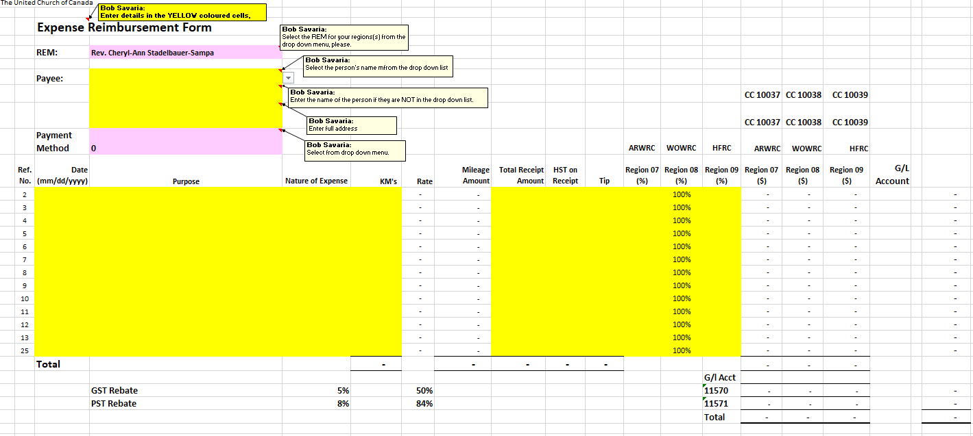
  - Provide a blank cheque or bank issued transit and account numbers.
1.
8.
7.
6.
5.
4.
2.
3.
- Select your name in the “Payee” drop down list.
- If it is not in the dropdown list please provide name and full mailing address
- Enter “Date” of expense
- Enter “Purpose” – include specific church and reason (e.g. pastoral charge supervision – xyz church)
- Choose the “Nature of Expense” from the drop down list
- If a mileage claim - enter the total km’s traveled
- If the “Nature of Expense” has a receipt fill in “Total Receipt Amount”, “HST on Receipt”, and “Tip” if there was any.
- Fill in the percentage to be applied to a region. Will most commonly be 100% for a particular region.

Additional Responsibilities:
- Ensure good communication between the liaison, search team and governing body if the community of faith is working toward a search process.
Note: The pastoral charge supervisor is not required at meetings called by the liaison

