Horseshoe Falls Regional Council
Fall 2023 Meeting Minutes
“Renewal and Transformation…A Season of Hope”

The Horseshoe Falls Regional Council was called to meet on Friday, October 13 and Saturday, October 14, 2023 via Zoom with approximately 125 participants online in attendance each day.

Meeting Session: Friday October 13, 2023
7:00 – 9:00 PM

Welcome & Constitute Meeting
President Lennox Scarlett constituted the meeting in the name of Jesus Christ, the one true head of the Church and by the authority vested in him by the Horseshoe Falls Regional Council for whatever business may properly come before it. The bounds of the meeting will be the Zoom call, the Regional Council Office, 1551 Hwy 6, Hamilton ON, and the sanctuary of Pelham United Church, Pelham ON.

Proposal #1 Opening & Procedural Motion
Wendy Lowden, Chair Agenda & Business Committee, provided an overview of Proposal #1 Opening & Procedural Motion.
MOTION: Wendy Lowden / Tessica Hackshaw
That the Horseshoe Falls Regional Council adopt the following as a consent docket:
- Adopt the agenda as circulated and authorize the Agenda and Business Committee to make any changes as necessary;
- Approve the minutes of the meeting of 2023-060810;
- Receive the minutes of the following meetings of the
i. Executive
23-08-09
23-06-28
23-06-15
23-05-24
ii. Congregational Support Commission
2023-05-16
2023-04-11
iii. Human Resources Commission
2023-05-24
Note: Minutes are posted on the website www.hfrcucc.ca “About” page
4. Confirm the appointment of James Grunden to the Executive (to honour his original expression interest).
5. Confirm the appointment of Debbie McMillan to the Executive;
6. Appoint Paul Shepherd as Parliamentarian;
7. Appoint Wendy Lowden as Chair, Agenda and Business Committee;
8. Name Yvonne Wright to serve as Equity Support Team Member;
9. Name President Lennox Scarlett, Chair Agenda and Business Committee Wendy Lowden, Acting Executive Minister Mark Laird, and Executive Assistant Sue Duliban, as the Agenda and Business Committee;
10. Set the bounds of the meeting as the zoom call, and the Horseshoe Falls Regional Council Office, 1552, Hwy 6 N., Hamilton, Ontario, and the sanctuary of Pelham Community Church, Pelham, Ontario;
11. Make the designated representative from any United Church ministry, other than a congregation, which has been invited to become a community of faith by entering into a covenant with the regional council, a member of the regional council for this meeting (Section C.1.2 c);
12. Make all guests corresponding members;
13. Set the deadline for new business to be submitted to the Agenda and Business Committee as 9:00 a.m., Saturday, October 14, 2023.
14. Adopt the following method for dealing with proposals for action by the regional council
Step One:
The Presenter will outline:
A) What is the issue? and
B) The suggested way in which the regional council might respond to the issue.
Step Two:
The President will inquire if there are questions for clarification. Please note this is for clarification only.
Step Three:
The President will then ask if there are changes or additions being suggested for the proposal. Using warm and cool signals, the regional council will seek to come closer to agreement on how to respond to the issue.
Step Four:
Once there is significant agreement, the President will invite the Presenter to move the motion at which point the regional council enters the formal debate process. CARRIED.

Introduction of Meeting Leadership
President Lennox introduced the leadership team, including himself as President.
Wendy Lowden: Agenda & Business Chair
Mark Laird: Acting Executive Minister
Paul Shepherd: Parliamentarian
Lennox Scarlett, Irene Ty, Deb McMillan: Worship Team
Sue Duliban: Executive Assistant/Minutes Secretary
Yvonne Wright: Equity Support Team member
John Neff, Michele Petick, Pretima Kukadia-Kinting: Zoom Tech
Kevin Steeper: Chaplain

President Lennox welcomed all gathered to the meeting and invited those, as comfortable, to introduce themselves if attending a regional council meeting for the first time. Those introduced included Mark Laird, Acting Executive Minister, Gert Van Rensberg, Adam Cresswell (Adam has attended as a guest, but is representing the Hub Network), Meghan Hare, Kelvin-Teeterville-Vanessa, Carolin McMillan, student at Appleby Burlington, John Bedell, St. John’s Stevensville and Niagara Online, Barb Creelman, Sue Starling, Port Rowan.

Opening Worship: President Lennox

A five minute break was taken.

Discipleship and Justice Commission Engagement
Lively videos highlighting the work of Cave Springs Camp and Ryerson Camp were shared.

Human Resources Commission Engagement
Morar Murray-Hayes spoke to the HR Commission Working Group report highlighting the working group’s recommendations to improve the commission's ability to support personnel and congregations in the pastoral relations process. Morar also referenced the Report on Connecting our Retired Ministry Personnel to the Region. Both reports were included in the meeting workbook.

Remit Education and Discussion/Questions:
Thérèse Samuel, Minister, Right Relations & Social Justice, and John Egger, Minister Social Justice, led a time of further education, including questions (many focusing on financial matters), comments and discussion, on the General Council Remit #1. Question raised: what are the financial implications if the remit passes. In response it was noted this remit is not looking at financial implications. The remit is about structure; creating the space for the Indigenous church to structure itself as it feels it needs to. The Indigenous church is currently funded and that will continue should the remit pass.

Reminder from Wendy Lowden, Agenda and Business Chair, of the deadline for new business: Saturday, October 14, 9 AM. Participants were also reminded of the importance of reviewing the workbook.

Closing Prayer: President Lennox

Meeting Session: Saturday, October 14, 2023
9:00 AM – 1:00 PM

Welcome Back: President Lennox welcomed all back to the meeting and invited those gathered to check-in.

Opening Worship: Irene Ty

President Lennox shared a letter regarding the remit from the General Secretary.

Remit Vote
President Lennox shared a prayer before calling the vote.
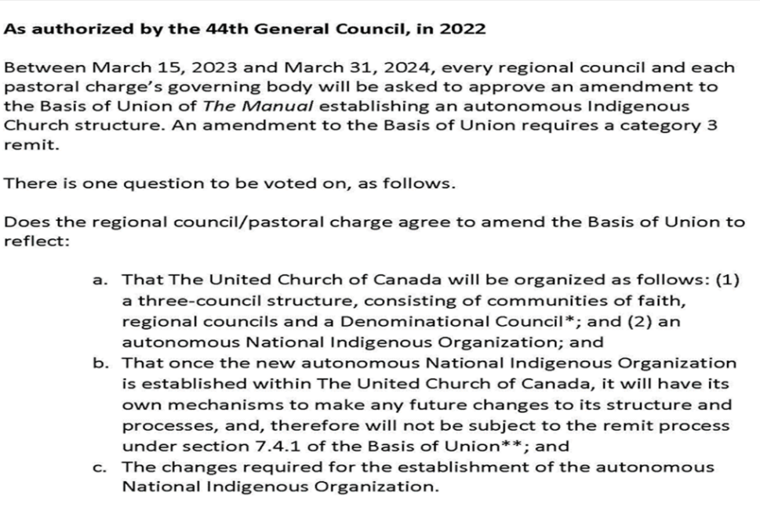
Remit Vote: Accepted.
President Lennox shared a prayer following the vote.

Going Deeper on the Regional Council Evaluation: Conversation Groups
Those gathered were invited by Mark Laird, Acting Executive Minister, to self-select a topic from the regional council evaluation to explore in depth in breakout room conversation.

The goal for this time of conversation being to focus on how the regional council might move forward with the evaluation recommendations by providing input and ideas that can help strengthen the regional council’s work together. Each breakout group had a facilitator and a recorder. A compilation of notes taken will be available to the Executive and Commissions and Staff whose work they relate to. Notetakers to send their notes to Mark Laird.

A 10 minute break was taken.

In Memoriam
President Lennox remembered Rev. Frank Walker, who passed away in June. A video presentation honoured and gave thanks for the life and service of
Rev. Sylvia Bethune DLM
Rev. Lorna MacQueen OM
Rev. Walter Marttila OM
Rev. Ha-Kyoo Park OM
Rev. Art Tobey OM

Community of Faith Life Cycle Changes
A video presentation honoured the following communities of faith.
Disbandments
Cawthra Park United Church, Mississauga
People’s Memorial United Church, Ridgeway
Mt. Carmel United Church, Troy
With thanks for their legacy and faithful service.

President Lennox closed with a time of prayer, transitioning from memoriam to the joy of new life and those serving the church.

Introduction of Admissionands/Addresses to the Court
Video messages were shared from Sarah Bruer, Program Coordinator for Admissions, Ministry and Employment Unit, the UCC, who introduced applicants for admittance Heather Myers and Russ Myers. Heather and Russ then addressed the court singly. Heather Myers and Russ Myers are serving in ministry at Pelham Community Church, Pelham.

Day of Fellowship: June 8, 2024
A brief video introducing the event was shown. President Lennox introduced the planning team: Sula Kosacky, Gabrielle Heidinger, Tessica Hackshaw, Kathy Douglas, Hewitt Homes, Ted Smith, Norma Cronkwright, Michael Shewburg, Diane Viney and Irene Ty. The team is currently exploring venues, looking for the ideal fit. The intent is to make this a day of fellowship and fun, including activities for children. Anyone interested in helping with planning or ideas for a location can email President Lennox.

Discipleship and Justice Commission
Chair Sula Kosacky added to the presentation made on &J Commission, first thanking camp staff for the amazing camp videos. Sula thanked all those who sent in Mission Service grant applications. She also noted the commission is heavily involved with the remit reach-out team.
Proposal 2: Budget 2024
Treasurer John Hurst reviewed the proposal, and, with Acting Executive Minister Mark Laird, answered any questions for clarification.
MOTION: John Hurst / Mark Laird
- Receive the internal 2023 operating statement to date for information;
- Direct the Executive to deal with the 2022 Auditors’ Report for information;
- Endorse the following principles for the 2024 budget:
  - Operating expenses increased by 4.5% for inflation and as the basis for investment income.
  - Prioritize Mission & Service grants.
- Appoint KPMG LLP as auditors for the 2023 Financial Year.
- Adopt the proposed 2024 budget authorizing the Executive to adapt as necessary within the
above guidelines. CARRIED.

Wendy Lowden, Agenda & Business Chair, left the meeting.

Congregational Support Commission Engagement: Paying Pastoral Charge Supervisors Discussion
Chair Adrianne Robertson shared information on Pastoral Charge Supervisors (PCS) and the new policy, beginning January 1, 2024, of compensation for time spent in supervision of a pastoral charge to be paid by the pastoral charge. Time was provided in breakout rooms to give participants an opportunity to discuss the role of a PCS and the new policy. Any questions arising from the presentation can be submitted to Congregational Support Commission Chair, Adrianne Robertson.

Proposal 3: GC 45 Commissioners Election in 2024
Mark Laird, Acting Executive Minister, presented Proposal 3. Discussion/questions for clarification included discussion on diversity of slate, entrusting the slate to a small number of people, concern about regional council voices being heard when determining the commissioners. Mark Laird clarified that if the slate is not accepted as presented at the spring meeting, it will go back to the Executive. The Executive will then work to prepared a revised slate to bring forward at the spring meeting.
MOTION: Debra McGill / Irene Ty
To extend order of the day by 10 minutes to continue discussion of Proposal 3. CARRIED.

Concerns were flagged about the regional council being presented with a slate to vote on with no input; if someone had a concern about one nomination, the only way to respond would be by voting against the entire slate. Suggested: an additional step, whereby the regional council, not only the recruitment team, can see the profiles of those nominated. Mark Laird reminded those gathered that the concept of a recruitment team (for Executive/Commissions as well as GC Commissioners) was approved at the last regional council meeting
MOTION: Patricia Konkle / Mervyn Russell
The Horseshoe Falls Regional Council agrees
- To close nominations for Commissioners to GC 45 as of midnight April 15, 2024; to publicize the deadline in advance (website, newsletter, with registration materials).
- To direct the Recruiting Team authorized by the spring 2023 meeting and appointed by the Executive to review the nominations with a view to:
- Ensure a diverse cohort of Commissioners and alternates who bring both experience and new energy to the role and who are committed to the preparation and online prior requirements for General Council;
- Recruit nominees to address gaps in representation.
- And that the recruiting team include in their discernment process an invitation to the members of the Regional Council regarding support or concern regarding individual nominees, prior to the completion and presentation of the slate.
To vote on the slate as a whole at the spring 2024 regional council meeting. CARRIED.
MOTION: Debra McGill / John Taylor
To extend the order of the day by ten minutes to conclude meeting business. CARRIED.

New Business: No new business.

Save the Dates: Spring 2024 Tri-Regional Council Meeting, online and in-person. May 24, 25, 26, 2024
at the UNIFOR Centre, Port Elgin. Speaker: Moderator Carmen Lansdowne. Day of Fellowship: June 8, 2024.

Courtesies: President Lennox thanked everyone who participated in the meeting and all those who worked on planning the meeting: Mark Laird, the Leadership Team, Worship Team and staff.

Thanking the President: Acting Executive Minister Mark Laird thanked President Lennox for his prayerful, spirit filled, thoughtful leadership in preparing and leading the regional council over the weekend.

Proposal 4: Closing Motion
MOTION: Mark Laird / Kim Shantz
The Horseshoe Falls Regional Council agrees to
- Entrust any unfinished business from its October 13-October 15, 2023 meeting to the Executive;
- Authorize the Executive to fill any vacancies on the understanding that appointments will be confirmed at the next spring regional council meeting;
- Direct the Executive to plan to convene a meeting of the regional council in the spring of 2024;
- Entrust the Executive and Commissions with the responsibilities and authority of Horseshoe Falls Regional Council in accordance with The Manual of The United Church of Canada and the Governance Handbook of the Horseshoe Falls Regional Council.
- Close the October 13-October 15, 2023 meeting of the Horseshoe Falls Regional Council at the close of the Celebration of Ministries Service on Sunday, October 15, 2023. CARRIED.

Closing Reflection: Debbie McMillan

Adjournment: 3 PM

The Celebration of Ministries Service was held following the meeting session at Pelham Community Church, Pelham.

