Horseshoe Falls Regional Council

Supports, Connects, Empowers Communities of Faith

Governance Handbook
February 2024

The United Church of Canada/L’Église Unie du Canada

Horseshoe Falls Regional Council
GOVERNANCE HANDBOOK

Purpose of Horseshoe Falls Regional Council
Supports, Connects, Empowers Communities of Faith

The following governance model has been designed to:
- Serve the purpose of the regional council.
- Support communities of faith in naming and claiming their role in God’s mission.
- Provide support for the formation of healthy pastoral relationships.
- Keep before communities of faith the call to be the church.
- Promote an open healthy and strong relationship between the regional council and communities of faith.
- Offer regional representatives a variety of ways of serving.

As the regional council experiments with this model, there may be refinements along the way due to insights learned. There will be no change in the delegation of responsibilities of The Manual, Section C, without the approval of the regional council.

Contents
Governance Schematic 4
Position Description: Regional Council Representative 5
Regional Council 6
Regional Council Executive 8
Congregational Support Commission 10
Congregational Support Commission Resource Pool 11
Discipleship and Justice Commission 12
Discipleship and Justice Commission Resource Pool 13
Human Resources Commission 14
Human Resources Commission Resource Pool 15
Staff Support Committee Mandate 16
Learning Grants 17
Professional Development Grants………………………………………………………………………………………………17
Individual Learning Grants………………………………………………………………………………………………………….17
Event Sponsorship Grants…………………………………………………………………………………………………………..17
Student Bursaries……………………………………………………………………………………………………………………….17
Appendix A The Manual Section C.2 18
Appendix B HFRC Investment Policy 23
Investment Policy……………………………………………………………………………………………………………..….……23
Appendix C HFRC Business Trust 25

Governance Schematic

Regional Council (RC)
(see The Manual, C.1 for Membership)

Elects

Regional Council Executive
(12 members plus President, President-Elect or Past President, Treasurer and Executive Minister)

RC also elects

Congregational Support Commission | Discipleship and Justice Commission | Human Resources Commission

Congregational Support Commission  Staff Resources:  - Minister, Congregational Support  - Administrative Support Staff | Discipleship & Justice Commission  Staff Resources:  - Minister, Pastoral Relations (primary)  - Minister, Pastoral Support (more limited)  - Administrative Support Staff | Human Resources Commission  Staff Resources:  - Minister, Faith Formation  - Minister, Right Relations and Indigenous Justice  - Minister, Social Justice  - Administrative Support Staff

Position Description: Regional Council Representative
Membership of the Regional Council can be found in The Manual, Section C.1

Skills and Gifts
A combination from among the following:
- An interest in fostering connections within various parts of the church.
- An interest in the life and work of the United Church.
- Energy and time.
- Curiosity and a willingness to learn.
- Interpersonal skills.
- Experience in wider church work would be helpful but is not required.

Requirements of Position
- For lay members - must be a full member of a community of faith within the regional council.
- Attend and participate in the regional meetings.
- Serve as the connection in the covenant between the regional council and the community of faith bringing the experience of each to the other.
- Serve in one of either the two following ways:
  - Commitment of 3 years, renewable once as a member of:
    - Regional council Executive OR
    - One of three regional council Commissions
(Congregational Support Commission, Human Resources Commission, Discipleship and Justice Commission)
OR
  - Short-Term Volunteer working as the representative of the regional council with communities of faith OR working in the organizing and delivering of regional council events.
- Have access to technology along with a commitment to learn how to use it.
- A current police record check may be required for some roles.

Time Commitment
This is an estimate and will be tracked and adjusted based on experience.
An average of two half days/evenings per month. Depending upon the role chosen, the time commitment may be spread consistently over the year or may involve more intense involvement for a briefer period of time during the year.

Support and Benefits for regional council volunteers as they serve the church
- Training to cover the role chosen and to improve use of technology.
- Opportunity to develop skills that will strengthen the life of the representative’s home community of faith.
- Opportunity to develop leadership skills
- Opportunity to deepen and widen relationships across the church.
- Opportunity to learn from one another.

Regional Council
Mandate
The regional council will fulfill the following responsibilities as outlined in The Manual, Section C.2.

Delegation of Responsibilities
Appendix A reflecting Section C.2 of The Manual.

Responsibilities are assigned to: Regional Council (full meeting of the regional council): RC
Executive: EX
Congregational Support Commission: CS (formerly CC)
Human Resources Commission: HR
Discipleship and Justice Commission: D&J (formerly M&D)

Please note the following responsibilities as outlined in sections G, H, I and J of The Manual.
- Section G: Any references to the regional council in Section G are the responsibility of the Congregational Support Commission.
- Section H: Any references to the regional council in Section H are the responsibility of the full regional council.
- Section I: Any references to the regional council in Section I are the responsibility of the Human Resources Commission, with the exceptions of I.1.3.2a), I.1.4.1 concerning community of faith profiles which are delegated to the Congregational Support Commission.
- Section J: Any references to the regional council in Section J are the responsibility of the regional council Executive.

In some cases, two bodies share responsibility for the effective fulfillment of The Manual requirements.

Officers
President *4 (four) year term in total: serving as President-Elect for 1 (one) year;
President for 2 (two) years, Past-President for 1 (one) year

The regional council will elect a President for a two-year term. The President will:
- Preside at the communion table and business table of the regional council and its Executive.
- Serve as the spiritual leader for the regional council, offer a theme and vision for the regional council.
- Serve, along with the Executive Minister, as the official representative of the regional council.
- Strive to inspire the members of the regional council and its communities of faith toward health, joy and excellence.

During the two-year term as President, the home community of faith of a President who is in a pastoral relationship will receive an honorarium in the amount of $1,200.00 per year to assist with coverage for any absences of the President. Any President not in a pastoral relationship will be invited to designate to the United Church of Canada ministry of their choice a donation of 1,200.00 per year.

At the conclusion of the term, the former President, once no longer serving in that capacity, will receive an honorarium of $2,000.00.

Past President
If someone else, such as the Past President or President Elect needs to take on a significant role of President, it is up to the Executive to determine a reasonable honorarium in keeping with what is outlined above.

Travel expenses of the President, President-Elect and Past-President associated with the fulfilment of their roles will be reimbursed.

Treasurer
The regional council will elect a Treasurer for a three-year term, renewable once. The Treasurer will:
- Serve as one of the signing officers for financial matters of the regional council.
- Oversee the financial management of the regional council in partnership with the Executive Minister.
- Assist with the preparation of the budget for the regional council in partnership with the regional council Executive.

The Treasurer will have travel expenses associated with this role reimbursed. Each December, the Treasurer will be invited to name a United Church of Canada ministry to receive a donation of $1,000.00 in recognition of the Treasurer’s service.

Membership
See The Manual, Section C.1.
Under section C.1.2b, the following are also members of the Regional Council:
- Any Past President of Horseshoe Falls Regional Council;
- Any past president of Hamilton or Toronto Conference or past chair of Erie, Halton, Hamilton, Niagara, Southwest Presbyteries who is a member of a community of faith in the regional council;
- Any retired Designated Lay Minister who retired while serving a community of faith in the regional council who is a member of a community of faith in the regional council;
- Provision will be made for youth and young adult members. This process is still being developed.

Under Section C.1.2, the Regional Council recognizes the following as members:
- Any past President of one of the Conferences (Hamilton and Toronto Conferences) that became part of the regional council along with any past Chair of one of the Presbyteries (Erie, Halton, Hamilton, Niagara, Southwest) that became part of the regional council, who is a member of a community of faith in the regional council.
- Up to 10 youth (up to age 19) elected by the youth at a gathering prior to the Annual Meeting, and
- 50% of the Young Adults registered for the Annual Meeting to a maximum of 10 to be elected from among the Young Adults attending. The balance to be corresponding members.

To honour the separation of oversight and discipline of ministry personnel established by the Office of Vocation and in recognition of the work attached to Office of Vocation roles, those members serving with the Board of Vocation or the Committees of the Office of Vocation will not be considered for the decision-making bodies of the regional council executive and regional council commissions. Their involvement as members of a resource pool would be most welcome if their Office of Vocation duties allow for such a time commitment.

Meetings
The regional council shall have at least one in-person meeting per year.

Regional Council Executive
Mandate
The regional council Executive will fulfill the following responsibilities as outlined in The Manual, Section C.3.1.

The regional council Executive will also:
- Keep the purpose statement before the regional council and evaluate the life and work of the regional council and its commissions against this.
- Hold accountable the Congregational Support Commission, Discipleship and Justice Commission, and Human Resources Commission for the responsibilities delegated to each respectively.
- Deal with any matter referred to it for action by one of these three Commissions.
- Oversee the finances of the regional council including preparing a budget for the consideration of the regional council and taking responsibility for the administration of the assessment funds, Mission & Service grants and other resources of the regional council.
- Be accountable for the number and position descriptions of regional council staff.
- Serve as the Nominating Committee preparing a proposed slate for the consideration of the regional council.
- Work with the Executive Minister to ensure clear and timely communication within the regional council.
- Meet annually with the Executive of the neighbouring regional councils served by the same Executive Minister and Executive Assistant.
- Facilitate an annual event with the Congregational Support Commission, Human Resources Commission, and Discipleship and Justice Commission to focus on purpose and planning.

All members of the regional council Executive will be required to sign a confidentiality agreement concerning any information to which they may have access regarding pastoral relationships.

Membership
12 Members, plus President, President-Elect or Past President, Treasurer, and Executive Minister.
To be elected to the Executive by the regional council.

- 5 (to be named by office or other
3 – 1 representative from each of the Commissions
Note: Commission members are elected by the regional council.
The members of the Commission will name their representative to Executive.
1 representative to be chosen by the Indigenous Ministries who belong to the regional council
1 representative of the United Church Women (UCW) to be named by the UCW of the regional council

B. Of the remaining 7 positions, 3 are preferred positions:
1 position reserved for a youth or young adult
1 position to ensure racialized representation
1 position to represent sexual orientation/gender identity diversity

Any nominee not elected on the preferred position ballot, will be placed on the ballot for the election of the remaining four positions.

Any groups not named specifically are encouraged to complete an expression of interest through the nomination process.

Nominations will be encouraged in advance of the regional council meeting and from the expressions of interest received this way, a slate of nominees will be presented to the regional council for election.

Two key principles will be considered when preparing the list of nominees:
- Living into the mandate of diversity adopted by the preceding Conference(s) in the process by which it/they were named an Affirming ministry, and
- supporting the development of leaders by providing opportunities and support.

Meetings
The schedule for meetings will be reviewed following the election of new members and set for the coming year with a view to workload and personal schedules. The majority of meetings happen virtually.

Congregational Support Commission
Mandate
The Congregational Support Commission carries primary responsibility for the relationship between communities of faith and the regional council and their partnership on matters requiring a decision by both the community of faith and the regional council, other than the pastoral relationship.

The responsibilities of the Commission include:
- The articulation of ministry and mission.
- The use of financial and property resources.
- Local governance.
- The overall health and well-being of communities of faith, such as changes in the life cycle, dealing with real property etc.

All members of the Congregational Support Commission are required to sign a confidentiality agreement.

The Congregational Support Commission assigns a member of the resource pool to resource a community of faith on matters requiring a joint decision.

The Congregational Support Commission will meet with representatives from a community of faith before acting on requests from the community of faith or exercising oversight and discipline of it.

See The Manual, Section C.2 references for responsibilities delegated to the Congregational Support Commission (CC).

The Commission is accountable to the Executive through:
- A representative of the Commission who also serves as a member of the Executive (may be the Chair but not necessarily so); and
- the timely provision of minutes of its meetings according to the format established by the regional council Executive.

Membership
Minimum of 7 members and a maximum of 12 members, at least one-third of total membership to be ministry personnel and one-third of membership to be lay, elected by the regional council, one of whom serves on the Executive.

Meetings
The schedule for meetings will be reviewed following the election of new members and set for the coming year with a view to workload and personal schedules. The majority of meetings happen virtually.

Congregational Support Commission Resource Pool
The Congregational Support Commission may create different resource pools. It assigns trained volunteers to accompany, resource and support communities of faith during times of self-assessment, change or struggle.

Members of the Congregational Support Commission Resource Pool assigned to be with a community of faith assists them to consider options. Members of the Congregational Support Commission Resource Pool can be available to the community of faith to assist with the preparation of documentation to make a request of the Congregational Support Commission on matters that require a joint decision. The member of the Congregational Support Commission Resource Pool who has worked with a community of faith will accompany community of faith leaders when they meet with the Commission.

These volunteers are resource people who have been trained in and can assist with matters such as:
- Changes in the life cycle of a congregation. Helping a congregation assess its health and plan for its future and hold the required meetings to facilitate change.
- Articulation of mission. Working with a congregation to identify its ministry, preparing the Living Faith Story documentation.
- Using the documents prepared in b) to identify its capacity to support ministry personnel.
- Assessing the use of resources for the fulfillment of mission, including property both real and personal.
- Reviewing proposed governance models for compliance with United Church requirements and helpful advice.
- Reviewing annual self-assessments from communities of faith and providing feedback.
- Reviewing record keeping and archives for communities of faith.
- Pastoral charge supervision when a community of faith is without called or appointed ministry personnel.

Training will be provided specific to the task requested. Resource pool volunteers report to the Congregational Support Commission.

Note: The foregoing is a list of possible roles. Other roles may be identified by the Congregational Support Commission.

Discipleship and Justice Commission
Mandate
The purpose of the Discipleship and Justice Commission is to provide information, education and opportunities for communities of faith and their members to deepen faith and strengthen service and witness.

All members of the Discipleship and Justice Commission are required to sign a confidentiality agreement.

The Commission provides both training and development opportunities as well as offering informed and timely responses to enable communities of faith to respond to emerging social and political situations.

The Commission encourages and equips communities of faith to enable their members to discern God’s call to different ministries and ways of service.

See The Manual, Section C.2 references for responsibilities delegated to the Discipleship and Justice Commission (D&J).

The Commission is accountable to the Executive through:
- A representative of the Commission who also serves as a member of the Executive (may be the Chair but not necessarily so); and
- the timely provision of minutes of its meetings according to the format established by the regional council Executive.

Membership
Minimum of 7 members and a maximum of 12 members, at least one-third of total membership to be ministry personnel and one-third of membership to be lay, elected by the regional council, one of whom serves on the Executive.

Meetings
The schedule for meetings will be reviewed following the election of new members and set for the coming year with a view to workload and personal schedules. The majority of meetings happen virtually.

Discipleship and Justice Commission Resource Pool
Volunteers provide leadership by researching information and opportunities and engaging communities of faith or their members with the same. This covers a wide variety of roles.

Volunteers working with children and youth will be subject to additional screening.

Volunteers may be involved with any of the following:
- social justice initiatives and outreach and living out the Affirm mandate
- living into right relations and Indigenous justice
- support for ministry with children and youth
- youth events
- camping ministries
- chaplaincy
- living into the call to become an inter-cultural church
- U.C.W. and local A.O.T.S.
- research and promotion of study resources
- refugee work
- white privilege
- provide support for communities of faith to become an Affirming ministry;
along with other important possibilities

Volunteers will meet with the Commission when needed concerning activities they are undertaking.

Training will be provided specific to the task requested. Resource pool volunteers report to the Discipleship and Justice Commission.

Note: The foregoing is a list of possible roles. Other roles may be identified by the Discipleship and Justice Commission.

Human Resources Commission
Mandate
The Human Resources Commission carries responsibility for:
- The formation and nurturing of healthy pastoral relationships.
- The equipping and licencing of lay worship leaders.

The Human Resources Commission may create different resource pools.

In light of the sensitive nature of its work, all members of the Human Resources Commission and Human Resources Commission Resource Pool(s) are required to sign a confidentiality agreement.

The Human Resources Commission will meet with representatives from a community of faith before acting on requests from the community of faith.

See The Manual, Section C.2 references for responsibilities delegated to the Human Resources Commission (HR).

The Commission is accountable to the Executive through:
- A representative of the Commission who also serves as a member of the Executive (may be the Chair but not necessarily so); and
- the timely provision of minutes of its meetings according to the format established by the Regional Council Executive.
- A Commission can choose to refer any matter delegated to it to the regional council executive.

Membership
Minimum of 7 members and a maximum of 12 members, at least one-third of total membership to be ministry personnel and one-third of membership to be lay, elected by the regional council, one of whom serves on the Executive.

Meetings
The schedule for meetings will be reviewed following the election of new members and set for the coming year with a view to workload and personal schedules. The majority of meetings happen virtually.

Human Resources Commission Resource Pool
The Human Resources Commission Resource Pool assigns trained volunteers to accompany, resource and support communities of faith in the pastoral relations search and selection process and in the formation and care of pastoral relationships. The member of the Human Resources Commission Resource Pool is available to communities of faith to assist them with pastoral relations matters and accompanies the community of faith when it meets with the Commission to discuss matters requiring a shared decision.

These volunteers are resource people who have been trained in and can assist with matters such as:
- Functioning as the liaison in the search and selection process and related congregational meetings.
- Facilitating United Fresh Start programming to support a new pastoral relationship.
- Serving as the region representative to an interim ministry setting to assist with goal setting and working towards identified change.
- Resourcing a community of faith ending a pastoral relationship.

Training will be provided specific to the task requested. Resource pool volunteers report to the Human Resources Commission.

Note: The foregoing is a list of possible roles. Other roles may be identified by the Human Resources Commission.

Staff Support Committee Mandate
The Staff Support Committee oversees the implementation of the Ministry Sharing Agreement signed by Antler River Watershed Regional Council, Horseshoe Falls Regional Council and Western Ontario Waterways Regional Council as that agreement pertains to staff positions.

The Ministry Sharing Agreement states:
Staff Support
A staff Support Committee will be formed to:
- Resource the Executive Minister in discussions of staff complement, recruitment, oversight and development;
- serve as the caring presence of the regional councils with their staff.
The Staff Support Committee will consist of six (6) members, two (2) from each regional council who are appointed by the regional council Commission or the regional council Executive and who serve for a period of three (3) years renewable once. Each regional council commits to provide the Staff Support Committee with a budget of $1,000 per year.

Resourcing the Executive Minister
The Staff Support Committee will meet with the Executive Minister regularly to review:
- Position Descriptions.
- Staff Changes: resignations, recruitment.
- Staff Development: supervision, performance reviews.
- Staff Team Building: meetings, retreats.
Any changes/decisions arising from the foregoing will be taken to the regional council Executives for action.

Serving as the Caring Presence of the Regional Councils
The Committee will consider ways to express care and appreciation:
- To the staff as a whole (e.g. such as at Christmas time).
- To assist the Executive Minister with recognizing individual staff at particular milestones (years of service, life events, resignation, etc.).
- To individual staff by serving as a liaison. Each member of staff support will be available to up to two staff to meet with them one-on-one for support and also available to accompany to performance reviews.

Concerns re: Performance
If concerns about the performance of a member of the staff team are brought to the attention of the Staff Support Committee, the Committee member will share them with the Staff Support Committee and Executive Minister to enable the Executive Minister to follow up on the matter.

If the concern involves inter-personal conflict, efforts will be made to facilitate face-to-face mediation between the individuals involved with the Staff Support Committee’s assistance.

If the concern involves the Executive Minister, the Staff Support Committee will bring this to the attention of the Executive Minister for discussion. Any matter not resolved in this way will be forwarded to the General Secretary as the supervisor of the Executive Minister.

Learning Grants
Terms of Reference

Professional Development Grants
- HFRC Executive will support the training of up to two people for interim ministry covering the full cost of tuition.
- HFRC Executive will support the training of up to two people for the ministry of supervision for paid accountable ministry learning sites covering the full cost of tuition.
- HFRC Executive will support the training of Licenced Lay Worship Leaders (LLWL) covering the full cost of tuition.

HFRC Executive will select recipients for Professional Development Grants on the basis of their suitability and the needs of the regional council. The grants will be awarded on condition that the recipient agrees to make use of their training within the regional council, (either in paid accountable ministry or as a volunteer),in the three years following completion of the course. Additional expenses (travel, residency, books) associated with professional development will be paid by the participants themselves.

Individual Learning Grants
- HFRC will award annual grants of up to $300 to ministry personnel to attend continuing education and personal development events on a matching grant basis. Ministry personnel will be expected to pay one half the cost of the event using the continuing education allowance paid to them by the community of faith.
- HFRC will award annual grants of up to $300 to lay leaders to attend continuing education and personal development events on a matching grant basis. Lay leaders will be expected to pay one half the cost of the event themselves, however the community of faith will be encouraged to match this amount.
- HFRC will support musicians employed by communities of faith with annual grants of up to $300 to attend continuing education events or to pay one half the cost of music lessons. Communities of faith will be encouraged (but will not be required) to match this amount.

Event Sponsorship Grants
HFRC will support organizing local events for at least 8 people by offering grants of up to $1,000 in order to promote continuing education and personal development. The budget for such an event will accompany the application.

Student Bursaries
HFRC Executive will distribute all the money received annually from covenanting services to candidates for paid accountable ministry, including OM, DM and DLM. HFRC Executive will support recognized candidates enrolled in theological studies with a minimum annual grant of $1,000.

See: “Financial Support” on the regional council website, for detailed criteria and application procedure.

Appendix A The Manual Section C.2
Note: CC, C now CS (Congregational Support Commission); M&D now D&J (Discipleship & Justice Commission)

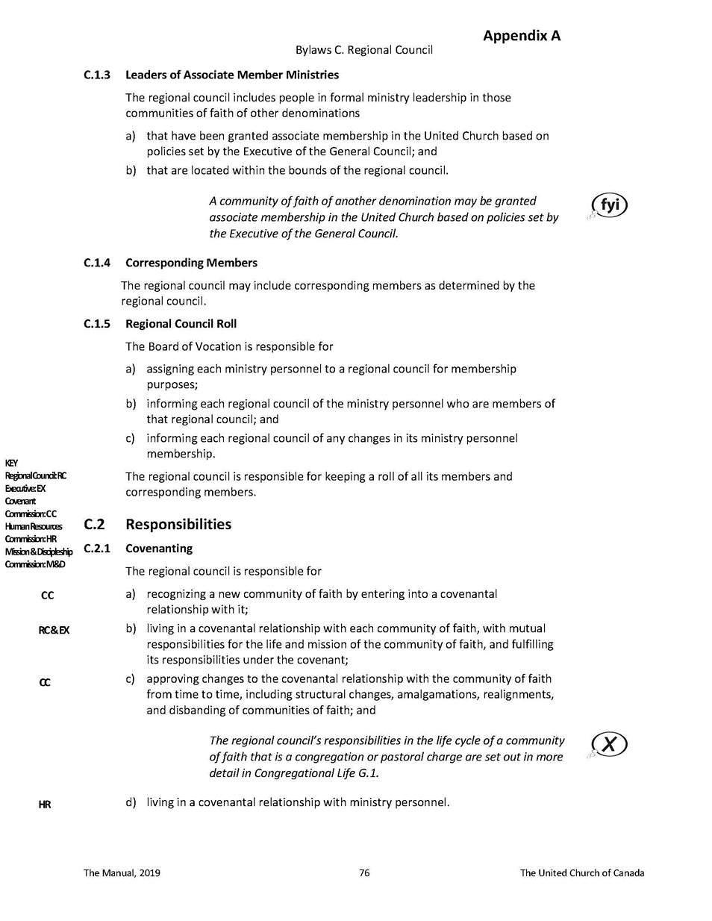
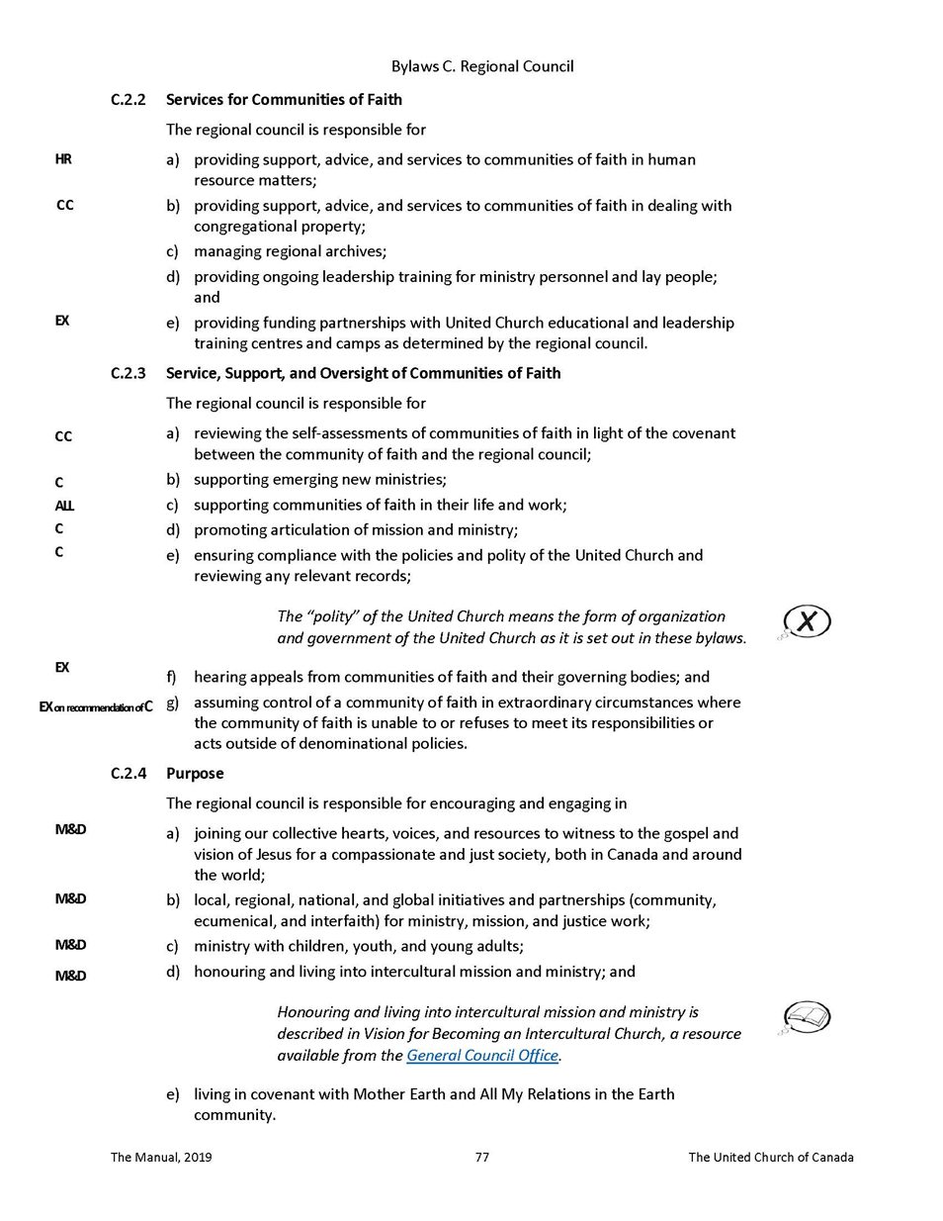

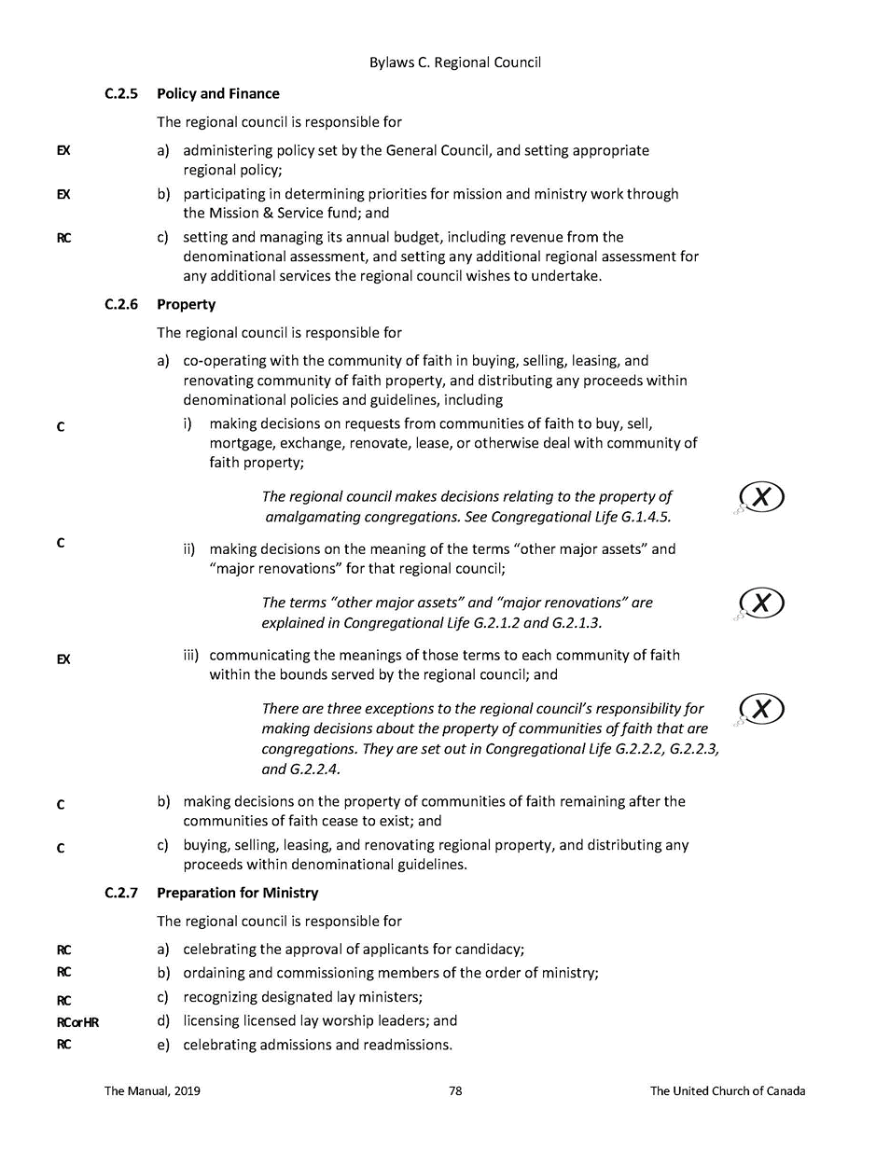

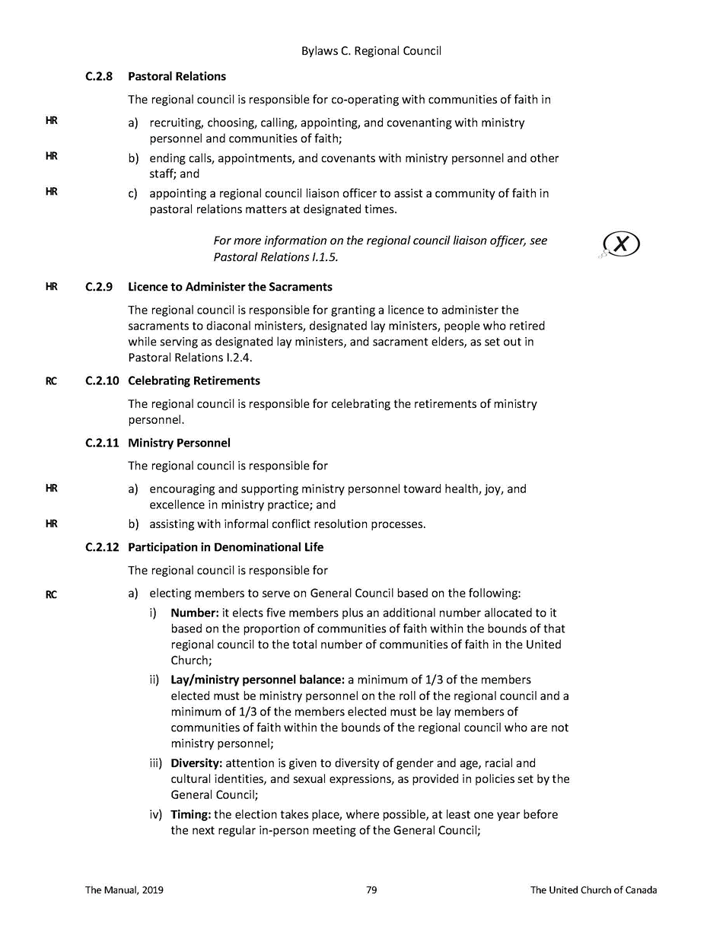

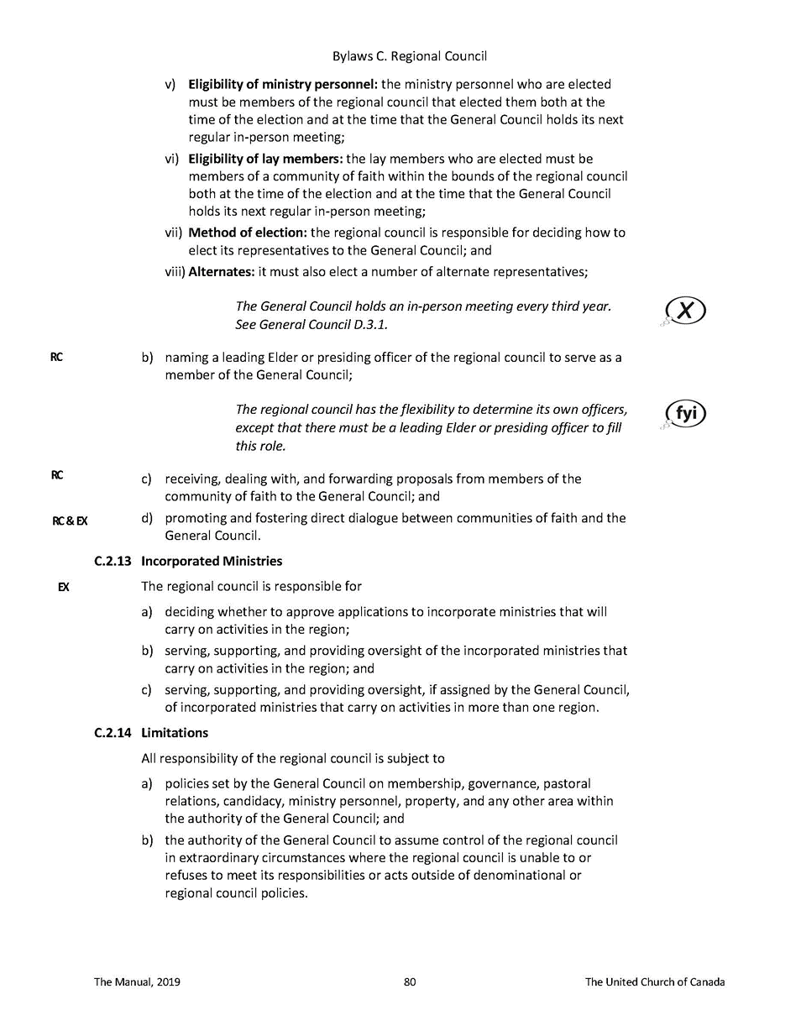

Appendix B HFRC Investment Policy

Investment Policy

Purpose
The regional council investments money to:
- Support the ministry of the regional council through the generation of income;
- Provide financial resources as necessary to address emerging situations.

Guidelines
- All investments will meet the test of reasonableness as seen by a prudent investor;
- The investment accounts will be managed in partnership with a certified investment advisor;
- There will be no investment in any entity whose operations might reasonably be regarded as contrary to the mission of The United Church of Canada (arms, tobacco, pornography, gambling, fossil fuels)
- The investments will be directed in accord with this policy by the Treasurer, Executive Minister, and two appointees named by the regional council Executive. All four will be invited to each consultation with the investment advisor and at least two must be present to take action.
- The investment team is authorized to move financial resources into investment vehicles provided the balance in the current account does not fall below $300,000 (over one quarter of annual expenses).

Investment Portfolio:
The investment portfolio will normally be held as:
20% Tier 1
40% Tier 2
40% Tier 3
These percentages may vary up to 5% depending upon financial conditions and investment advice.

Tier 1
Definition
Assets that are likely to be turned into cash within one year.

Objectives
Security, liquidity and income.

Eligible Investments
- Deposits in Canadian Chartered banks
- Debt instruments of the federal or provincial governments of Canada or Crown Corporations guaranteed by them, maturing within one year
- Debt instruments of Canadian Trust Companies up to the limit of the Canada Deposit Insurance Corporation (CDIC) insurance, maturing within one year
- Debt instruments of Ontario Credit Unions up to a limit of $100,000 maturing within one year.

Tier 2
Definition
Assets not likely to be turned into cash within a year but which could be required to address a specific situation or fund a new initiative.

Objectives
Security, income and liquidity

Eligible Investments:
- All investments listed in Tier 1 but with maturities up to three years. If a higher than average GIC rate may be realized, a five-year maturity may be used.
- Debt instruments of Canadian companies rated BBB/Bbb or higher by Standard & Poor’s or Canadian Bond Rating Service (CBRS), maturing within three years;
- The portfolio can own Exchange Traded Funds (ETF’s) and mutual funds that meet Tier 2 requirements.

Tier 3
Definition
Assets not likely to be turned into cash in the foreseeable future.

Objectives
Return on investments (including both income and capital gains), liquidity and security.

Eligible Investments
- All investments listed in Tier 2 above
- Shares of Canadian companies listed on the Toronto Stock Exchange (TSE)
- Units of Canadian Income Trusts listed on the TSE
- Units of ETF’s
- Shares of companies listed on the New York Stock or Nasdaq Exchanges

Policy Review:
This policy shall be reviewed every three years. This will include a review of the appointed investment advisor.

Appendix C HFRC Business Trust

The Horseshoe Falls Regional Trust is for the benefit of the Regional Council. The beneficiary of the Regional Trust is the Regional Council and a wholly-owned affiliate United Property Resource Corporation (UPRC) is the corporate trustee of the Regional Trust.

The United Church of Canada (UCC) incorporated United Property Resource Corporation (UPRC) agrees that, in carrying out its mandate and conducting its operations, it will support and comply with, as fully as possible, the values, applicable policies and priorities of the United Church. This includes, without limitation:
- ensuring continued availability of space for worship and Christian faith formation for United Church communities of faith;
- providing housing in Canada, including affordable housing;
- tailoring facilities and space in the development and redevelopment of church properties to meet community needs, especially the needs of community members who face structural barriers to full inclusion; and
- creating environments that are accessible for all people.
In achieving these goals, the United Church recognizes the need to hold or develop properties to serve ministry needs when financially viable. To achieve these objectives, UPRC, through Kindred Works, has created a professional real estate team to identify, evaluate and institutionally manage and/or develop these properties in cooperation with the Regional Council in a streamlined portfolio approach that can support the above objectives.

The Regional Trust structure allows for one consolidated entity to be managed by Kindred Works on behalf and in cooperation with the Regional Council. In cases in which properties are currently held by the General Council Office on behalf of the Regional Council, the beneficial interest in the properties will be transferred from the Regional Council to the Regional Trust.

In addition, properties of disbanding congregations can also be transferred to the Regional Trust, after consultation between UPRC and the Regional Council with respect to each such property. Where title is still held by the disbanding congregation, title will be transferred to UCC or another nominee designated by UCC from time to time.

This structure is intended to facilitate retention of church properties where the Regional Council deems this to be strategically important and financially feasible. This structure facilitates a systematic and professional portfolio approach to holding property while following the polity of property of the United Church.

