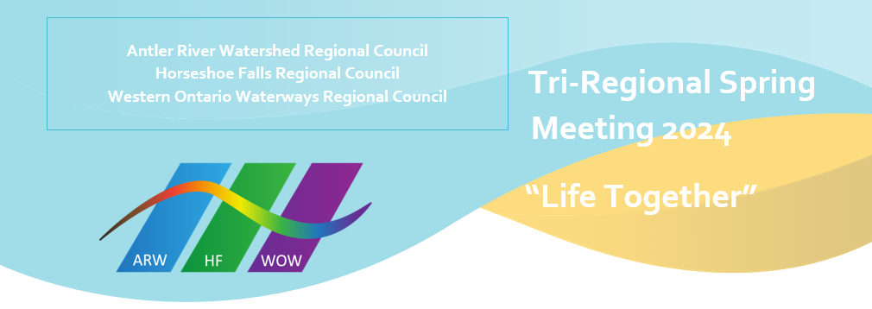
In Memoriam

Antler River Watershed Regional Council
Ruth Butt OM
Lewis Snow OM
Colin Swan OM

Horseshoe Falls Regional Council
Dorothy Cunningham OM
Nora Fueten OM
Meg Grieve OM
William “Bill” Thorneloe OM
Frank Walker OM

Western Ontario Waterways Regional Council
Barbara Curzon DM
Joyce Johnston OM
George Albert Baker ‘Ab’ Moore OM
Timothy Reaburn OM
Bruce Scott OM

