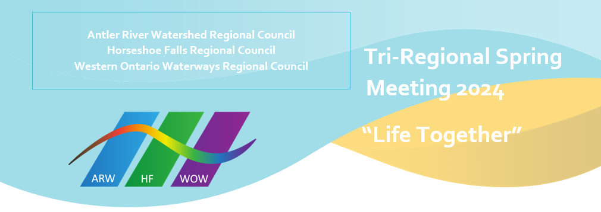
Staff Support Committee

The Staff Support Committee acts as a resource for the Executive Minister in discussions of staff complement, recruitment, oversight and development. It serves as the caring presence of the Regional Councils with their staff.

Acting as a resource, the Staff Support Committee meets with the Executive Minister regularly to review position descriptions, staff changes, staff development and team building. The Committee also tries to serve as a caring presence for the Regional Councils. It assists the Executive Minister with recognizing individual staff at particular milestones. The Staff Support Committee engages individual staff by serving as a liaison and if desired, accompaniment to performance reviews.

This year we are celebrating the five-year ministry milestones with the Regional Council of

Kevin Steeper, ARW/HF/WOW Pastoral Support Minister
Kathy Douglas, ARW/HF/WOW Minister, Faith Formation
Lynne Allin, ARW/HF Minister, Congregational Support

We are grateful for their service and the gifts they share generously with the Church.

