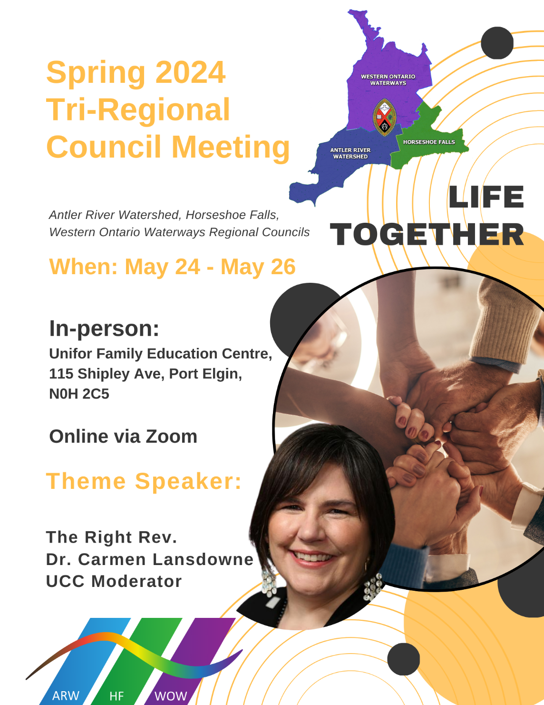
Tri-Regional Council Spring Meeting 2024
Horseshoe Falls Regional Council
WORKBOOK

Table of Contents
Welcome Information 3
President’s Message 5
AGENDA 6
PROPOSAL #1 8
BRAVE: Commitment to Community Safety 10
Designated Lay Ministers 11
Candidates 12
PROPOSAL #2 13
President Elect Nominee 15
Proposal #3 16
PROPOSAL #4 17
Staff Support Committee 18
Community of Faith Life Cycle Changes 19
In Memoriam 21
Jubilands 22
Retirees 23
A Deep Look at Fall Meeting Break Out Groups 24
Remit Project Summary 32
Remit Reach-Out Volunteer Leaders Report 37
Office of Vocation – Vocational Minister Update 40
United Church Rural Ministry Network 45
Emmanuel College 2024 Update to Regional Councils 47

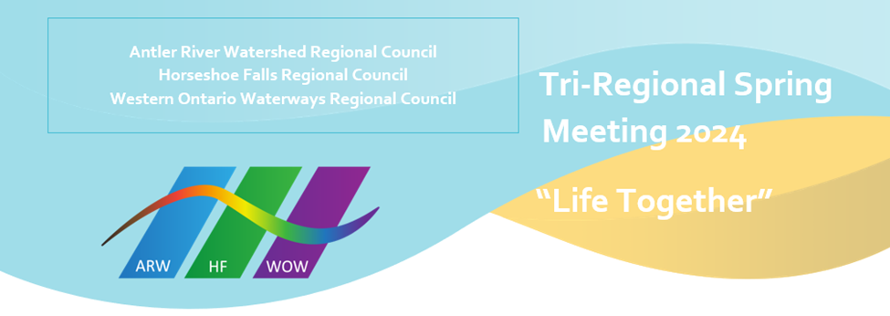

Welcome Information

Welcome all in-person registrants to our Tri-Regional Council Meeting, May 24-26, 2024.

The Hospitality Team has been working tirelessly to make sure everything is in place to help you navigate the venue. Please take a moment to look at the interior map (below) of UNIFOR to familiarize yourself with the space (UNIFOR Family Education Centre, 115 Shipley Ave, Port Elgin).

Arrival at UNIFOR
The Hospitality Team will be onsite to welcome you! All volunteers will be wearing rainbow t-shirts for easy identification, as well as orange vests when stationed at outside entrances.

2 volunteers will be stationed at the most westerly entrance to the upper parking lot.
1 volunteer will be at the UNIFOR front desk entrance.

Signage
There will be 2 signs on UNIFOR property indicating that the United Church of Canada meeting parking is accessed at either entrance to the upper parking lot.

There will be a 3rd sign at the UNIFOR front desk.

There will be signage throughout the facility as well.

Assistance
If you have accessibility needs, including requiring porter services, please contact Sue Duliban sduliban@united-church.ca or Michele Petick mpetick@united-church.ca. They will provide you with the cell number for a Hospitality Team member.

If you find you need assistance when you arrive at UNIFOR, our volunteers will be there to help.

Registration
Registration is open at 1 PM on Friday. Please proceed to Assembly Hall once you are in the building. DO NOT go to the front desk first. The Hospitality Team volunteers will be taking groups of registrants to the registration desk, to help with traffic flow and ease any potential bottlenecks. You can leave your luggage in Assembly Hall while you register.
If you are staying at UNIFOR: Checkout is 10 AM.
Remember: ALL in person registrants need to register; even if staying offsite. You can pick up a lanyard for your Regional Council in Assembly Hall (if you have a lanyard from a previous meeting, please remember to bring it along!). You will be given a nametag and meal ticket when you register.

Where are we gathering?
Plenary, Celebration of Ministries Service: Assembly Hall
Antler River Watershed RC: Sisterhood Room
Horseshoe Falls RC: Bob White Boardroom
Western Ontario Waterways RC: Anishinaabe Meeting Room
Children’s Program: Youth Workers Salon
Youth Program: Abilities Salon
Bookroom: in the Alcohol Free Café

Celebration of Ministries Service, 2:30 PM, Saturday May 25th
The service starts at 2:30 PM on Saturday, May 25th. Volunteers will be available to provide direction to guests to and from the Service. Volunteers will not be available while the Service is in progress.

Notes
Meals will be served cafeteria style by the catering staff. Meals can be eaten in the dining room, Assembly Hall, on the deck (if open) and in Union Station, NOT in bedrooms. If you do eat outside of the dining room, please remember to take your used plate, cutlery, etc., back to the dining room.

Union Station bar will be open at 8:30 PM on Friday and Saturday nights.

Please bring your own writing implement(s), paper, if desired. You may bring a refillable water bottle if you wish.

For those participating online
Each Regional Council will have a Zoom community host. If you have questions/comments during the meeting, or are feeling disconnected from the community, please check in with your Zoom community host so they can assist you.

COVID 19 AND OTHER RESPIRATORY VIRUSES (COLD, FLU, AND/OR RSV)
UNIFOR POLICY
If you are feeling sick or unwell, please do not come to the Centre. If you start to feel sick or unwell while at the Centre, notify the Front Desk. Please stay in your room and arrangements will be made for you to return home. If you need further guidance on the severity of your symptoms. Complete the self-assessment tool located at https://www.ontario.ca/self-assessment/ and follow their guidelines.

President’s Message
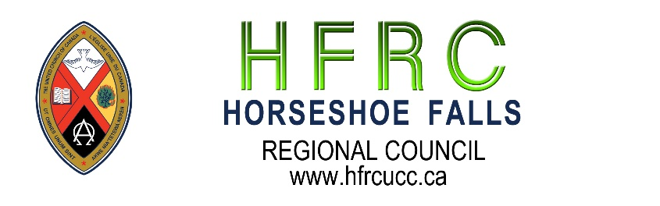
It is my absolute delight to extend welcome to all who will join us either in-person or online over the weekend of May 24-26 at the Unifor Family Education Centre, Port Elgin, for this very important Tri-Regional Council Meeting. From the Book of Psalms, A Song of Ascents, of David, the writer echoes the words of delight in 133:1, “Behold, how good and how pleasant it is for brothers and sisters to live together in unity! Our coming together to transact the business of the Horseshoe Falls Regional Council, to engage and fellowship with believers from the Antler River Watershed and Western Ontario Waterways regional councils are all clear signs of a slice of “Life Together”. The Moderator, The Right Rev. Dr. Carmen Lansdowne, will be keynote speaker on Friday May 24th, lifting up the theme: Life Together. Rev. Mark Laird, in his new capacity as Executive Minister, will form part of the critical leadership over the weekend to ensure the seamless movement of the business of the tri-region.
I am also excited that a number of persons have expressed interest to serve on the respective Commissions, as General Council 45 Commissioners, on the HFRC executive, and as President-Elect. These are wonderful signs of the movement of the spirit and testimony of the flourishing to which we all are directed. Nelson Mandela’s poignant words ring true, "It always seems impossible until it's done."
What’s being done for the first time is an executive approved regional Day of Fellowship to be held at Wellington Square United Church, Burlington on June 8th. This event is intended to bring together the entire Horseshoe Falls Regional Council in a day of celebration, praise, worship and fellowship. The world-renowned Toronto Mass Choir will be in attendance and their music is just absolutely fantastic. The keynote speaker for the service will be Rev. Alexa Gilmore and the General Secretary, Rev. Michael Blair will officially launch United Church 100 in our regional council. What a great way to move into United Church 100!
As an executive, it is our aim to foster re-connection and encourage fellowship towards flourishing. With the words of Rosa Parks, "To bring about change, you must not be afraid to take the first step. We will fail when we fail to try", it is our hope that there can be a change of the old presbytery mindset to the emerging regional pathway of renewal and transformation. If your community of faith is yet to appoint a Regional Representative, perhaps now is the time to do that.
Looking forward to meeting you all!
Blessings!
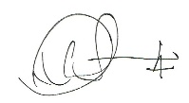
Lennox Scarlett

AGENDA
Friday May 24: Plenary
2 PM: Welcome
Worship/Covenanting with Executive Minister
Speakers
- Tanya Cameron, Vocational Minister/Tim Hackborn, Office of Vocation Minister - Indigenous Church
- Brenna Baker, Community of Faith Stewardship Support
- Greg Smith-Young, Growth Animator
Introduction of DLMs
Speakers
- Kindred Works
- Tim Hackborn, Martha Pedoniquotte, Community Capacity Development Coordinator (CCDC) – Indigenous Ministries & Justice Unit, Micol Cottrell, Minister Pastoral Relations, Lynne Allin, ARW/HF Minister Congregational Support, John Neff, WOW Minister Congregational Support
5:30-7:30 PM: Dinner
7:30 PM: The Moderator
8:30 PM: Vespers

Saturday May 25

7:30-9 AM: Breakfast
9 AM: Regional Council
Proposal 1 Opening and Procedural Motion
Proposal 2 GC45 Commissioners Slate
10:30 AM: Break
10:50 AM: Plenary
Worship
Introduction of Candidates and Candidates Address the Court
11:20 AM: Plenary
The Moderator and Presentation of Gift to the Moderator
NOON- 2 PM: Lunch (Celebration of Ministries Service rehearsal for those involved Noon-12:30 PM/Choir practice for those involved 1 PM)
2:30 PM: Celebration of Ministries Service
Possible free time following service
5:30-7:30 PM: Dinner
7:30 PM: Regional Council
- President Elect Nominees speeches
- Proposal 3 Executive/Commissions Slate
- Order of the day: Visit from the Moderator

Sunday May 26

7:30-9 AM: Breakfast
9-10:00 AM: Regional Council
- Election of President Elect
- Regional Council Evaluation: Update on regional council follow-up
- New & Unfinished Business
- Proposal 4 Closing Motion
10:00 AM: Break
10:15 AM: Plenary
Worship, honouring In Memoriam, Community of Faith Life Cycle changes, Retirees, Jubilands
Message: Rev. Mark Laird
Noon-12:30 PM: Closing, pick up bagged lunch

PROPOSAL #1

Title: Opening and Procedural Motion
Origin: Executive Minister

What is the issue?
The regional council must establish the procedures by which it will conduct business.

Why is this issue important?
This clarifies and confirms the way in which decision-making will happen.

How might the regional council respond to the issue?
The regional council might adopt the following as a consent docket:
- Adopt the agenda as circulated and authorize the Agenda and Business Committee to make any changes as necessary;
- Approve the minutes of the meeting of 2023-10-13-14;
- Receive the minutes of the following meetings of the
- Executive
24-04-24
24-03-06
24-02-26
24-02-06
24-01-24
24-01-13
23-12-13
23-11-22
23-10-25
23-09-26
- Congregational Support Commission
2024-01-23
2024-01-09
2023-12-12
2023-11-30
2023-11-14
2023-10-17
2023-09-26
2023-09-12
2023-08-17
2023-07-25
2023-06-14
- Human Resources Commission
2023-06-28
- Discipleship and Justice Commission
2023-09-26
2023-05-30
for information.
Note: Minutes are posted on the website https://hfrcucc.ca/meeting-minutes/
- Appoint Martha Lockwood as Parliamentarian;
- Appoint Wendy Lowden as Chair, Agenda and Business Committee and Recording Secretary;
- Name Tessica Hackshaw to serve as Equity Support Team Member;
- Name President Lennox Scarlett, Chair Agenda and Business Committee and Recording Secretary Wendy Lowden, Parliamentarian Martha Lockwood, as the Agenda and Business Committee;
- Name the Chair Agenda and Business Committee and Parliamentarian as scrutineers;
- Set the bounds of the meeting as the zoom call, and the UNIFOR Family Education Centre, Port Elgin, Ontario;
- Make the designated representative from any United Church ministry, other than a congregation, which has been invited to become a community of faith by entering into a covenant with the regional council, a member of the regional council for this meeting (Section C.1.2 c);
- Make all guests corresponding members;
- Set the deadline for new business to be submitted to the Agenda and Business Committee as 2:00 p.m., Saturday, May 25, 2024.
- Adopt the following method for dealing with proposals for action by the regional council
Step One:
The Presenter will outline:
- What is the issue? and
- The suggested way in which the regional council might respond to the issue.
Step Two:
The President will inquire if there are questions for clarification. Please note this is for clarification only.
Step Three:
The President will then ask if there are changes or additions being suggested for the proposal. Using warm and cool signals, the regional council will seek to come closer to agreement on how to respond to the issue.
Step Four:
Once there is significant agreement, the President will invite the Presenter to move the motion at which point the regional council enters the formal debate process.

BRAVE: Commitment to Community Safety

We strive, in this time of co-learning, to be brave by:

B – bring accountable for the impact of both our words and our silence
R – reflecting on and naming our own biases
A – actively listening
V – vocalizing questions that arise from our learning
E – encountering new ideas with curiosity and wonder

ARW, HF, WOW Regional Councils Affirming Ministries Vision Statement
SAFETY. SANCTUARY. UNCONDITIONAL LOVE

Striving to be faithful followers of Jesus in our time and place, Antler River Watershed / Horseshoe Falls / Western Ontario Waterways Regional Councils will continue to remove barriers to participation in the life and work of the regional council and society, committing ourselves to be open to the Spirit.

Resisting all forms of oppression, we welcome and celebrate people of any sexual orientation and gender identity, and all others who are marginalized.

The Regional Council, Staff, Executive, Commissions, networks, and members commit to working toward fulfilling the vision statement by:
- Continuing to remove barriers to participation in the life and work of Antler River Watershed/Horseshoe Falls/Western Ontario Waterways Regional Councils.
- Continuing to remove barriers to participation in society.
- Committing to be open to the Spirit.
- Resisting oppression.
- Welcoming and celebrating people of any sexual orientation and gender identity.

Designated Lay Ministers
Previously been recognized as Designated Lay Ministers that have met the requirements of our church to enter the order of ministry

Antler River Watershed Regional Council
Marilyn Arthur DM
Pat Morrison OM
Michael Shewburg OM
Eric Skillings OM
Pam Wilcox OM
Karen Willis OM

Horseshoe Falls Regional Council
Jen Auger DM
Dawn Ballantyne OM
Kim Belanger DM
Sue Cowan OM
Barbara Creelman OM
Maureen Ellison OM
Wendy Lowden OM
Carolyn Smith OM
Diane Viney OM

Western Ontario Waterways Regional Council
Doug Brown OM
Andrew Hyde OM
Marianne Leach Hoffer OM
Paul Vollick DM
Judy Zarubick OM

Candidates

Antler River Watershed Regional Council
Dan Leaver, Commissionand

Horseshoe Falls Regional Council
Jeff Learmonth, Ordinand
Carolin MacMillan, Ordinand

Western Ontario Waterways Regional Council
John Adeyemi, Ordinand

PROPOSAL #2

Title: General Council 45 Commissioners Slate
Originating Body: Volunteer Recruitment Team

What is the issue?
The 45th General Council will meet in Calgary in July 2025 and the regional council has the opportunity to elect a slate of Commissioners to attend and represent the regional council.

Why is this important?
The decisions of the General Council impact all communities of faith and ministry personnel. It is important the Commissioners be people of vision and commitment who can bring diverse perspectives to lead to bold and daring decisions (to borrow from the Call of the Strategic Plan).

What might the regional council do?
The regional council might agree to

- Approve the slate prepared by the Volunteer Recruitment Team as presented:
General Council 45 Commissioners Slate
Ministry Personnel
YongSeok Baek
Tessica Hackshaw
Deborah Laforet
Martha Lockwood
Deb McMillan
Alison Miculan
Lennox Scarlett

Lay
Ralph Hayman
Heather King
Steven Lowden
Karen Toogood Seagrave
Yvonne Wright

Pat Tooley (L): First alternate
Heather Weaver-Orosz (OM): Second alternate

- Empower the HFRC Executive to name further Alternates to General Council 45, as required, who will serve if any of the HFRC GC45 Commissioners are unable to attend.

President Elect Nominee

Introduction of President Elect Candidate: Rev. Sula Anne Kosacky
Sula joined the United Church of Canada in 2001, after immigrating to Canada from the U.S. Her educational background was in molecular biology and biochemistry, and her goal at that time was a career in genetics research. Shortly after joining the church in Grimsby, she started to volunteer as a Sunday school teacher, youth group leader, and puppet ministry leader, as well as acting in the chancel drama group. In other words, she became a full-time church volunteer.
In 2008 she began ministry discernment and then completed her MDiv. at Emmanuel College in Toronto. While still in school, and after her ordination, she studied with the Canadian Association of Spiritual Care, completing 4 advanced studies in CPE. She worked as a spiritual health specialist in William Osler Healthcare System in Brampton Ontario for 9 years. In 2018 she was certified by Mindfulness Without Borders as a mindfulness program teacher, and in 2019 she was invited to the International Conference on Mindfulness in New Zealand to present a research project and theory paper on using Mindfulness Based Stress Reduction with frontline medical staff.
In 2020 she accepted a call to Smithville United Church, where she has run grief support, anti-bullying, and mindfulness programs open to the community. Since 2021 she has served as a commissioner on the Discipleship and Justice Commission, and in 2023 moved into the role of chairing the DJC, and serving as the Discipleship and Justice representative on the HFRC Executive. She is passionate about mental and spiritual health in church and community, and communication, and relationship within the church.
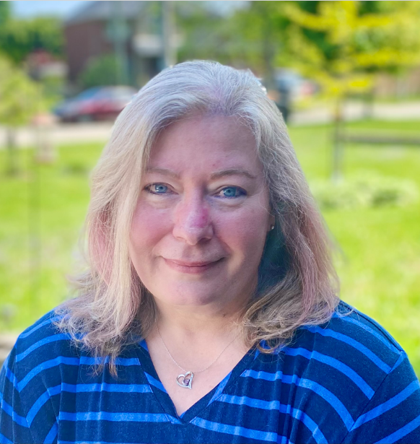

Proposal #3

Title: HFRC Executive/Commissions Slate
Originating Body: Volunteer Recruitment Team
What is the issue?
The regional council can best fulfill its decision-making responsibilities if it has a full slate of diverse members in decision-making roles.
What might the regional council do?
The regional council might agree to:

Approve the slate prepared by the Volunteer Recruitment Team as presented:

HFRC May 2024
Executive/Commissions Slate
(Terms are 3 years, renewable once)

Executive
Rev. Gabrielle Heidinger (First term to 2027)

Congregational Support Commission
Doug Caldwell (Lay, First term to 2027)
Rev. Barb McGill (First term to 2027)
Rev. Kate Young (First term to 2027)

Discipleship and Justice Commission
Lahring Tribe (Lay, First term to 2027)

Human Resources Commission:
Rev Heather Weaver-Orosz (First term to 2027)

PROPOSAL #4

Title: Closing Motion
Origin: Executive Minister

What is the issue?
The work of the regional council continues between regional council meetings.

Why is this issue important?
The regional council must be clear how the work will continue.

What might the regional council do?
The regional council might
- Entrust any unfinished business from its May 24, May 25 and May 26, 2024 meeting to the Executive;

- Authorize the Executive to fill any vacancies on the understanding that appointments will be confirmed at the next spring regional council meeting;

- Direct the Executive to plan to convene a meeting of the regional council in the fall of 2024; and

- Entrust the Executive and Commissions with the responsibilities and authority of Horseshoe Falls Regional Council in accordance with The Manual of The United Church of Canada and the Governance Handbook of the Horseshoe Falls Regional Council.

- Close the May 24, May 25, and May 26, 2024 meeting of the Horseshoe Falls Regional Council at the close of the worship service on Sunday, May 26, 2024.

Staff Support Committee
The Staff Support Committee acts as a resource for the Executive Minister in discussions of staff complement, recruitment, oversight and development. It serves as the caring presence of the Regional Councils with their staff.

Acting as a resource, the Staff Support Committee meets with the Executive Minister regularly to review position descriptions, staff changes, staff development and team building. The Committee also tries to serve as a caring presence for the Regional Councils. It assists the Executive Minister with recognizing individual staff at particular milestones. The Staff Support Committee engages individual staff by serving as a liaison and if desired, accompaniment to performance reviews.

This year we are celebrating the five-year ministry milestones with the Regional Council of

Kevin Steeper, ARW/HF/WOW Pastoral Support Minister
Kathy Douglas, ARW/HF/WOW Minister, Faith Formation
Lynne Allin, ARW/HF Minister, Congregational Support

We are grateful for their service and the gifts they share generously with the Church.

Community of Faith Life Cycle Changes

Antler River Watershed Regional Council
With thanks for their legacy and faithful service
Disbanded Congregations
Belle River United Church, disbanding spring 2024 with final worship service October 29, 2023.

Many blessings as these communities of faith continue their ministries together
Amalgamations and Name Changes
Bryanston United Church and Villages United Church, Granton amalgamated to form Villages United Church.
Central United Church and Emmanuel United Church amalgamated to form Emmanuel United Church, Windsor.
Kerwood-Bethesda United Church and Strathroy United Church amalgamated to form Strathroy United Church.
Parkhill United Church and Thedford United Church amalgamated to form Ausable United Church.
Zion United Church and Thorndale United Church amalgamated to form Thorndale United Church.

Nesting
Wesley United Church, now nesting with Charing Cross United Church.
Fletcher United Church, now nesting with Merlin United Church.

Horseshoe Falls Regional Council
With thanks for their legacy and faithful service
Disbanded Congregations
Trinity United Church, Thorold
Elcho United Church, Wellandport
People’s Memorial United Church, Ridgeway
Mount Carmel United Church

Many blessings as these communities of faith continue their ministries together
Amalgamation
Binkley United Church, Dundas and St. Mark’s United Church, Dundas

Western Ontario Waterways Regional Council
With thanks for their legacy and faithful service
Disbanded Congregations
Goldstone United Church
Oliphant United Church

Amalgamations and Name Changes
Many blessings as these communities of faith continue their ministries together
Shelburne Primrose Pastoral Charge; Trinity United Church, Shelburne and Primrose United Church to Shelburne Primrose Pastoral Charge; Trinity Primrose United Church
Angus United Church with Grenfel United Church. Now Grenfel United Church.
Parkview United Church, Stratford with Avondale United Church, Stratford. New name Avondale United Church, Stratford.
Walters Falls Pastoral Charge to Temple Hill Pastoral Charge; Temple Hill United Church

In Memoriam
Antler River Watershed Regional Council
Ruth Butt OM
Lewis Snow OM
Colin Swan OM
D. Graham Tipple OM

Horseshoe Falls Regional Council
Nora Fueten OM
Meg Grieve OM
William “Bill” Thorneloe OM
Frank Walker OM

Western Ontario Waterways Regional Council
Barbara Curzon DM
Joyce Johnston OM
George Albert Baker ‘Ab’ Moore OM
Helen Prior OM
Timothy Reaburn OM
Bruce Scott OM

Jubilands

Antler River Watershed Regional Council
50 Years
Derek Parry OM
William Vanderveeken OM

Horseshoe Falls Regional Council
50 Years
John Allsop OM
D. Paul Crittenden OM
Kenneth MacDonald OM
Jeff Maissan OM
Wayne Myhre OM
55 Years
David Iverson OM
W. Robert Johnstone OM
J. Ross Routliffe OM

60 Years
W. Leslie McSpadden OM
Ronald Wallace OM
75 Years
Ward Kaiser OM

Western Ontario Waterways Regional Council
50 Years
Elizabeth Eberhart-Moffat OM
Peter Moffat OM
Paul Ross OM
60 Years
David Burns OM
John Gertridge OM
Kenneth Myers OM
65 Years
Joan Gugeler DM
Morley Hammond OM
Paul Webb OM
70 Years
Robert Clyde OM

Retirees

Antler River Watershed Regional Council
Mary Dillon DLM
John Lovering OM
Sheila Macgregor OM
Brenda MacMain DLM

Horseshoe Falls Regional Council
Laura Borgerson OM
Cathy Dilts OM
Brian Donst OM
Maureen Ellison DLM
Debra McGill OM
Kim Shantz DM
Karen Williams OM

Western Ontario Waterways Regional Council
Kate Crawford Mulrooney OM
Ed Laksmanis OM
Gwen Nicol-MacDonald OM
Cathy Paul OM
Joan Tuchlinsky DM

A Deep Look at Fall Meeting Break Out Groups

Below are jpeg images of the data of A Deep Look at Horseshoe Falls Regional Council Fall break out room sessions for the
Regional Evaluation. Accessible version available online https://hfrcucc.ca/wp-content/uploads/2024/05/Spring-2024-HFRC-A-Deep-Look-at-the-Notes-from-the-HFRC-Fall-Break-Out-Rooms-on-the-Regional-Evaluation.docx
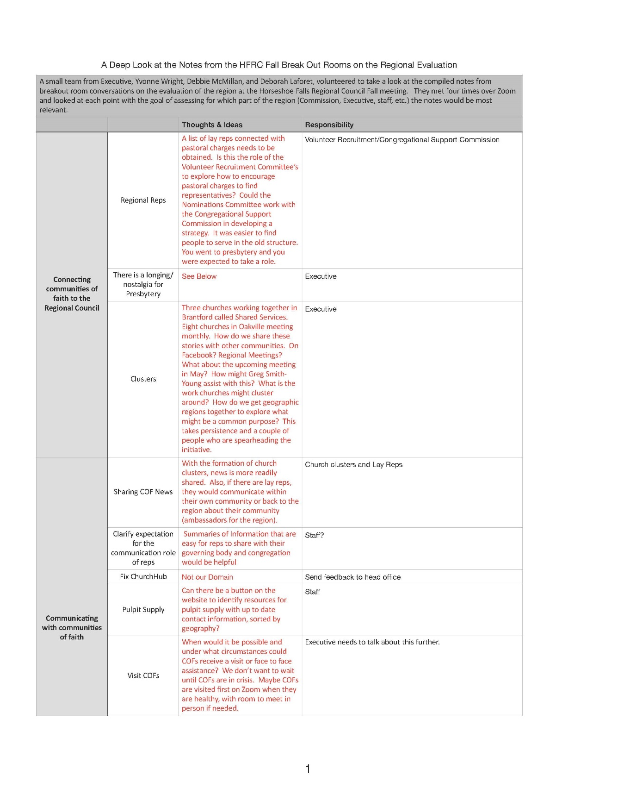

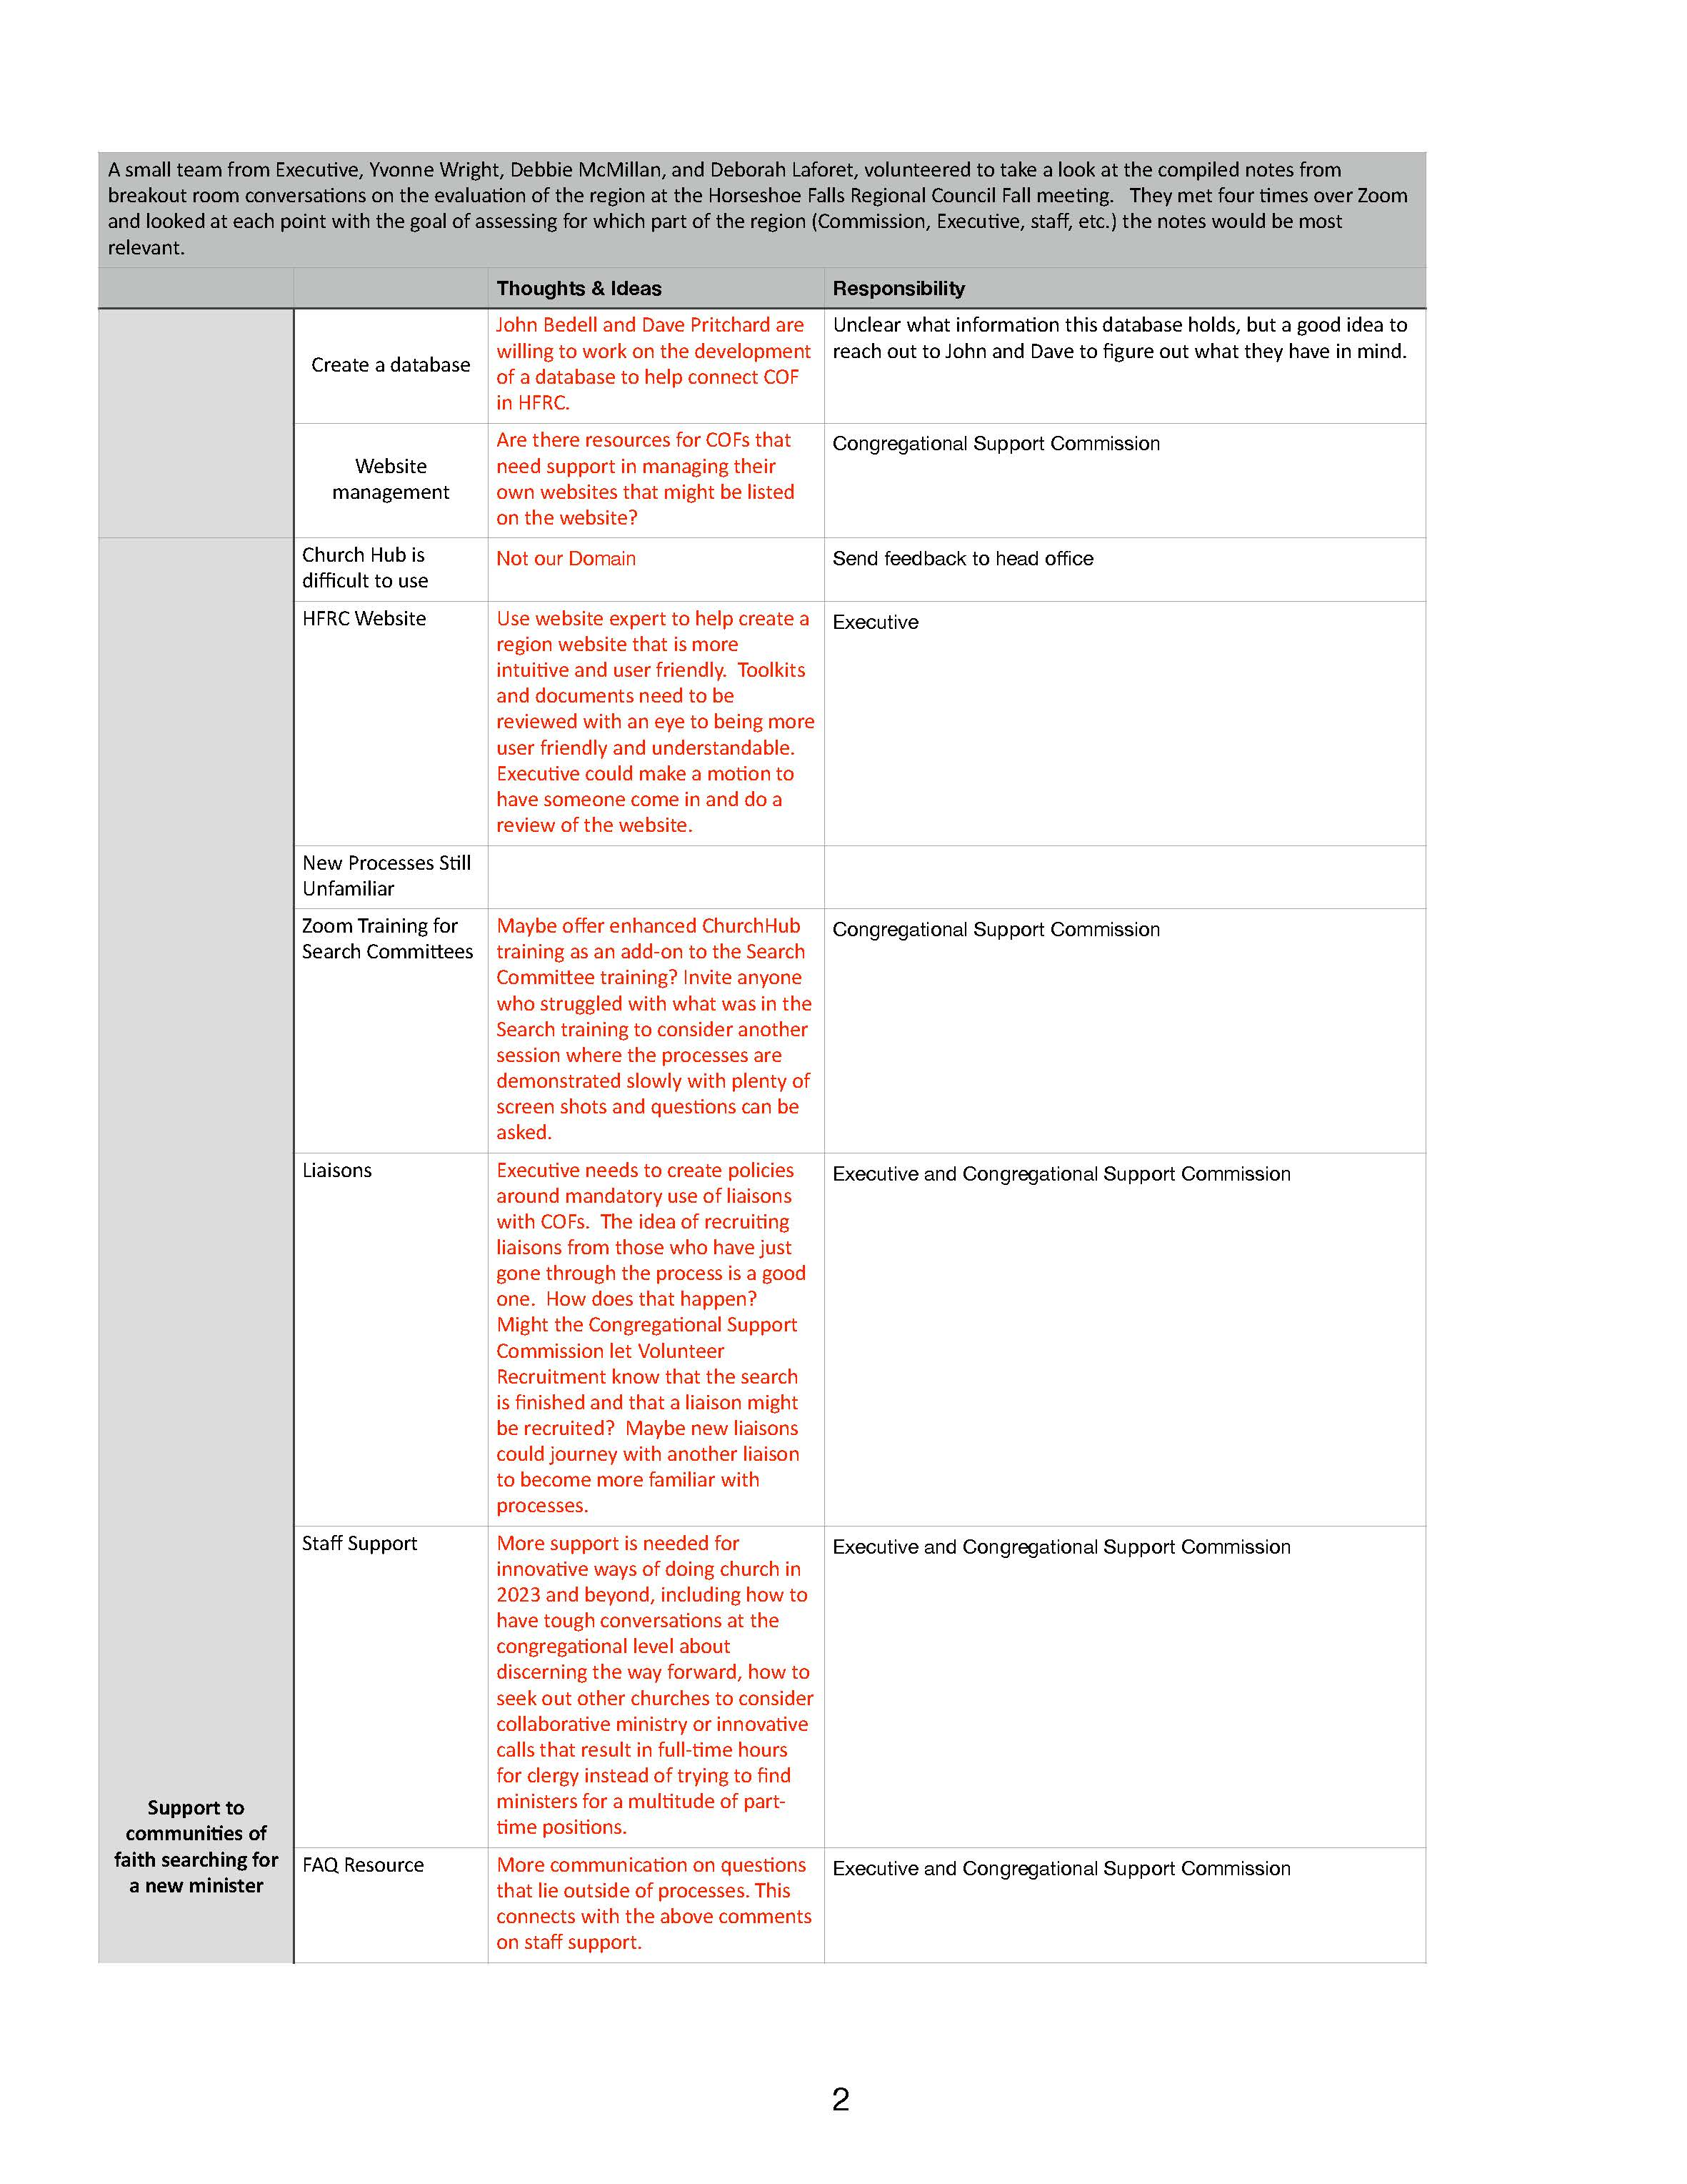
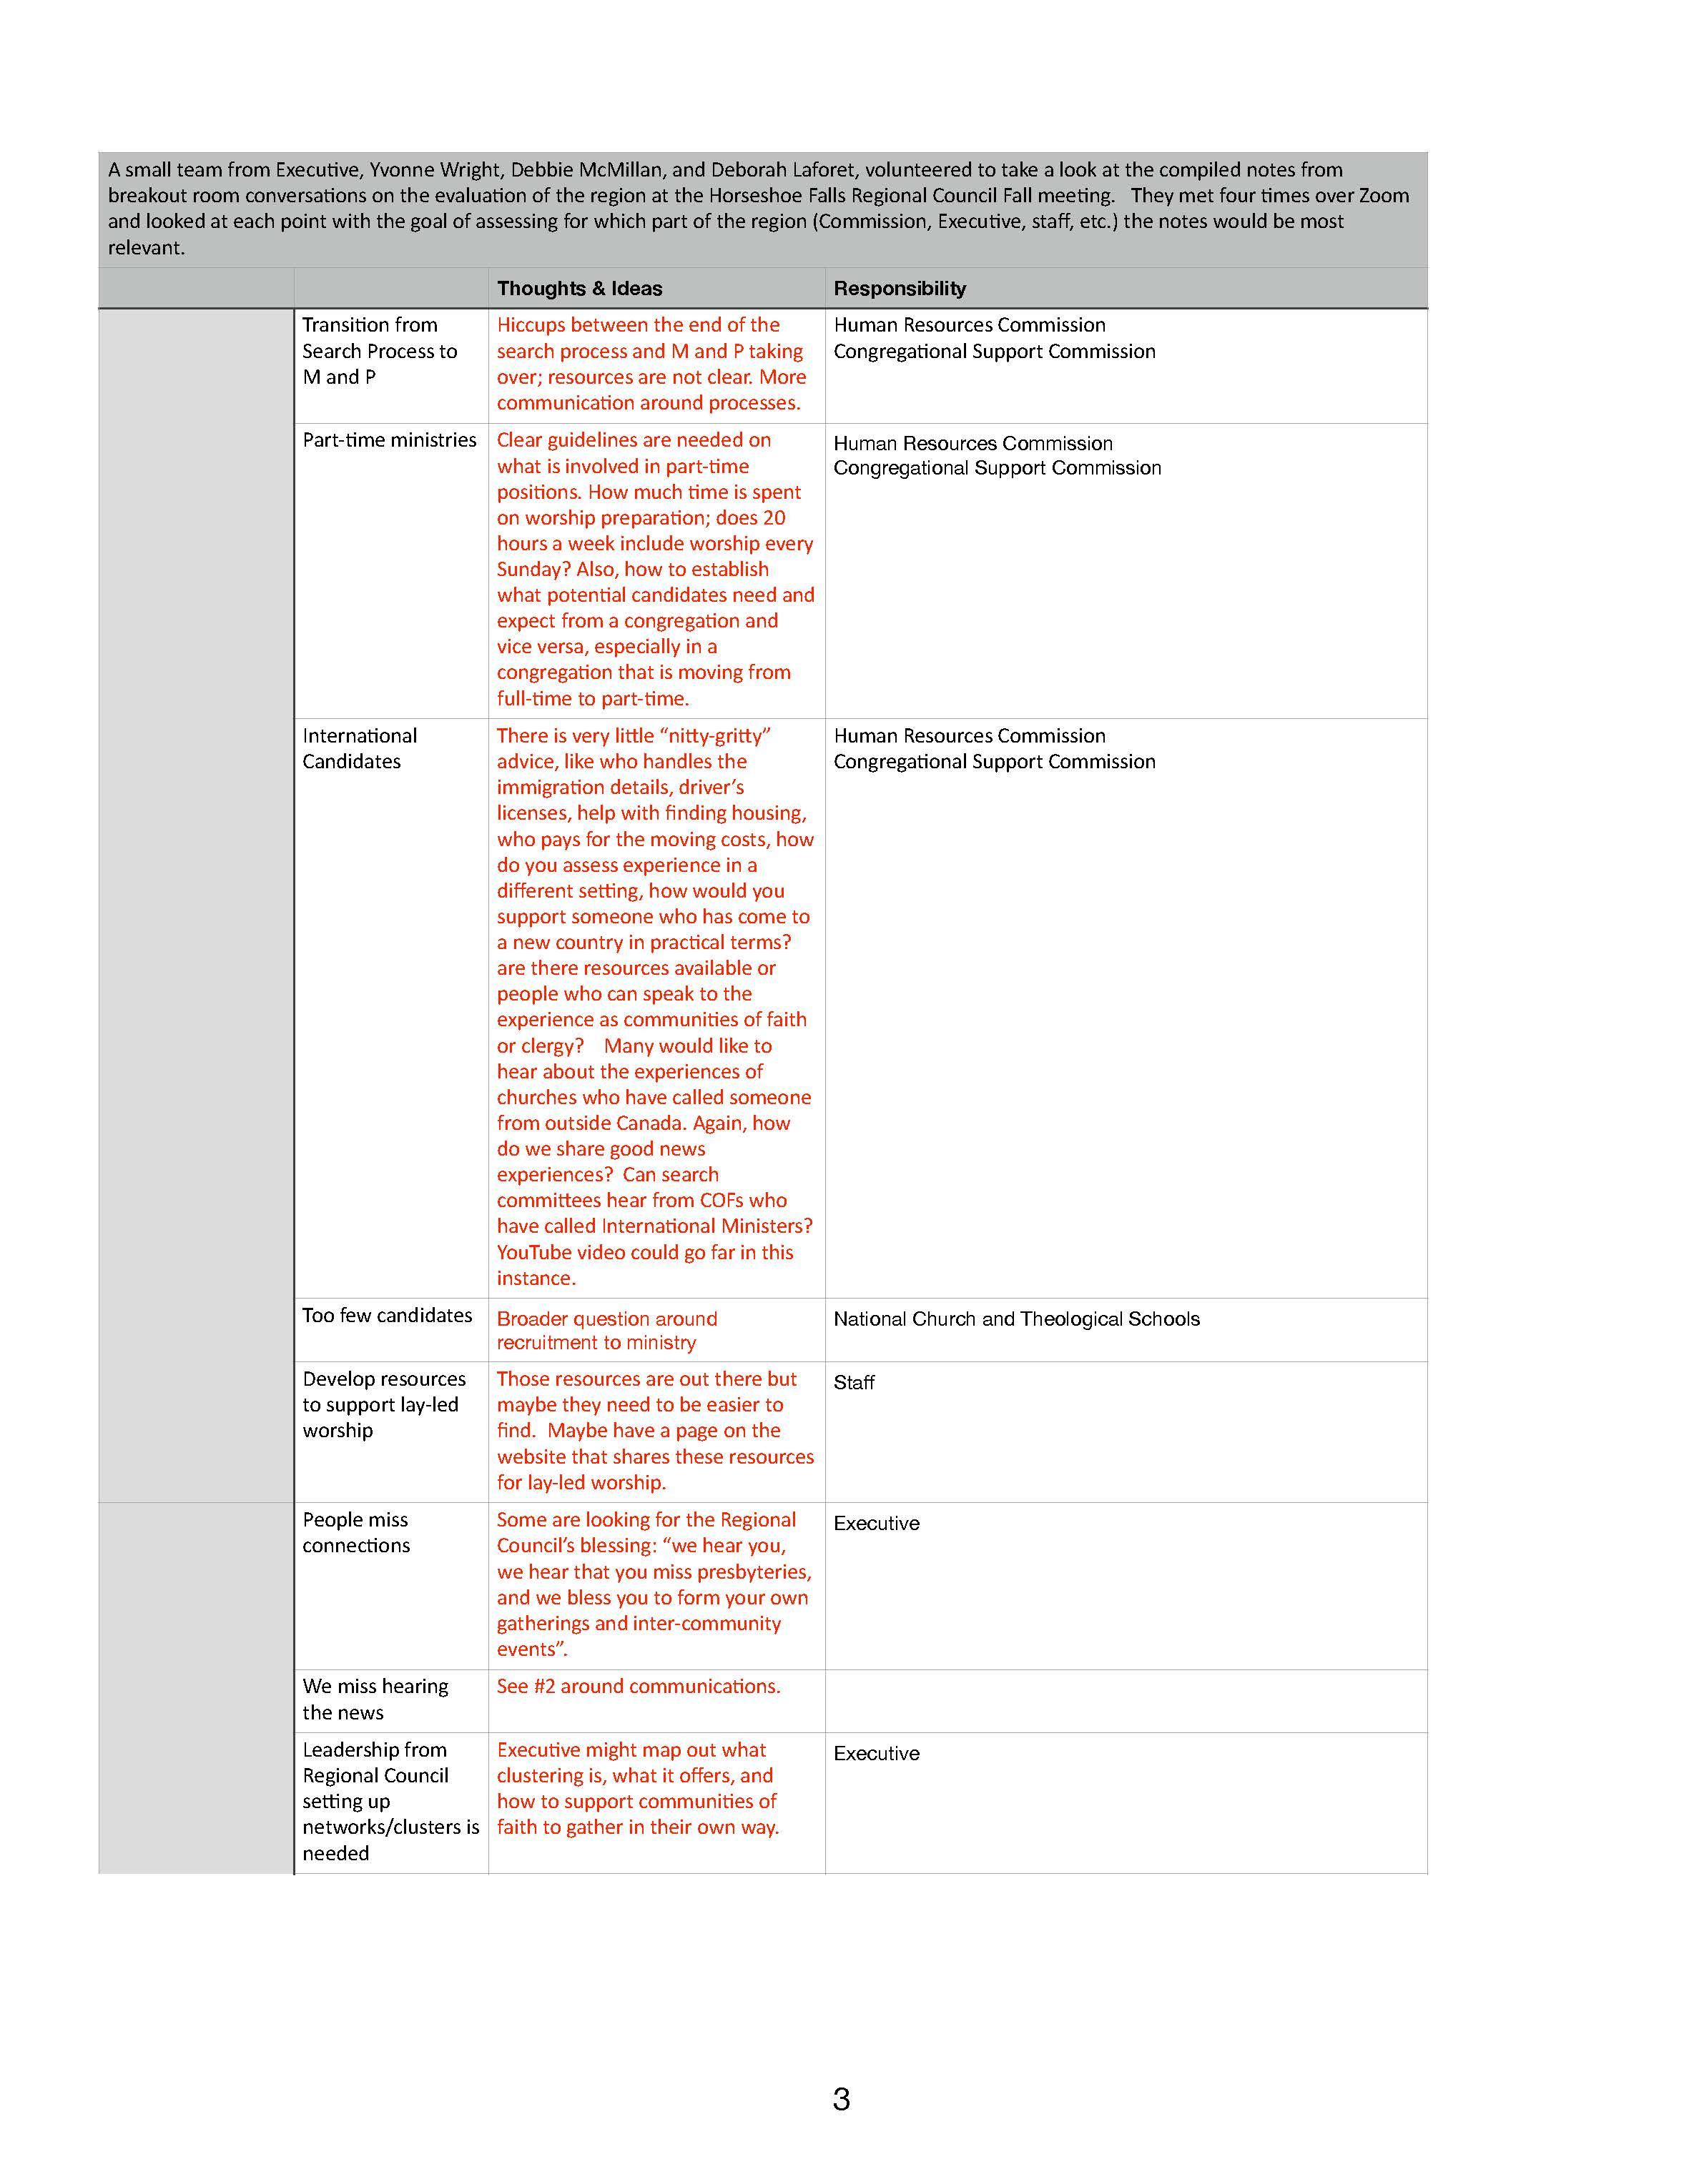

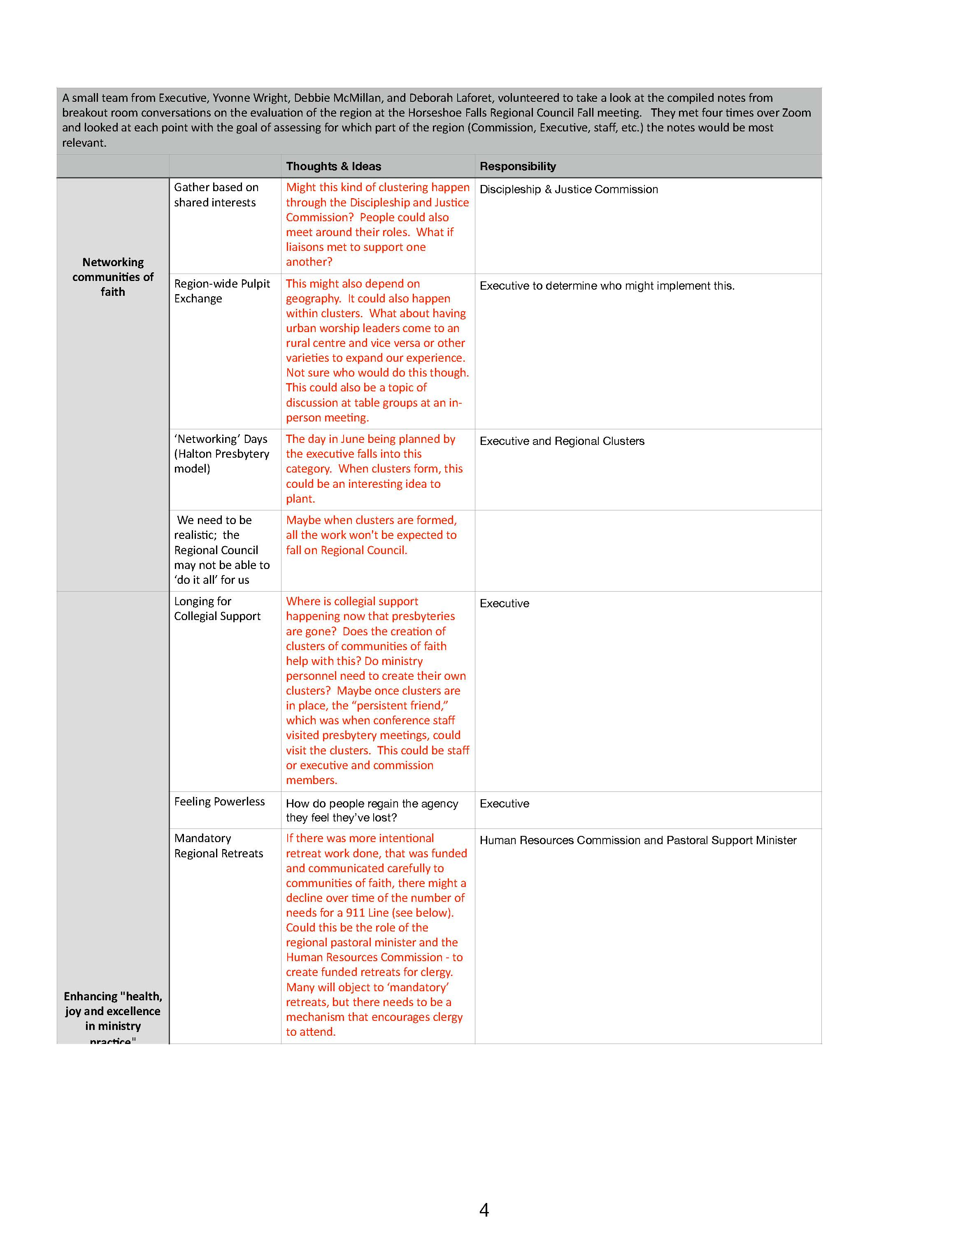

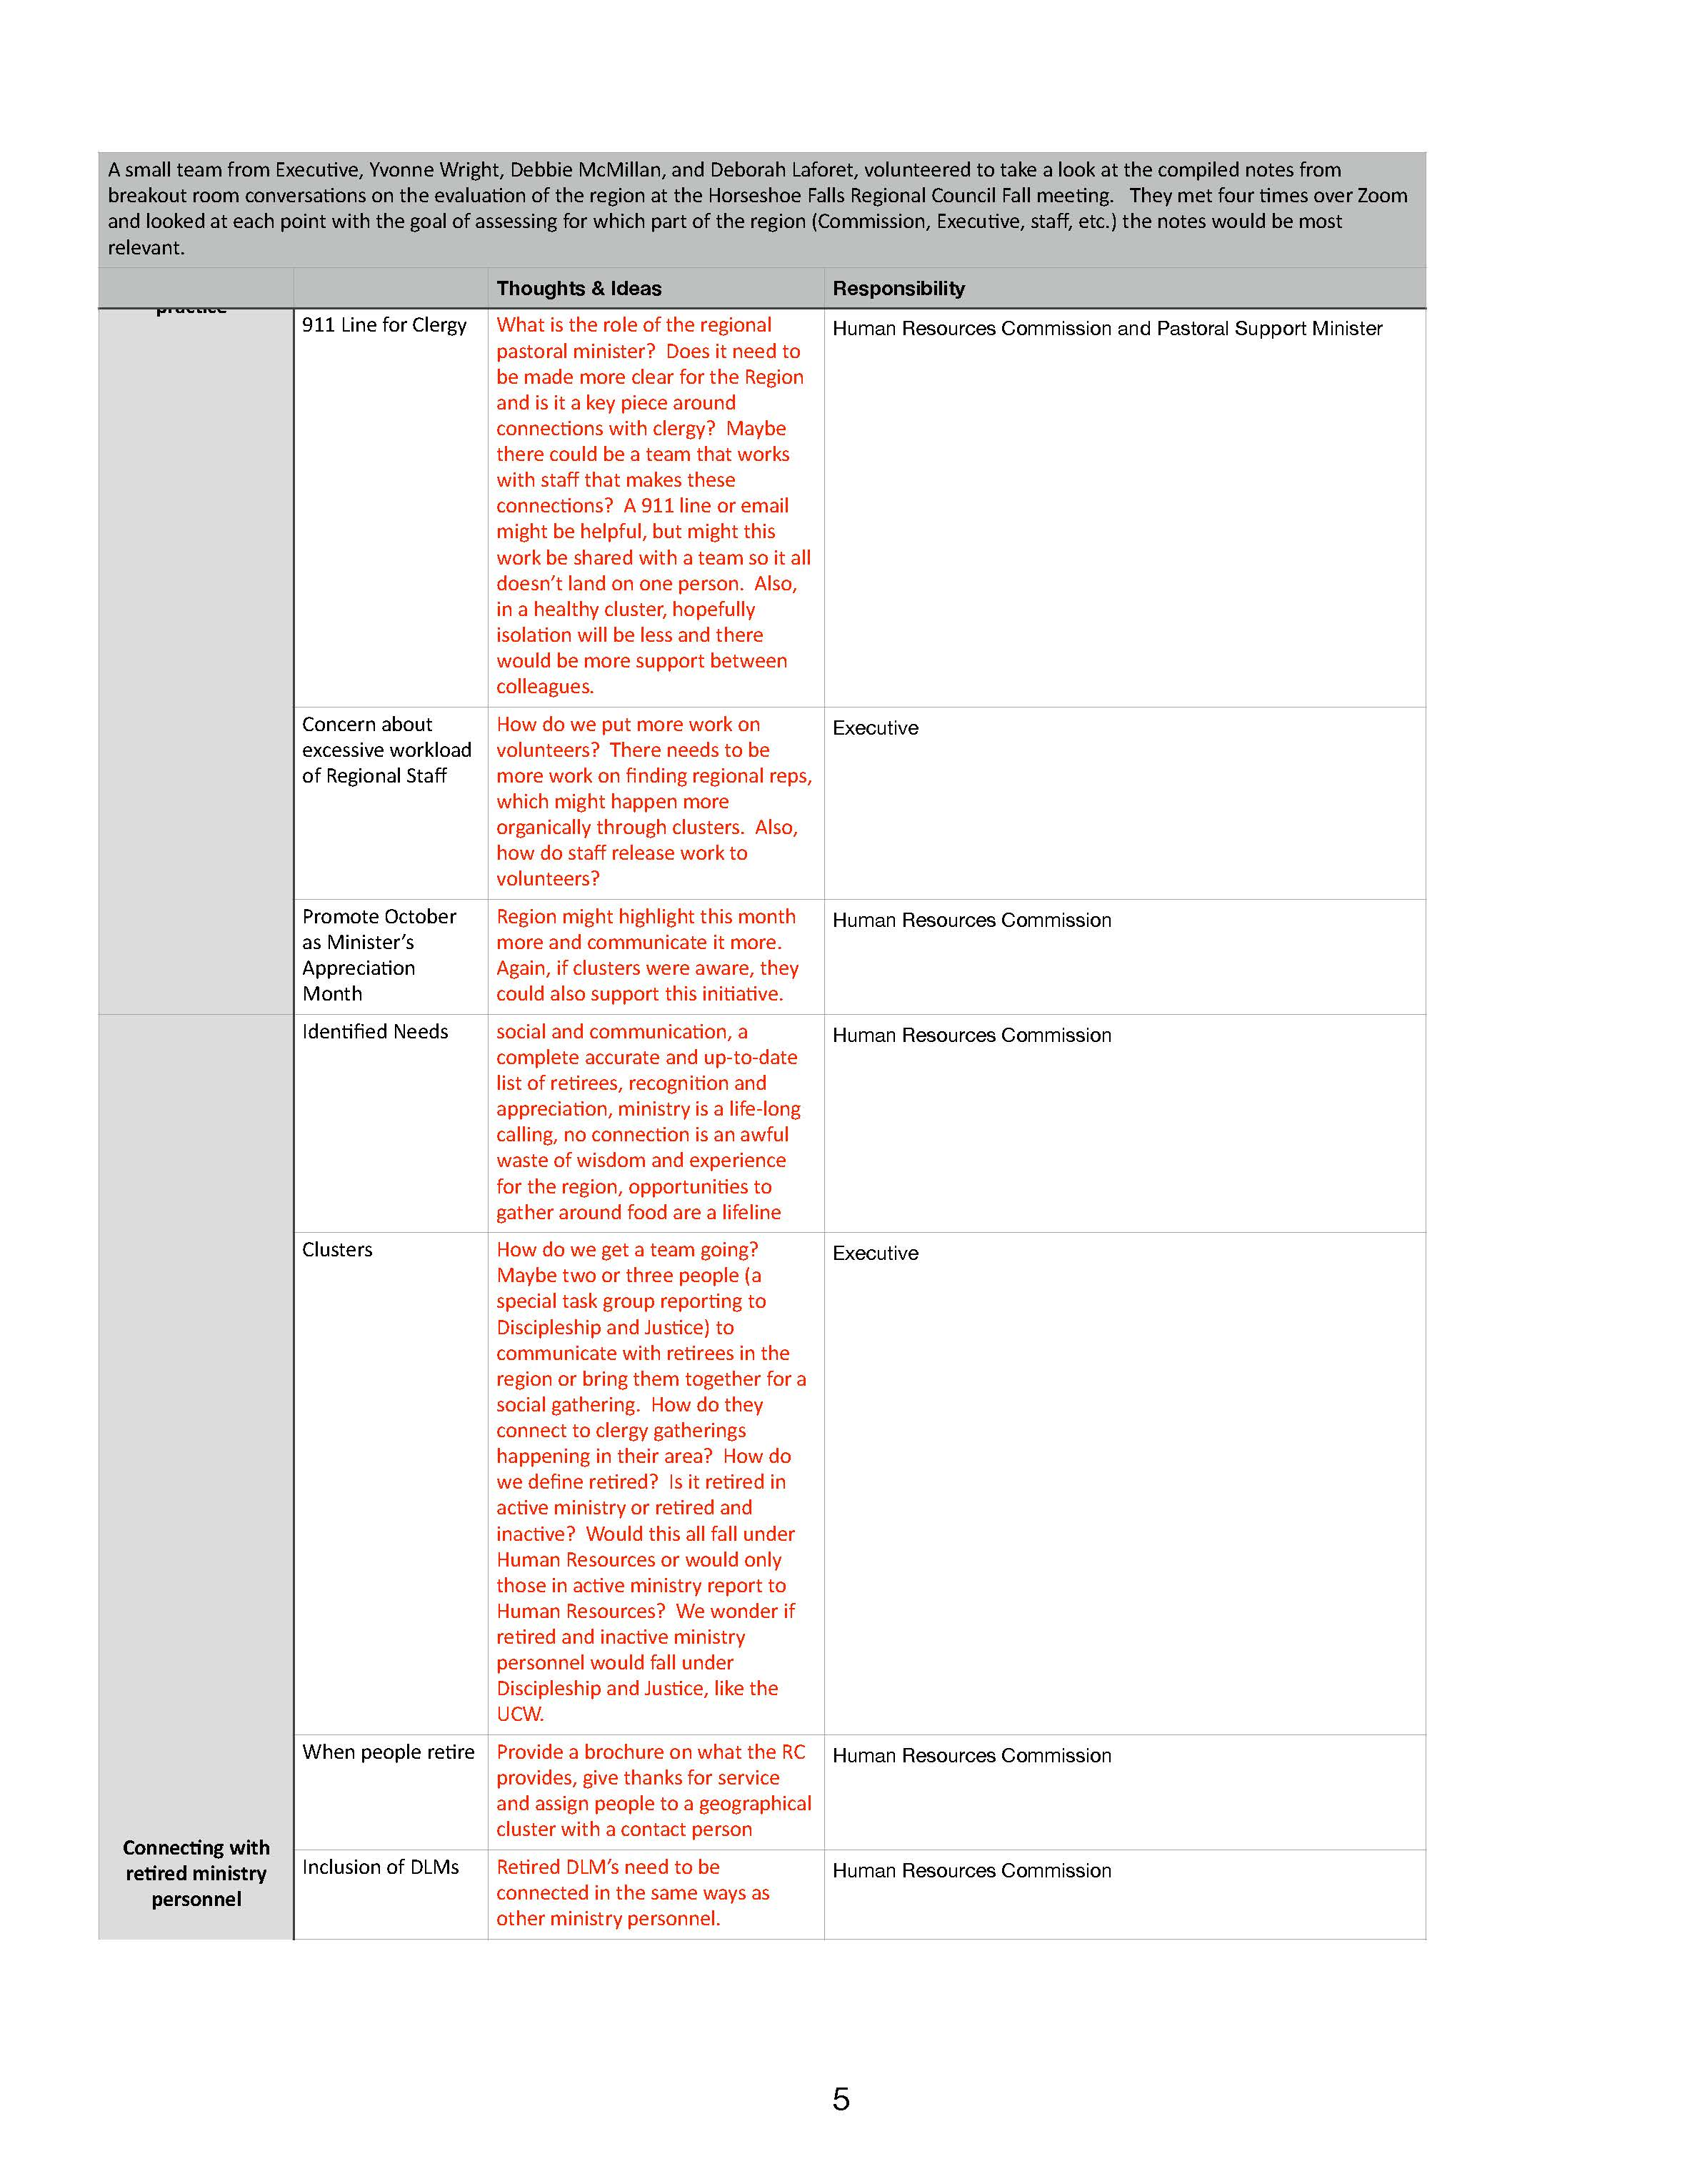

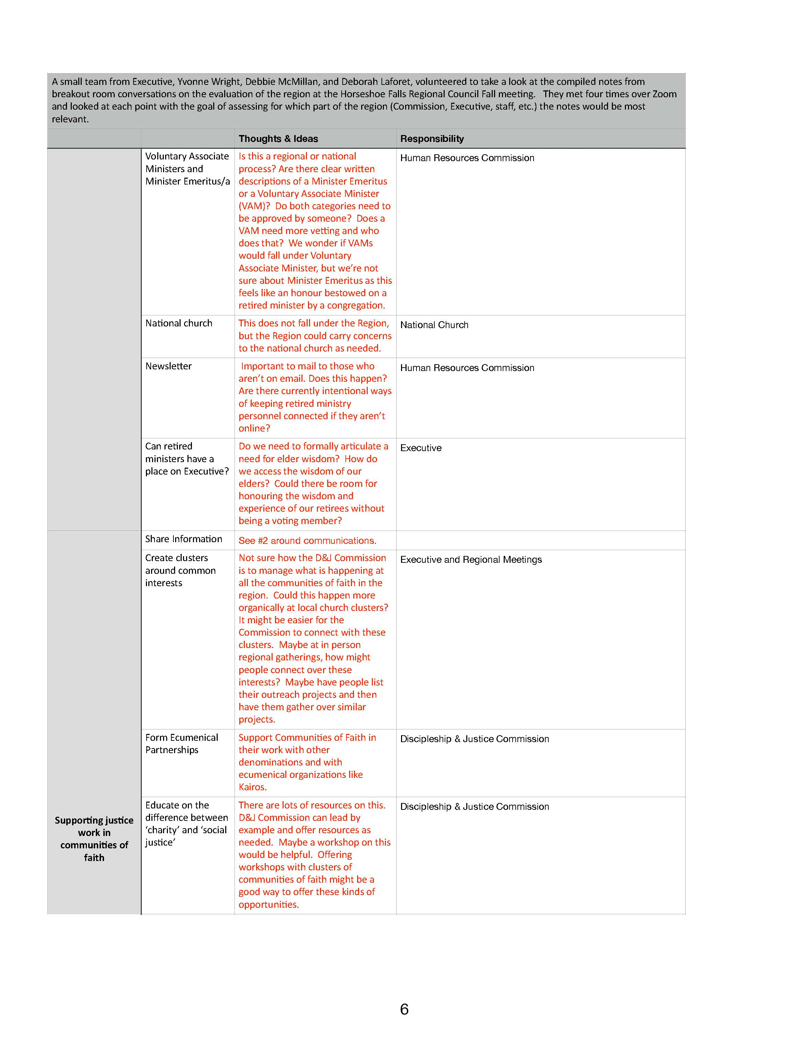

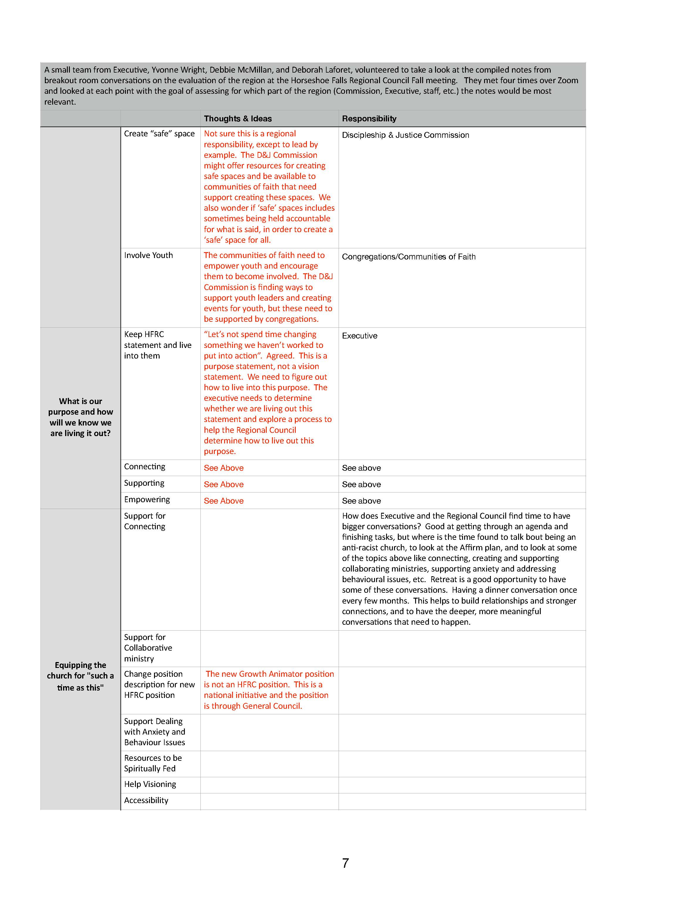

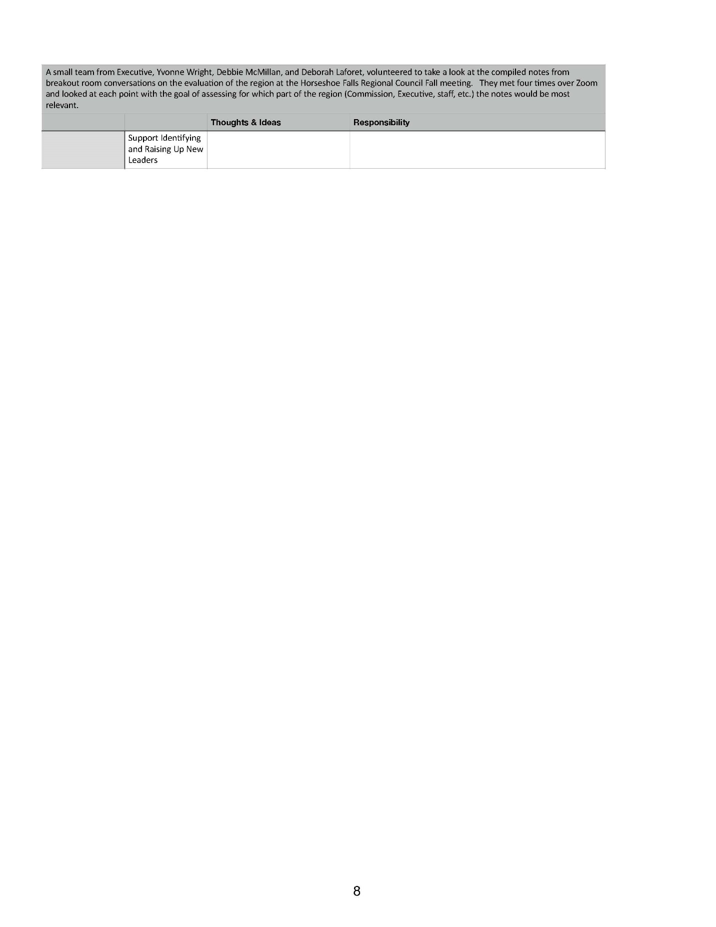

Remit Project Summary

The remit process is now over, passing nationally with 80% of pastoral charges giving their approval. Before the results were announced the Right Relations and Social Justice Minister (Thérèse Samuel) and the Social Justice Minister (John Egger) for the Regional Councils prepared the following report that offers our observations and reflections on the process. The remit was a significant focus for us this past year, and provided us with much contact with individuals and pastoral charges, stretching far beyond the remit itself. We would like to share a bit about what we learned in the process and our reflections on the racism and colonialism that was encountered in the conversations and our thoughts about future directions for this work in right relations and the broader work of anti-oppression and intercultural ministries.
In July of 2022, when the remit was authorized, Thérèse thought, “I know what my next year is going to be focussed on.” But didn’t know how true that would turn out to be.
When the remit question came out in March of 2023, Thérèse provided a presentation to the Discipleship and Justice Commissions (D&J) of ARW, HF and WOW, and all three expressed a commitment to supporting the remit discussion. Thérèse then worked with the Executive Minister (EM) to provide education and question and answer sessions at each of the RC Spring Meetings. Cathy Hird, a WOW Discipleship and Justice Commission (D&J) member, came forward and expressed a desire to encourage the pastoral charges to engage the discussion and vote. In the summer of 2023, the EM assigned John to work with Thérèse in the remit process. Thérèse and John met with Cathy to plan what would become the Remit Reach-Out.
During the next few months, as the remit project moved into high gear, John and Thérèse continued to provide leadership in promoting the remit, while receiving support and guidance from the EM (first Cheryl-Ann, then Mark, then Cheryl-Ann, then Mark again), as well as assistance from other tri-RC staff when needed. We supported Cathy throughout the reach-out process, and worked as a team to provide educational seminars and resources for pastoral charges, to respond to questions about the remit, and to support governing bodies in discussing the remit. For both John and Thérèse, the majority of our work until the end of March was devoted to the remit in one way of another. It took us both a while to realize how much time and energy the remit discussion was going to take, and we also quickly realized that many of the benefits of this work were going to go beyond the remit itself.
We discovered very early on that there is much more to this than was at first apparent. Questions were complex. Some were simply seeking understanding about the remit and its implications, but stirring in the background there were numerous other dynamics, including:
  - Troubled relationships with the wider church, polity and past remits, and dissatisfaction with the remit process itself
  - Settler colonialism and racism that are embedded in our church and society and were the basis of what was historically known as “missions to the Indians”
  - Concerns about the viability (financial and otherwise) of local congregations and the broader United Church
  - Layers of grief and uncertainty as the church comes to terms with the harmful impacts of colonialism on Indigenous communities, and as many congregations deal with losses in their own contexts.
We also found that while the remit was about a specific set of changes to The Manual, it was also about the breadth of our relationships as Indigenous and Non-Indigenous in The United Church of Canada. These complexities often made it challenging to discern the concerns embedded in questions and to respond to them meaningfully.
We also began to realize that, whether or not the remit was to pass, there would be positive benefits of the remit discussion, including:
- As the church is learning to live into a structure which is still very new, the Remit Reach-Out engagement gave an opportunity for volunteers from across the regional councils to make contacts with leaders in almost all of the pastoral charges
- As the Discipleship and Justice Commissions continue to learn to live into their roles and mandates, through the Remit Reach-Out they have actively initiated contacts with congregations
- Governing bodies and congregations across our regional councils engaged in discussion on right relations in a way that likely would not otherwise have happened and in so doing engaged in relationship as an Indigenous and Non-Indigenous church in a new way
- People in Non-Indigenous congregations across the regional councils grew in their awareness of the Indigenous church within the United Church
- Connections were made between regional councils across the country as we shared and supported one another in our remit promotion activities; this collaboration continues with other portfolios
- John and Thérèse as staff are better equipped to support the regions in a broad range of justice and right relations ministries

Remit Project Components
Presentations:
- 3 RC D&J presentations (TS)
- 6 RC presentations (TS: 3 in team with the EM and 3 in team with JE)
- 4 public presentations (TS&JE: 3 hybrid, 1 online only)
- 1 Outreach Group (TS with Lee Claus)
- At least 4 online visits with PCs in fall and winter (TS&JE)
Resources Created:
- 1 video compilation including Revs. Maggie Dieter and Cathy Hird, and CCDC Martha Pedoniquotte, and a power-point presentation (TS)
- 1 Responses to Questions document (TS&JE with consultation of staff of GCO, IMJ and Indigenous OV)
Numerous consultations with other UCC staff, especially
- Sara Stratton (Reconciliation and Indigenous Justice Animator, Indigenous Ministries and Justice)
- Adele Halliday (Antiracism and Equity Lead, General Council)
- Alison Jordan (Law Clerk, General Council)
- Executive Minister
Remit Reach-Out:
- July- Aug Development of initial process in consultation with Kathy Douglas
  - Worked with Cathy as she determined parameters of Reach-out
    - Confidentiality and scope of the role of contact people
    - Putting in place RC Team Leaders from the D&J Commissions
    - Planning orientation for callers
  - Accessing and compiling contact lists for 400 PCs in 3 RCs
- Sept Training for Callers
  - Team with Cathy to lead orientation/training for callers
- Received lists of those who had not voted.
  - Initially we had to ask GC for the lists, and by January GC automatically sent out the list every 2 weeks. These were relayed to Cathy.
- Available for follow-up,
  - questions or concerns that callers or team leaders had
  - questions relayed from callers
Receiving questions about or in response to Remit 1, consulting, researching and formulating responses, referring when appropriate, on varied topics including:
- Logistics of the remit—COF ID and M&S number, where to get ballots, etc.
- Questions directly relating to the remit question
- Questions related to Indigenous Ministries that were beyond the scope of the remit
- Questions, concerns and/or dissatisfaction with the remit process itself:
  - ties in with concerns about the previous remits
  - the polity governing remits—why abstentions are not permitted, why changes cannot be made to the question itself, etc.
- Clarifying and responding to questions related to polity and procedures in specific situations:
  - about amalgamating and disbanding PC votes
  - Reconsidering a previously registered vote
Broader work:
- Consulting with GCO and IMJ staff in our communication materials and responses to questions
- Receiving referrals of questions/concerns from GCO and IMJ staff to follow up on some of the more complex questions from PCs in our RCs
- Meetings with GCO, and RC staff in other regions
- Working with Michele and Pretima on communications in Website, Newsletters and social media

Reflections
Remit 1 was asking the wider church to allow the Indigenous church to self-determine its internal organizational structure and procedures within The United Church of Canada, and to authorize changes to The Manual that would allow that. But there were assumptions underlying that question that brought specific challenges to many people in congregations.
The remit was not asking for a new structure that would require new funding—the funding and mechanisms for funding the Indigenous church, as well as processes for reviewing how funding is allocated, are already in place and not under question in the remit. It also relied on the wider church trusting the General Council and Indigenous leaders in the church to continue to negotiate that funding. The remit was not asking the church to endorse the Caretakers’ Calls to the Church—not officially. That was already endorsed by General Council in 2018, and the remit relied on the Caretakers’ Calls as a foundational document. But for many in pastoral charges The Calls to the Church was a new document, and to consider the remit required understanding and endorsement of The Calls to the Church. The remit was on the surface about specific and limited changes to The Manual, but on a deeper level it was about entering into relationship in a new way as an Indigenous and Non-Indigenous church.
On the surface, it was a simple and straightforward question. But we gradually realized that for many in the church it was asking something more, something unspoken, something they couldn’t quite put their finger on. In recent years there has been much movement happening in Indigenous Ministries and Justice and the NIC and in the evolving relationship between IMJ, NIC and the General Council that most people in congregations are not aware of. The remit directly addressed one specific part of that dynamic—internal organizational structure and procedures. In the beginning it seemed that many people did not understand what they were voting on when it came to the remit question. As we engaged, it became apparent that the remit question and remit process itself did not acknowledge the work that individuals and congregations would be required to do in order to meaningfully discuss and vote on the remit. Most of our engagement on the remit was in addressing these matters that the remit was not directly asking, but that were foundational to the remit question and the remit process itself. And these matters are foundational to our commitments to right relations as Indigenous and Non-Indigenous peoples, and our commitments to trust in God, grow in faith together as disciples of Christ, and to allow the Spirit to work in us and one another.
The irony of the Remit 1 process was that it required the church to follow a settler colonial remit process to loosen our hold on that same settler colonial remit process. It was, in a sense, a remit about remits and as such it drew the church’s focus to the remit process in a way that no other remit has (at least, that we are aware of). On the surface it was a simple matter of business and of justice. But deeper down it was asking the church to learn and grow and engage very deeply in a short period of time. Across the tri-regions of ARW, HF and WOW, pastoral charges and individuals took up the challenge and lived into our shared faith. They engaged in what were often risky and difficult conversations in ways that surprised us, that challenged us and that inspired us. We come to the end of the remit process exhausted, but full of hope.

Thérèse’s and John’s further reflections include:
- On the surface, the remit was about a specific and limited change to our polity and institutional structure. But at its core, the remit was about relationship.
- Observations about underlying but unnamed racist and colonialist assumptions
- The impact of questions within the context of colonialism and racism
- Awareness that people were at vastly different places with the conversation.
- Our engagement in the remit-related dialogue had personal impacts on each of us
- The benefits and necessity of teaming in this work
- We felt it was important to offer the education as non-Indigenous people, and to not burden Indigenous leaders with doing this work for us.
- We noticed a difference between answering questions in a workshop (participants invited into a space where planned the process) and in a meeting of the pastoral charge governing body where we had been invited into their space to answer questions.

We noticed… we wonder…
- We noticed that sometimes people expressed opposition to the remit because of dissatisfaction with the process, and we also noticed that the remit was asking the church to loosen its grip on the remit process and to loosen its grip on the colonial power that is vested in the remit process.
We wonder what the church would learn if we had some deep discussions about our polity and the remit process and made space to intentionally listen to all voices, especially the voices of people who feel dissatisfied, disregarded, or silenced by the process.

- We noticed that the remit question brought all kinds of people into the conversation. People with diverse experiences and perspectives entered into conversations in varying degrees—some engaged deeply, some less so.
We wonder, is that engagement a momentary thing? Now that the remit process has closed, is the engagement done and gone? Or will it lead to further engagement in the coming months and years?
Theological Reflection
As we prepare this report, the results of the remit have not yet been revealed. And we are reminded of Moses and the Israelites who journey together. The people may be of different minds and have different expectations. The journey is challenging, but whether the people are pleased or dissatisfied, the journey continues. As it was for Moses and the people, in many ways so, too, is it for us. Many of the changes that were debated in the discussions on the remit are changes that will happen whether the remit passes or not. The journey continues, whether we want it to or not. We have fears, but the journey continues. We are engaged in a project that is bigger than this moment. We are called to trust and be part of the bigger movement not just for ourselves, but for the generations to come. Very likely we, like Moses, will never quite make it to the promised land, but if we remain faithful on the path - not perfect, but faithful - we will find that God gives us a glimpse of it. And through it all, the important thing is that we are in relationship. Relationship with one another. Relationship with God. And even when we falter, even when our actions are not as grand as our intentions, God does not stop guiding us, forgiving us, loving us.

The Remit 1 conversation is over but, as we noted at the beginning, there will be many more conversations ahead. Let us continue to trust that wherever the future takes us, we are not alone. God is with us.

Thanks be to God.

Remit Reach-Out Volunteer Leaders Report

As project coordinator of the Remit Reach Out process, I (Cathy Hird) with Sula Kosacky and Richard Auckland offer this report as a companion to the staff report of Thérése Samuel and John Egger. Their report focusses on the wider implications of the remit process and on the work they did. We will not repeat their work, though I will quote from it. We are submitting this report to pave the way for future remits, to inform the work of the regional councils, and to reflection on the on-going work of building right relations. The focus here is on the practicalities of the process in the three regions. This report is prepared before the results of the remit have been made public.

In early March 2023, the Discipleship and Justice Commission (D&J) of WOWRC heard Thérèse’s initial report on Remit 1, Establishing an Autonomous National Indigenous Organization within The United Church of Canada. I reacted with deep concern, as did other members of all three commissions, because getting a category three remit passed is hard work. Many have failed. At the time I felt that it was essential that we get this remit through. (Later, while I still hoped it would pass, I understood that communities of faith had engaged in the conversation about right relations in a way that would in and of itself make a difference.)

There is a history of right relations work in our church. Most people are aware of the two apologies and the fact that there was an indigenous conference, the ANCC and the existence of the Healing Fund. Many communities of faith and especially UCWs made raising money for that fund a focus. Other aspects of this journey—from the “native consultations” in the 80’s to the Caretakers Calls to the Church—are not as well known. It was important to provide pastoral charges with background that could inform their conversation and their vote. Some of this was prepared by our tri-region staff—see the report of Thérèse and John—some was prepared by national staff, and other video resources were offered by indigenous individuals and groups within the church.

Recognizing that many pastoral charges are without a settled minister and that many do not have a regional council representative, we knew that some pastoral charges would not hear about the remit and others would not know where to find resources. The idea of having volunteers contact every pastoral charge surfaced. While this would be a major task, it felt essential.

Volunteers were recruited by the chairs of the D&J commissions in ARWRC and HFRC and by Cathy Hird for WOWRC. Some of these were members of the commission. Others were people that the recruiters felt would care enough to engage in this work for eight months. Recruitment happened in August and September. More than thirty people stepped forward and made this commitment.

An online orientation to the work was offered in September. This was held on Zoom and recorded. Volunteers were not given contact information until they had attended or viewed the orientation. While background information was included, there were two specific points: 1, the role was to encourage pastoral charges to engage in the conversation and to vote, not to press for a specific vote and 2, the contact information for people in the pastoral charge was confidential, to be used only for this process.

Thanks to the work of John Neff, we received four lists with contact information: pastoral charges, pastoral charge roles (i.e., regional council reps, board chairs, board secretaries), ministers, and pastoral charge supervisors. While some of this information was up to date, much was not. This required volunteers to use ingenuity and time to reach these pastoral charges. (The fact that national lists are not up to date is an issue which needs to be considered—the shift to online processes requires congregational initiative and computer skills not everyone has.)

Each of the team leads (Sula, Richard, and Cathy) then divided the list between their volunteers providing all the contact information. A letter was drafted for the volunteers to use providing background on the remit and links to the regional council websites for educational information. The letter requested a reply and gave notice that if there was no reply, a phone call would follow. The volunteers were encouraged to pass questions on to John, Thérése, and Cathy. This was to help keep the volunteers focused on process and to ensure that questions that surfaced racism and settler colonialism were addressed carefully and appropriately. To quote the report from Thérèse and John, “We also found that while the remit was about a specific set of changes to The Manual, it was also about the breadth of our relationships as Indigenous and Non-Indigenous in The United Church of Canada. These complexities often made it challenging to discern the concerns embedded in questions and to respond to them meaningfully.”
Through the fall, the volunteers emailed, followed up by email, followed up with phone calls and/or personal contacts to make sure that the remit remained on the agenda of pastoral charges. A few had voted in the late spring. A few voted in the fall. Many did not vote until February and March.
Once we received lists of who had not yet voted, the team leads distributed this information to the volunteers. Volunteers then knew who to contact again. The way the lists came to us, we again required the assistance of staff devoted to congregational support to identify which “First United” or “Trinity United” had not yet voted. On the other hand, we could now provide pastoral charges with the numbers they needed to put on their remit vote reporting form.
Once we received lists of who had not yet voted, our volunteers also discovered that some pastoral charges that had voted were still on the list. After consultation with Alison Jordan at the national office, pastoral charges were strongly encouraged to take a photo of the ballot once filled out and email it. The process of resubmitting ballots was frustrating. For future remits, the process of receiving ballots needs to be better managed. As far as we know, however, all votes from our three regions were eventually registered. Volunteers who had started this work in September had to keep alert right through March and Holy Week. While the final stats of how many pastoral charges voted have not yet come out, as a whole, our three regions were well over the national average.
In the evaluation of the regional councils, recommendation 11 suggested that we “determine how the Discipleship and Justice Commission(s) might support the discipleship and justice work in communities of faith and the commitments of the regional council.” While the commissions need to figure out ways to do this going forward, during late 2023 and early 2024, the commissions and additional volunteers helped engage communities of faith in the work of right relations.
A virtual follow-up and feedback meeting is planned for late April. This is an opportunity to thank our volunteers, to learn from them what we could have done better, and to check that folks are okay. Some of the conversations were difficult, and it is important to give people space to debrief.

Additional Concerns
Noted above was the challenge of contact information that was out of date. This is not the place to speculate on why that is so only to note that if regional councils are to engage more closely with communities of faith, this information is crucial.
There were pastoral charges that we were unable to reach. Consultation with the congregational support ministers helped reach some. The Remit Reach-out team will share with those staff who remained unreachable.
Cathy met virtually with a community of faith that is not a pastoral charge. This is a funded and accountable outreach ministry. They wondered why they did not get a vote. This is a good question. As we learn about the remit process (again John and Thérèse raise these questions), is there an underlying assumption that needs to be examined about the place of communities of faith that are not pastoral charges.
There were many good conversations within pastoral charges reported to us by the volunteers. There were complicated conversations with racist and colonial settler overtones. These were difficult at times.
This was a complicated process. A lot of issues were surfaced. I would like to quote Thérèse and John’s report again to make sure that our shared concerns are not missed. They wrote:
We discovered very early on that there is much more to this than was at first apparent. Questions were complex. Some were simply seeking understanding about the remit and its implications, but stirring in the background there were numerous other dynamics, including:
  - Troubled relationships with the wider church, polity and past remits, and dissatisfaction with the remit process itself
  - Settler colonialism and racism that are embedded in our church and society and were the basis of what was historically known as “missions to the Indians”
  - Concerns about the viability (financial and otherwise) of local congregations and the broader United Church
  - Layers of grief and uncertainty as the church comes to terms with the harmful impacts of colonialism on Indigenous communities, and as many congregations deal with losses in their own contexts.
It is important to recognize that while this past twelve months was an important step in building right relations, the conversation and the work are not finished. The dialogue between indigenous and non-indigenous people in our church must continue whether the remit passes or fails.

Submitted by Cathy Hird with Richard Auckland and Sula Kosacky

Office of Vocation – Vocational Minister Update
It is my privilege as the Vocational Minister for the three regions in SW Ontario to provide a report on the work of the Office of Vocation for the past year. I continue to have many conversations with ministers involving the vocational realm: Excitement for a new call or appointment; helping discern “if it’s time for a change”; the stressors and joys of service; and general wide-ranging ministry topics. This report will touch on some elements of this role and you can find the full Office of Vocation Accountability Report to the Board of Vocation in the United Church Commons.

Who Are We?

 |  |  |  | % Compared to National Average per Category
 |  |  |  | (it is not % status distribution within region)
Minister Status @ May 8, 2024 | National Distribution of Status by Type |  | Antler River Watershed |  | Western Ontario Waterways |  | Horseshoe Falls |  | Tri-Regional Councils
Active | 1806 | 43.7% | 88 | 4.9% | 118 | 6.5% | 124 | 6.9% | 330 | 18.3%
Admissions | 81 | 2.0% | 1 | 1.2% | 0 | 0.0% | 1 | 1.2% | 2 | 2.5%
Long Term Disability | 62 | 1.5% | 7 | 11.3% | 6 | 9.7% | 4 | 6.5% | 17 | 27.4%
Ministry Partner | 14 | 0.3% | 3 | 21.4% | 0 | 0.0% | 0 | 0.0% | 3 | 21.4%
Non-UCC | 10 | 0.2% | 2 | 20.0% | 2 | 20.0% | 1 | 10.0% | 5 | 50.0%
Restorative Care | 36 | 0.9% | 1 | 2.8% | 3 | 8.3% | 3 | 8.3% | 7 | 19.4%
Retired | 2128 | 51.4% | 113 | 5.3% | 172 | 8.1% | 175 | 8.2% | 460 | 21.6%
Totals | 4137 | 100.0% | 215 | 5.2% | 301 | 7.3% | 308 | 7.4% | 824 | 19.9%

Candidacy Pathway
At the end of December 2023, there were 193 candidates for ministry in Candidacy Pathway, guided by the 7 Candidacy Boards and resourced by Vocational Ministers. The SW Ontario Candidacy Board has been meeting entirely online for the past year and engages with other Candidacy Boards in regular gatherings hosted by the General Council Office to “tend to the pathway” as needs arise and to share and receive best practices. There has been a recent update to the role of the Community of Faith Connection team, and in October 2022 the new Guide to Competencies for Ministry and Lifelong Ministry Leadership was implemented.
The SW Ontario Candidacy Board currently has 25 candidates in various phases of the Pathway (plus 1 to be Commissioned and 3 to be Ordained on May 25, 2024) with more applicants to be interviewed for Suitability for Ministry throughout 2024.:
3 in the Designated Lay Ministry Program at St. Andrew’s College, Saskatoon SK
6 in the Diaconal program at the Centre for Christian Studies, Winnipeg MB 15 in Ordained programs:
6 Emmanuel College, Toronto ON
7 Atlantic School of Theology – Summer Distance Integrated, Halifax NS
2 Vancouver School of Theology
Many candidates are in ministry-based integrated programs requiring Supervised Ministry Education (SME) sites; similar to 2022, the 2023 calendar year had 15 active SME appointments at December 31, 2023 with 17 active as of May, 2024.
The SW Ontario Candidacy Board has partnered with the Indigenous Church to arrange a unique SME partnership experience with Grand River United Church, Six Nations of the Grand River. A non-Indigenous candidate is exploring and developing ministry leadership with a focus on the parallel path, while being mentored by an elder and a Grandmother’s Circle. It is proving to be full of learnings and deepened relationship.
A functioning SME site requires intensive investment and discernment by Communities of Faith (CoF), Regional staff, Regional Commissions, and Educational Supervisors. Together they do the critically important work of candidate formation. SME appointments are generally 24 months and during that time, candidates meet regularly with their Educational Supervisor and Community of Faith Connection Teams. Working collaboratively these three bodies perform evaluations, work on Learning Goals, offer theological reflections and identify and ensure opportunities for growth in the competencies of ministry.
The Regions support SME experiences and Candidate formation by offering initial discernment meetings with CoF leadership when a congregation wonders about engaging with the ministry of formation; providing financial support to candidates; appointing pastoral charge supervisors to an SME site; and, continuous pastoral relations support. In addition to the 17 candidates in SME appointments, there are 5 candidates in supply appointments not under supervision (diaconal; in 5th year of AST integrated program; or are about to complete 3rd year in non- integrated MDiv program and will interview for SME Readiness in 2024.)
The SW Ontario Candidacy Board is incredibly thankful for the more than 107 volunteers that facilitate Candidacy Pathway in our regions. (17x4 CFC + 22 Charge Supervisors + 17 Educational Supervisors – all volunteers - that make ensure that those in Candidacy Pathway become faithful, effective and well-equipped to serve the church.) God is good!
The Board is ably and well-served by its current membership:

Rev. Laurie O’Leary, Chairperson  Rev. Tessica Hackshaw Rev. Gerry Hofstetter  Rev. Mary Elizabeth Piercy  Rev. Gord Dunbar | Pastor Jenn Brown  Rev. Ann Stafford Rev. Wendy Noble  Nancy Hind, Recording Secretary

The SWON CB meets monthly on the third Thursday morning of each month and interviews 6x per year (the Thursday afternoon and Friday mornings of 6 different months in addition to their regular third-Thursday meetings).
Admissions (excerpted from the Office of Vocational Accountability Report)
The number of ministers in the Admission process reached 200 people in 2022. This led to a shortage of accompaniers meaning that ministers expressing interest in admission were told there were dozens of ministers ahead of them waiting to speak with someone about applying for the Admission process.
Most significantly, the Admission Board noted an alarming reality: when it came time to seek an admission appointment, the process was not functioning equitably for racialized ministers. Consequently, we entered 2023 with the Admission process paused. Throughout 2023, the focus of admission work has been on addressing these bottlenecks and inequities. The Admissions Pilot Matching Program began in 2023, and evaluation of the Admissions experience and various processes revealed two priorities:
- We need to help these ministers get their foot in the door. They have so many skills and gifts that The United Church of Canada has identified as needed in our strategic plan.
  - One fifth of them are people who have or are currently working on PhDs.
  - Almost all of them speak at least two languages, with many of their additional languages being those that newcomers to Canada also speak.
  - All of them bring diverse theological backgrounds and life experiences that can enrich our denomination. Many of them have specialized experience in ministry such as youth ministry, church planting, chaplaincy, and ecumenical work.

- We need to continue working with congregations to confront xenophobia and racism; as well as making sure that support for search teams are well informed of the Admission process and the benefits of considering an applicant from another country. While the myth exists in our denomination that we have a shortage of ministers, the reality is that we have more than 50 who are available. They simply need our search teams to recognize that they are highly qualified, experienced ministers who are keen and feeling to called to serve in The United Church of Canada.

Enhancing Effectiveness, Oversight and Discipline Of Ministry Personnel
(excerpted from the Office of Vocational Accountability Report)

This area represents a significant portion of the work of the Office of Vocation, and is managed by staff, elected members who sit on the response and remedial committees, along with consultants, reviewers and investigators. There was a training event held in person over 5 days for 39 Consultants, Investigators, Reviewers and Staff of the Office of Vocation in October, including the revisions made to the Sexual Misconduct and Workplace Discrimination, Harassment and Violence Response Policies & Procedures and Office of Vocation: Structure & Responsibilities, Appendix A.

Sabbatical and Strategic Plan
From September through November, 2023, I was on sabbatical with a project focused on analyzing the outcomes of the Response and Remedial committees, and identifying supports to ministry personnel to regain effectiveness. Response and Remedial are the bodies responsible for managing the Complaint Response process involving ministry personnel.
This project aligned with my role as Activity lead in the Strategic Plan; specifically, “Activity lead in 2.2.1 related to examining work done previously in effective leadership including regarding isolation.” My research involved reading the complete set of minutes of these two committees since inception and seeking to identify if isolation had a role in the precipitating action to the complaint. Between January 1, 2019 and January 31, 2024 (60 months) the Response Committee met 48 times and the Remedial Committee met 106 times. At September 7, 2023 Response had ordered 61 investigations or reviews (formal process) of ministry personnel.
The roles of Vocational Minister, Pastoral Relations Minister or Community Capacity Development Coordinator, and others involved in this work are also consistently engaged in informal processes. This data set had the possibility of expansion to analyze and provide learnings related to ministry effectiveness and isolation that are not captured in the formal process. I asked the Vocational Ministers to tally up their informal situations that met the following criteria:
- You have had concerns about minister’s performance brought to you by the Pastoral Relations Minister or M&P or other body that has knowledge (perhaps a fellow ministry colleague or yourself); and,
- Does not fit into our formal complaint process; and,
- You have had at least 2 long conversations about the concerns directly with the minister that includes areas of growth or development for them; and,
- The PRM or Executive Minister or M&P or Regional Staff/Commissions (or combination of same/similar) is also party to various conversations/concerns about this person’s ministry; and,
- You suspect that they are isolated, lonely, do not have collegial support in their role, or do not engage in wider church or regional events. You might also colloquially call some of these ministers “Lone Wolves.”
At September 30, 2023 an additional 119 ministers since 2019 were identified that might qualify for consideration of the focus of this project. From the Board of Vocation Accountability Report, “the themes arising in the remedial work are
- emotional intelligence (self-awareness and relationship management)
- boundaries power dynamics
- awareness of polity and procedures
- isolation in ministry practice
- relationships with persons served
- concerns related to social media use.
Newer themes emerging relate to understanding of, and compliance with, oversight responsibilities; those in long-term pastoral relationships, and those who have not utilized their full study leave, vacation and sabbatical opportunities. The Remedial Committee is hoping to seek out additional resources for Directed Programs, particularly learning what other denominations find effective in similar remedial matters, in 2024.”
There have been many instances in the Remedial process where developing conflict resolution skills, attending emotional intelligence workshops and working with an executive coach or Spiritual Director on specific goals,
and mentorship by United Church ministry colleagues have been very successful components in directed learning programs.
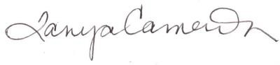
Respectfully submitted,

Tanya Cameron, MBA Vocational Minister
Antler River Watershed, Western Ontario Waterways and Horseshoe Falls Regions

United Church Rural Ministry Network

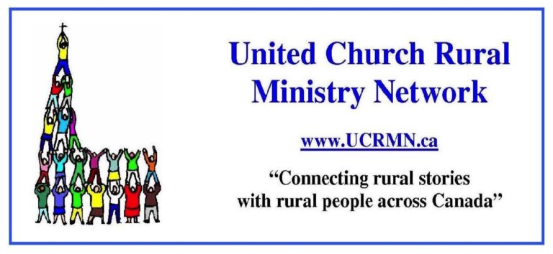
2024 UPDATE FOR ANNUAL MEETINGS OF REGIONAL COUNCILS
The United Church Rural Ministry Network (UCRMN) is a national network, that connects electronically sharing stories and news of rural communities across Canada (and around the world), by networking with lay and clergy leaders of rural communities of faith. Find us on website ucrmn.ca.
Let me walk with you through some of the resources on the UCRMN website. Peter Chynoweth (Cochrane, AB) is the web minder. The ‘Network’ connection includes a partner Atlantic Canada network called Rural Roots Through the Holy which has sponsored conferences in the Maritimes for 3 years. In the Prairies is highlighted the ecumenical Centre for Rural Community Leadership and Ministry (CiRCLe M) which has connections to Saskatoon Theological Union. CiRCLe M is hosting a conference, Experiencing the Rural Culture of the Alberta Foothills, June 18-21.
Then there are ‘Resources’. I would like to recommend to all ‘Tech Resources’. Martin Dawson, from Cornwall, PEI, and web minder Peter Chynoweth write thoughtfully, with humour and matters of ethical consideration of computers. They discuss the use of inexpensive software, like the free Jitsi meet instead of Zoom, refurbishing old and tired computers using open source software – in short, ‘tech for scarce budgets’ with an eye to keeping our tech out of landfills.
Next comes practical and helpful information on Collaborative Ministry, ways for congregations and communities of faith to work in partnership with others.
Then there are interviews that Martin hosts: With Peter on Open Software as an Ethical Alternative; with George Bott on Rural Connect; with Catherine Smith on her views of rural ministry and initiatives in the Maritimes; with Catherine Christie and Eric Skillings on the founding and workings of UCRMN. (These interviews are also found on Short-Wave Radio stations, a huge love of Martin’s)
The next area is Workshops, with information about the quarterly Zoom workshops that UCRMN has hosted through the years. During this Regional Council year, 2023-24, workshops have been: on April 18 - Social Media in the Rural Church, facilitated by United Church Digital Team, Cara Czech, Stephen Fetter and Aaron Gallogos; Feb. 15 – Life Long Learning facilitated by St. Andrew’s College staff, Dr. Bernon Lee and Shawn Sanford Beck; Nov. 16 – Pastoral Care to the Rural Church, led by Kathy Douglas of Antler River Watershed; Sept. 21 – further discussions on Collaborative Ministry; June 22 - Radically Welcoming and Rural, the opportunities of Diversity in the Rural Church.
Then there is ENews, with an archive of all the past ENews, from 2020 to 2024. We print 9 editions of UCRMN ENews during the year. Events happening throughout the Church are publicized, advertising from Regions and committees, the regular column on Tech Advice, a regular column from Joyce Sasse’s Gleanings of a Prairie Pastor, reports from Conferences, and most importantly, stories from congregations of community action and ministries. We love to have stories shared. If you have something to tell, send an article (about 300 to 500 words) to editor@UCRMN.ca.
There are over 400 members of UCRMN across the country and in most Regional Councils. As a Network, UCRMN asks for financial support from each Regional Council. We thank those who have given support from their Networking funds. Our suggestion is $300 from each RC - UCRMN wishes to support all the Regional Councils in their rural ministries. (70% of United Church congregations across the country are in rural or small towns, therefore a relevant cost to each Regional Council.)
UCRMN members are taking part in the “Rural Townhall” by Edge Network for Ministry Development, to hear peoples’ thoughts about what is going on in rural churches, and how rural ministries can be supported.
We are a grassroots initiative for Rural Ministry in the United Church of Canada. Our goal is to connect the many Rural Ministry initiatives across Canada.

Respectfully submitted by UCRMN Board:
Catherine Christie, President UCRMN, Abbey, SK, Living Skies RC
Eric Skillings, Secretary/Treasurer UCRMN, Merlin, ON, Antler River Watershed RC
Shelley Roberts, Vice President UCRMN, Lanark ON, Eastern Ontario Outaouais RC
Donna Mann, Officer UCRMN, Elora ON, Western Ontario Waterways RC
Yvonne Terry, Officer UCRMN, Milestone SK, Living Skies RC

Emmanuel College 2024 Update to Regional Councils

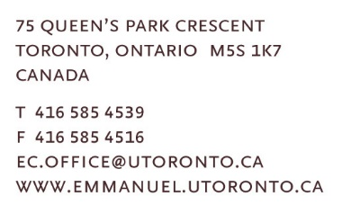

Spring 2024

Dear Friends:

On behalf of Emmanuel College, I want to bring greetings to your region as you meet this spring season. I pray that your meeting goes well and that you experience God’s presence and blessing in this important work of the church. My name is HyeRan Kim-Cragg and it is my privilege to bring you greetings as Emmanuel’s Principal. I hope to see you in person in the near future and share good news of Emmanuel College with you and hear good news of this region’s wonderful ministry.

Faculty Compliment, Trauma Informed Pedagogy & Faculty on the Road
Last year, we completed three significant faculty searches, marking historical milestones for the Toronto School of Theology (TST) of which we are a part. Rev. Dr. Glenn McCullough joined as assistant professor through a partnership with Knox, a first in TST's history. Dr. Jenny Bright became Emmanuel's first assistant professor of Buddhist Spiritual Care and Counseling. The Right Rev. Dr. Carmen Lansdowne will be appointed as the first assistant professor of United Church of Canada studies at Emmanuel after completing her moderator's role in December 2025. Additionally, Néstor Medina was promoted to associate professor, and Pam McCarroll to full professor, holding the Jane and Geoffrey Martin Chair in Practical Theology.

This academic year, the faculty has engaged training in Trauma Informed Pedagogy (TIP), with monthly discussions involving faculty, staff, and Research Fellows. TIP emerged from student discussions in response to our EDIA stance, “DEAR” (Dignity, Equity Accountability, Responsibility) Declaration, and has been supported by grants from the Wabash Center and the Association of Theological Schools. We plan to host a TST-wide conference in May 2024 to share our insights and impact other theological schools.

The current faculty is keen to go out into different communities of faith to promote Emmanuel and share their scholarship and wisdom. Andrew Aitchison as Admissions Counsellor and Recruitment Coordinator will be a liaison connecting faculty with communities. Please let him know if your communities want to invite our Christian, Muslim or Buddhist faculty. That would be so wonderful.

The Indigenous Healing Garden Project
This project, which aligns beautifully with Victoria University’s sustainability strategic framework and Emmanuel’s commitment to right relations with Indigenous communities, is currently underway, thanks to an initial grant from the United Church Foundation’s Seeds of Hope. Brook McKllroy, the architectural firm, has been commissioned to redesign the courtyard which features the Crucified Woman Sculpture. The proposed designs have received approval from the project's advisory committee in collaboration with the Indigenous Elder circle. We aim to begin construction this summer and anticipate project completion by 2025, as part of the UCC Centennial celebration.

Major Celebrations at Emmanuel College
In the next few years, there are several significant anniversaries we're eagerly looking forward to celebrating! Firstly, in 2024-2025 we'll be commemorating three remarkable milestones: the 10th anniversary of the Buddhist Focus in our Master of Pastoral Studies (MPS) program, the 15th anniversary of the Muslim Focus in the MPS program, and the grand 100th Anniversary of the United Church of Canada. In 2025-26 we will celebrate 30 years of the Committee on Asian/North American Asian Theologies (CANAAT). Then fast forward to 2027-2028, which promises to be another monumental period, marking the 20th anniversary of the Master of Sacred Music Program and the 100th anniversary of Emmanuel College itself. Stay tuned for more information about these celebrations to come.
I envision our celebrations will incorporate multiple fundraising opportunities to establish scholarships, enriching our offerings and supporting marginalized students. Notable progress has already been made in securing scholarships. We proudly unveiled our first named scholarship for Buddhist students in February 2024. Efforts are underway to establish a Korean Scholarship, with an inaugural fundraising dinner held this past fall, and another planned as a music concert commemorating the 100th birth year of the Right Rev. Dr. Sang Chul Lee on October 26, 2024, at Willowdale Emmanuel United Church. Additionally, a special fundraising event is in the works to establish a scholarship for Queer students, scheduled for November 2 for Drag Show paid event, in collaboration with the Drag and Spirituality Summit, to be held at Emmanuel November 1 to 3, 2024.

Hybrid Master of Divinity Program
Our Hybrid Master of Divinity (MDiv) program began this past year which allows for 2 years of a 3-year MDiv can be done online. We hope this will reach more prospective students outside of the Greater Toronto Area. Read this story about two folks who began the Hybrid MDiv this year.

Multi-faith Spiritual Life
Spiritual and religious activities thrive, in person every week, Tuesday and Wednesday. These sessions are led by Buddhist faculty members, guest religious leaders and our dedicated student Spiritual Life Team (SLT), along with students from Christian worship/preaching and Buddhist ritual courses. This SLT is enrolled in a year-long course for credit called "Worship and Ritual Leadership Practicum." Our Wednesday Spiritual Life Gathering continues to be the heartbeat of our week and alternates between Christian Worship and a Multi-faith Gathering. These gatherings are streamed live on YouTube and are open to the public and all are welcome!

Faith Community Partnerships
Over the past year and a half, we've been fortunate to receive community lunch sponsorships from various Christian, Muslim, and Buddhist faith communities. They've joined us at Emmanuel to share food, stories, and teachings about their faith traditions while learning from our students about their interfaith experiences. Addressing food insecurity is crucial today, and providing meals to our students in this manner has been a great blessing. If your church is interested in partnering with Emmanuel, please be in touch!
Financial Support
Emmanuel College continues to provide significant financial support to students. Through the John W. Billes Fund, Emmanuel continues to provide 100% of tuition coverage to all domestic students who are registered full-time in the M.Div. program and who are engaged in The United Church of Canada’s candidacy pathway process. All basic degree domestic full-time students are eligible for our Entering Theological Education grant, which offers 50% tuition coverage to their first year courses. We also offer all (domestic and international) students who are registered in the Ph. D. program, 100% tuition coverage for four years. For more information about studying at Emmanuel College and about the financial support available for all Emmanuel programs, whether one is studying full-time or part-time, please contact Andrew Aitchison, emmanuel.admissions@utoronto.ca.

Emmanuel is offering an increasing number of Continuing Education events online. These events are offered through the Centre for Religion and Its Contexts (CRIC). A list of upcoming offerings are found on the Emmanuel College website. For further information about these events please contact Shawn Kazubowski-Houston: ec.events@utoronto.ca.

Please follow us on social media:
Facebook: @EmmanuelCollegeofVic
Instagram: @emmanuelcollegetoronto
YouTube: @EmmanuelCollege1

If you have questions or are seeking further information about Emmanuel College, please be in touch with us or explore Emmanuel: http://bit.ly/exploremmanuel.

Yours sincerely,
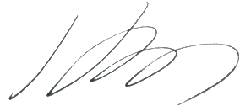

Rev. Dr. HyeRan Kim-Cragg,
Principal
Timothy Eaton Memorial Church Professor of Preaching
Emmanuel College

