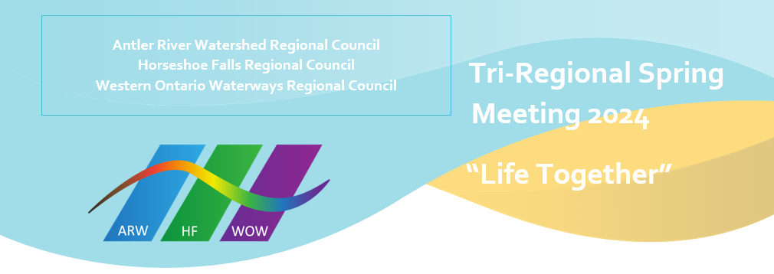
Previously been recognized as Designated Lay Ministers that have met the requirements of our church to enter the order of ministry

Antler River Watershed Regional Council
Marilyn Arthur DM
Pat Morrison OM
Michael Shewburg OM
Eric Skillings OM
Pam Wilcox OM
Karen Willis OM

Horseshoe Falls Regional Council
Jen Auger DM
Dawn Ballantyne OM
Kim Belanger DM
Sue Cowan OM
Barbara Creelman OM
Maureen Ellison OM
Wendy Lowden OM
Carolyn Smith OM
Diane Viney OM

Western Ontario Waterways Regional Council
Doug Brown OM
Andrew Hyde OM
Marianne Leach Hoffer OM
Paul Vollick DM
Judy Zarubick OM

