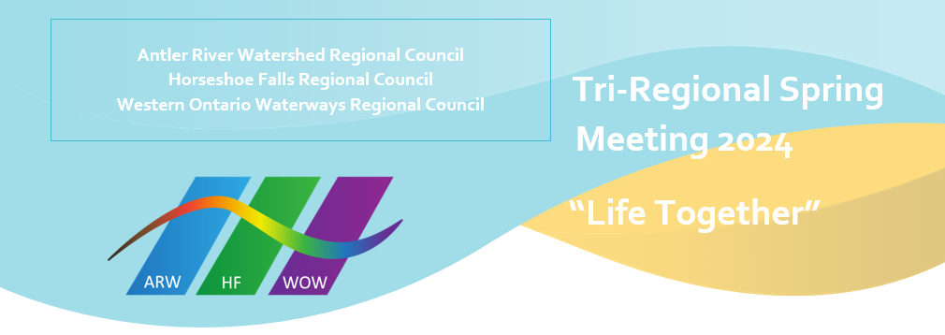
It is my absolute delight to extend welcome to all who will join us either in-person or online over the weekend of May 24-26 at the Unifor Family Education Centre, Port Elgin, for this very important Tri-Regional Council Meeting. From the Book of Psalms, A Song of Ascents, of David, the writer echoes the words of delight in 133:1, “Behold, how good and how pleasant it is for brothers and sisters to live together in unity! Our coming together to transact the business of the Horseshoe Falls Regional Council, to engage and fellowship with believers from the Antler River Watershed and Western Ontario Waterways regional councils are all clear signs of a slice of “Life Together”. The Moderator, The Right Rev. Dr. Carmen Lansdowne, will be keynote speaker on Friday May 24th, lifting up the theme: Life Together. Rev. Mark Laird, in his new capacity as Executive Minister, will form part of the critical leadership over the weekend to ensure the seamless movement of the business of the tri-region.
I am also excited that a number of persons have expressed interest to serve on the respective Commissions, as General Council 45 Commissioners, on the HFRC executive, and as President-Elect. These are wonderful signs of the movement of the spirit and testimony of the flourishing to which we all are directed. Nelson Mandela’s poignant words ring true, "It always seems impossible until it's done."
What’s being done for the first time is an executive approved regional Day of Fellowship to be held at Wellington Square United Church, Burlington on June 8th. This event is intended to bring together the entire Horseshoe Falls Regional Council in a day of celebration, praise, worship and fellowship. The world renowned Toronto Mass Choir will be in attendance and their music is just absolutely fantastic. The keynote speaker for the service will be Rev. Alexa Gilmore and the General Secretary, Rev. Michael Blair will officially launch United Church 100 in our regional council. What a great way to move into United Church 100!
As an executive, it is our aim to foster re-connection and encourage fellowship towards flourishing. With the words of Rosa Parks, "To bring about change, you must not be afraid to take the first step. We will fail when we fail to try", it is our hope that there can be a change of the old presbytery mindset to the emerging regional pathway of renewal and transformation. If your community of faith is yet to appoint a Regional Representative, perhaps now is the time to do that.
Looking forward to meeting you all!
Blessings!
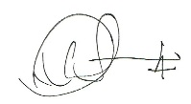
Lennox Scarlett

