UNITED CHURCH RURAL MINISTRY NETWORK
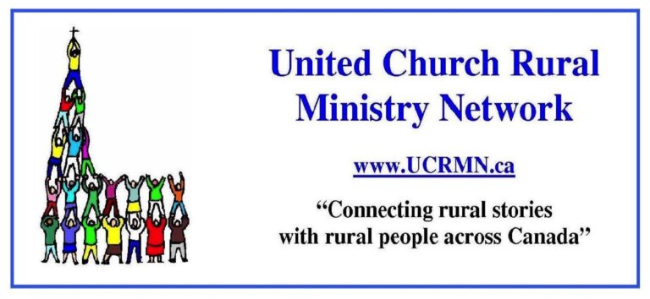
2024 UPDATE FOR ANNUAL MEETINGS OF REGIONAL COUNCILS
The United Church Rural Ministry Network (UCRMN) is a national network, that connects electronically sharing stories and news of rural communities across Canada (and around the world), by networking with lay and clergy leaders of rural communities of faith. Find us on website ucrmn.ca.
Let me walk with you through some of the resources on the UCRMN website. Peter Chynoweth (Cochrane, AB) is the web minder. The ‘Network’ connection includes a partner Atlantic Canada network called Rural Roots Through the Holy which has sponsored conferences in the Maritimes for 3 years. In the Prairies is highlighted the ecumenical Centre for Rural Community Leadership and Ministry (CiRCLe M) which has connections to Saskatoon Theological Union. CiRCLe M is hosting a conference, Experiencing the Rural Culture of the Alberta Foothills, June 18-21.
Then there are ‘Resources’. I would like to recommend to all ‘Tech Resources’. Martin Dawson, from Cornwall, PEI, and web minder Peter Chynoweth write thoughtfully, with humour and matters of ethical consideration of computers. They discuss the use of inexpensive software, like the free Jitsi meet instead of Zoom, refurbishing old and tired computers using open source software – in short, ‘tech for scarce budgets’ with an eye to keeping our tech out of landfills.
Next comes practical and helpful information on Collaborative Ministry, ways for congregations and communities of faith to work in partnership with others.
Then there are interviews that Martin hosts: With Peter on Open Software as an Ethical Alternative; with George Bott on Rural Connect; with Catherine Smith on her views of rural ministry and initiatives in the Maritimes; with Catherine Christie and Eric Skillings on the founding and workings of UCRMN. (These interviews are also found on Short-Wave Radio stations, a huge love of Martin’s)
The next area is Workshops, with information about the quarterly Zoom workshops that UCRMN has hosted through the years. During this Regional Council year, 2023-24, workshops have been: on April 18 - Social Media in the Rural Church, facilitated by United Church Digital Team, Cara Czech, Stephen Fetter and Aaron Gallogos; Feb. 15 – Life Long Learning facilitated by St. Andrew’s College staff, Dr. Bernon Lee and Shawn Sanford Beck; Nov. 16 – Pastoral Care to the Rural Church, led by Kathy Douglas of Antler River Watershed; Sept. 21 – further discussions on Collaborative Ministry; June 22 - Radically Welcoming and Rural, the opportunities of Diversity in the Rural Church.
Then there is ENews, with an archive of all the past ENews, from 2020 to 2024. We print 9 editions of UCRMN ENews during the year. Events happening throughout the Church are publicized, advertising from Regions and committees, the regular column on Tech Advice, a regular column from Joyce Sasse’s Gleanings of a Prairie Pastor, reports from Conferences, and most importantly, stories from congregations of community action and ministries. We love to have stories shared. If you have something to tell, send an article (about 300 to 500 words) to editor@UCRMN.ca.

There are over 400 members of UCRMN across the country and in most Regional Councils. As a Network, UCRMN asks for financial support from each Regional Council. We thank those who have given support from their Networking funds. Our suggestion is $300 from each RC - UCRMN wishes to support all the Regional Councils in their rural ministries. (70% of United Church congregations across the country are in rural or small towns, therefore a relevant cost to each Regional Council.)
UCRMN members are taking part in the “Rural Townhall” by Edge Network for Ministry Development, to hear peoples’ thoughts about what is going on in rural churches, and how rural ministries can be supported.
We are a grassroots initiative for Rural Ministry in the United Church of Canada. Our goal is to connect the many Rural Ministry initiatives across Canada.

Respectfully submitted by UCRMN Board:
Catherine Christie, President UCRMN, Abbey, SK, Living Skies RC
Eric Skillings, Secretary/Treasurer UCRMN, Merlin, ON, Antler River Watershed RC
Shelley Roberts, Vice President UCRMN, Lanark ON, Eastern Ontario Outaouais RC
Donna Mann, Officer UCRMN, Elora ON, Western Ontario Waterways RC
Yvonne Terry, Officer UCRMN, Milestone SK, Living Skies RC

