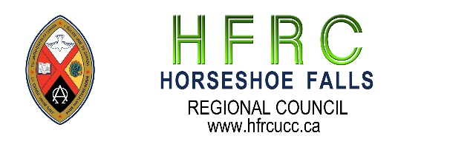

BRAVE: Commitment to Community Safety
We strive, in this time of co-learning, to be brave by
B – bring accountable for the impact of both our words and our silence
R – reflecting on and naming our own biases
A – actively listening
V – vocalizing questions that arise from our learning
E – encountering new ideas with curiosity and wonder

Horseshoe Falls Regional Council Affirming Ministry Vision Statement
SAFETY. SANCTUARY. UNCONDITIONAL LOVE

Striving to be faithful followers of Jesus in our time and place, Horseshoe Falls Regional Council will continue to remove barriers to participation in the life and work of the regional council and society, committing ourselves to be open to the Spirit.

Resisting all forms of oppression, we welcome and celebrate people of any sexual orientation and gender identity, and all others who are marginalized.

The Regional Council, Staff, Executive, Commissions, networks, and members commit to working toward fulfilling the vision statement by:
- Continuing to remove barriers to participation in the life and work of Horseshoe Falls Regional Council.
- Continuing to remove barriers to participation in society.
- Committing to be open to the Spirit.
- Resisting oppression.
- Welcoming and celebrating people of any sexual orientation and gender identity.

Horseshoe Falls Regional Council of The United Church of Canada
Box 100, Carlisle, Ontario, L0R 1H0 | Main Phone: 1-833-236-0280 / 905-659-3343

