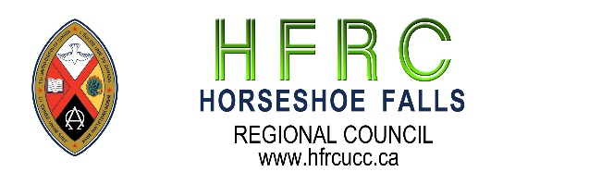

As at October 2024

In Memoriam
Rev. Edith Bolton, DLM

Rev. Bryan Melick, OM

Community of Faith Life Cycle Changes Disbandment and Disbanding

With thanks for their legacy and faithful service
Vineland UC ceased to worship June 2024

York UC will cease to Worship Dec 2024

