Congregational Support Commission

Horseshoe Falls Regional Council
of The United Church of Canada
Supports, Connects, Empowers Communities of Faith

Minutes

Date: June 10, 2025 at 7:00 PM via Zoom

Roster: (8) Jane Capstick (co-chair), Adrianne Robertson, Jane Wyllie, Steven Lowden, Shawn Bausch, Ross Gowan, Karen Tobey, Kate Young, Barb McGill, Doug Caldwell
Staff Support: John Neff Congregational Support Minister (WOW) HFCSM@united-church.ca
John Egger, Social Justice Minister HFCSM@united-church.ca
Michele Petick, Administrative Assistant

Present: Jane Capstick (co-chair), Adrianne Robertson, Jane Wyllie, Steven Lowden, Shawn Bausch, Ross Gowan, Karen Tobey, Kate Young, Barb McGill, Doug Caldwell, John Neff WOW CSC Minister, John Egger, Social Justice Minister, Michele Petick, Administrative Assistant

Regrets: Shawn Bausch, Doug Caldwell, Jane Wyllie

Welcome and Constitute Meeting: Jane Capstick
I constitute this meeting in the name of Jesus Christ, the one true head of the Church and by the authority invested in me by this meeting of the Horseshoe Falls Regional Council for whatever business may properly come before it. The bounds of the meeting will be the Zoom call.

Acknowledging the Land: Barb McGill

Opening Worship: Barb McGill – UCC 100th Anniversary and Pádraig ó Tuama – poem “In the Shelter”

Opening Motions:

Approval of Agenda:
MOTION: Kate Young / Ross Gowan That the Congregational Support Commission of the Horseshoe Falls Regional Council accept the meeting agenda of June 10th, 2025 as circulated.
CARRIED

Corresponding Members: None

Consent Docket

Approval of May 20, 2025 Minutes

Email Motions

Appointment of Pastoral Charge Supervisors
- Joseph Hopkins to St. John’s UC Georgetown, effective September 1, 2025
- Ross Leckie to St. John’s UC, Georgetown for one meeting June 1, 2025

Annual Reports Received

- Burford - 2024 Complete AGM Report.pdf
- Christ First UC, Mississauga Annual Report June 2025.pdf

Self Assessments Received
- None

~~~~~~~~~~~~ End of Consent Docket ~~~~~~~~~~~~
MOTION: Barb McGill / Adrianne Robertson that the Congregational Support Commission of Horseshoe Falls Regional Council approve the consent docket as circulated.

CARRIED

Pastoral Charge Supervision

Ryerson UC, Ancaster (PCS Request, Re_ PASTORAL CARE DOC.msg, Re_ Ryerson United Church Pastoral Care Position.msg, Re_ Annual Meeting.msg, Ryerson Pastoral Supervision Report.msg)
Update: PCS resigned after the annual meeting where his advice and guidance was rejected and he was treated with disrespect and inappropriate language. (see report)
- Chair of Worship has been trying to hire a minister for pastoral care, and has been advised by both LA and MC on the process, but it hasn’t been followed
- Chair of Worship has asked that CSC appoint a specific person as PCS, this does not come from the board
- Advised that the board will need to meet with reps from CSC to discuss the role and authority of PCS before a new appointment will be made.
- In the meantime, it may be necessary for a member of CSC or staff to attend meetings if they are prepared to follow process for hiring a supply minister
- CSC will also need to determine whether or not their annual meeting was valid as they did not have quorum based on membership listed in annual report. (don’t know how many were in attendance, but it was less than 20)
- Chair Jane Capstick and Barbara McGill will meet with them to discuss the process of filling a Pastoral Charge Supervisor position, the responsibilities of a PCS, their annual meeting, and search process for a minister.

Transitions

York United Church – Disbursements
MOTION: Karen Tobey / Steve Lowden That the Congregational Support Commission of Horseshoe Falls Regional Council consent to the request from York United Church to disburse 33% of their final assets equally to Ryerson United Church Camp and Five Oaks Retreat Centre.

CARRIED

Rockton United Church and Freelton-Strabane United Church (Re_ Reset the sails_ .msg)
Update: Rockton UC and Freelton-Strabane UC have agreed to begin the process to amalgamate
- As a result, the collaboration discussions between Freelton-Strabane and Millgrove UC have ended
- Sheffield UC, the other point in the Sheffield-Rockton Pastoral Charge will need to be contacted to confirm that they will be able to continue as a solo point. Also, any shared assets with Rockton will need to be divided according to a plan acceptable to both congregations.

c. St. John’s UC, Georgetown, Glen Williams – Cover Page, Financial Viability, Demographics, Real Property, Living Faith Story, Financial statement, position description)
MOTION: Steve Lowden / Barb McGill that the Congregational Support Commission of Horseshoe Falls Regional Council receive the community of faith profile from St. John’s UC, Georgetown Glen Williams and agree with the recommendation that St. John’s UC is viable to call/appoint a minister for up to 20 hrs in Category F or equivalent.
CARRIED
1-Abstention: Kate Young

Collaboration Agreement

Central UC, Welland and Southminster UC, Niagara Falls (Welland Motion, Southminster motion, Collaboration Agreement)
MOTION: Kate Young / Adrianne Robertson That the Congregational Support Commission of Horseshoe Falls Regional Council, with appreciation for the work of both communities of faith, approve the collaboration agreement between Central United Church, Welland and Southminster United Church, Niagara Falls which will come into effect on September 1, 2025.

CARRIED

Property

Oakland-Scotland - For information (Re_ Former Oakland Church.msg)
- Oakland church property was sold when the congregations amalgamated
- The current owners have been asked to remove the sign or take the church name off but do not seem to be cooperating.
- Need to see if Mark Laird will be following up. May need to get legal advice from GCO

7. Other Business:

a. Update:
Exit Interview with Christina Crawford re: St. Paul’s Milton for information. Human Resources Commission has advised that St. Paul’s will be required to have an intentional interim minister. Lynne Allin has requested that a member of CSC be a member of the transition team. Kate Young might be able to fill this role.

Carlisle/Kilbride PC – Report on meeting on June 5, 2025 (Addrianne, Ross, Kate)
Ross Gowan appointed to continue working with Carlisle/Kilbride PC.
- Each community of faith shared about the process
- Options 1. Realignment of the pastoral charge. 2. They would work together and call an Interim Minister (Worship with Kilbride and Interim with Carlisle). 3. Call a minister to serve both pastoral charges and Carlisle would hire a consultant. These three options were agreed upon by both communities of faith.
- Everyone left the meeting hopeful.
- Ross Gowan will work with them as they work through these options alongside representatives from the HF Human Resources Commission.

Mississauga: Christ First UC – Community of Faith Profile (Financial Viability, Demographics, Real Property, Living Faith Story, Financial statement)
MOTION: Steve Lowden / Barb McGill That the Congregational Support Commission of Horseshoe Falls Regional Council receive for information the Community of faith profile from Christ First UC, Mississauga.

CARRIED

Executive Report:
- Shawn Bausch, Lynne Allin and Jane Capstick attended the Executive to ask for a review of New Vision which was approved. To be done within 30 days at their discretion. If after 30 days they have not retained a suitable auditor, one will be appointed for them, to be paid for by the Regional Council.

Staff Report:
- John Egger and John Neff reviewing emails.
- Send emails to HFCSM@united-church.ca
Ministers searching in HFRC by category and hours:
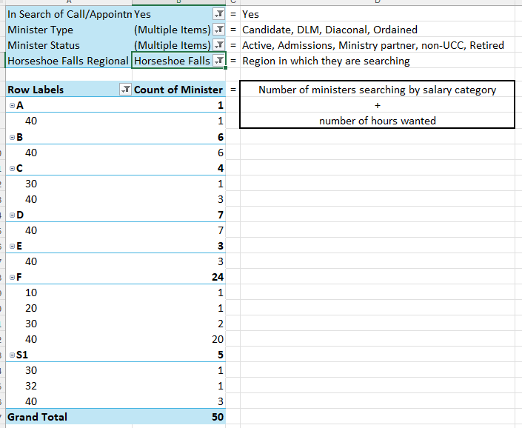

Next Meeting: July 22nd at 10am via Zoom
Territorial Acknowledgement: Steven Lowden
Worship by: Steven Lowden

Affirm Initiatives
Section A Encourage communities of faith to make use of available resources, including the Affirm Network, to discuss issues of inclusion and diversity
Section B Encourage conversations with ecumenical and interfaith groups and community partners, especially with our full-communion partners regarding best practices
Section E Encourage communities of faith to engage in conversations about making safer spaces within the church and community for people of any sexual orientation or gender identity.

Sample Motion:
MOTION by Choose an item. / Choose an item. That the Congregational Support Commission of Horseshoe Falls Regional Council … .

