Congregational Support Commission
Horseshoe Falls Regional Council
of The United Church of Canada
Supports, Connects, Empowers Communities of Faith

July 22, 2025 – 10 am EST Via Zoom

MINUTES
Roster: (8) Jane Capstick (co-chair), Shawn Bausch (co-chair), Steven Lowden, Ross Gowan, Karen Tobey, Kate Young, Barb McGill, Alison Nicholson
Staff Support: Beverly Tyhurst (Congregational Support Minister), John Neff (Congregational Support Minister), Michele Petick (Administrative Assistant)
Present: Jane Capstick (co-chair), Shawn Bausch (co-chair), Steven Lowden, Ross Gowan, Karen Tobey, Kate Young, Beverly Tyhurst, HF Congregational Support Minister, John Neff, WOW Congregational Support Minister, Michele Petick, Administrative Assistant
Regrets: Barb McGill
Absent: Alison Nicholson
Welcome and Constitute Meeting:
I constitute this meeting in the name of Jesus Christ, the one true head of the Church and by the authority invested in me by this meeting of the Horseshoe Falls Regional Council for whatever business may properly come before it. The bounds of the meeting will be the Zoom call.
The meeting was constituted and opened by Co-chair, Shawn Bausch.
Acknowledging the Land: Steven Lowden
Opening Worship: Steven Lowden
Opening Motions:
Approval of Agenda:
MOTION by Ross Gowan / Steve Lowden that the Congregational Support Commission of the Horseshoe Falls Regional Council accept the meeting agenda of July 22, 2025 as circulated.
CARRIED

Corresponding Members: None

Approval of Previous Minutes: (June 10, 2025)
MOTION by Jane Capstick / Kate Young that the Congregational Support Commission of the Horseshoe Falls Regional Council accept the meeting minutes of June 10, 2025, as circulated.
CARRIED

Consent Docket:

-------------------------------------BEGIN CONSENT DOCKET---------------------------------------------
Email Motion(s):
Ridgeway Property
MOTION: Kate Young / Steven Lowden.
That the Congregational Support Commission of Horseshoe Falls Regional Council approve the request of the Trustees of People’s United Memorial Church for the sale of People’s United Memorial Church, the legal address which is Pt Wesleyan Parsonage Plan 349 Village of Ridgeway, as in MMD10157 Except Pt 1, 59R10565 R0572025 & Pt 1 ON 59R14427; Fort Erie to 1000226178 Ontario Inc. as per the following:
Sale price: $750,000
Closing September 11, 2025
Signing deposit: $25,000
Firmed up deposit: $25,000
Closing deposit: $175,000
Vendor Take Back mortgage (non-transferable): $525,000 at 4% per annum. Interest only payments for two years at $1,750, open pre-payable with no penalty.
Carried on June 25, 2025.
Appointment of Pastoral Charge Supervisors:
Barb McGill to Fonthill, effective September 1, 2025
Diane Walker to Ryerson UC, effective July 22nd, 2025
Jan McCormick to Lowville UC, effective June 25, 2025
Christina Paradela to Millgrove, UC, effective July 1, 2025
Scott Martin to Erin Mills UC, effective January 1, 2026

MOTION by Kate Young / Steve Lowden that the Congregational Support Commission of Horseshoe Falls Regional Council approve the consent docket.

CARRIED
--------------------------------------END CONSENT DOCKET-----------------------------------------------

COMMISSION INTRODUCTIONS and WELCOME Beverly Tyhurst, HFRC Congregational Support Minister:

- John Neff and John Egger (referred to in these minutes as JE) have been covering the work before Beverly Tyhurst’s arrival on July 14th.
- Welcome to Beverly Tyhurst, HF Congregational Support Minister.
- Commission members individual introductions to Beverly.
Collaborative Agreements
- JE: St. Paul’s UC, Paris and Richwood UC, Drumbo
(St. Paul’s is in HF, Richwood is in ARW.)
ARW CSC passed a motion to approve the collaborative agreement at its June 18 meeting. They also asked the two communities of faith to have a discussion about mileage breakdown.
Document: Collaborative Covenant Richwood&St. Paul's.pdf

MOTION: Moved by Ross Gowan, seconded by Karen Tobey
That the Congregational Support Commission of Horseshoe Falls Regional Council approve the collaborative agreement between Richwood UC (ARW) and St. Paul’s, Paris UC from October 1, 2025 to October 1, 2026.

CARRIED

- JE: Shared Ministry Covenant among St Andrews UC, Harmony UC, and Fairview UC (Brantford)
Documents: Shared Ministry Covenant Among- St. Andrews, Harmony & Fairview United Churches.pdf, Motion re Shared Ministry.odt, 2025-07-14 Region's copy- Minutes-July 14,2025 FairviewUC Cong Mtg.docx, [motion for St. Andrew’s is still coming]

MOTION by Kate Young / Jane Capstick that the Congregational Support Commission of Horseshoe Falls Regional Council approve the collaborative covenant among St. Andrew’s UC, Brantford, Harmony UC, Brantford and Fairview UC, Brantford effective September 1, 2025 to August 31, 2026.

CARRIED
- JE: Update on South Coast Collaboration (collaborative covenant among Bethel UC, Central UC, Morgan’s Point and Fork’s Road Pastoral Charge). This is four congregations, as Morgan’s Point and Fork’s Road Pastoral Charge consists of two congregations
The commission voted at its meeting on April 8 to approve the covenant and at its meeting on May 20 to support their request to hire a minister at 40 hours per week, cat. F. HF HRC at its meeting on June 25 asked for changes to the position description, so approval of the description is depending. Meanwhile, all four congregations have now approved the collaborative covenant. Effective date of the agreement will depend on the hiring of a minister.
Documents: Collaborative-Covenant-South Coast March 25 rev.pdf , BUC Congregational Meeting motion May 11 2025.pdf , Minutes of June 1 2025Congregation Meeting CUC.pdf, Morgan's Point Minutes.pdf, Forks Road vote June 2025.pdf
Receive for information the approvals of the Collaboration agreement.

Community of Faith Profiles:
- JE: Erin Mills United Church, Mississauga
Position description approved by HRC June 25.
Documents: 2025 Community of Faith Final.docx, ViabReptEMUC Final.docx, 2025 EMUC Request to Search for a New Minister.docx
MOTION by Jane Capstick / Steve Lowden that the Congregational Support Commission of Horseshoe Falls Regional Council, having reviewed the community of faith profile for Erin Mills United Church, approves their request to hire a minister for 40 hrs per week up to category F.
CARRIED
- JE: Faith United Church, Hamilton (need recommendation filled out.)
Documents: Faith United-Living Faith Journey-250612 - Google Docs.pdf, Faith United-Financia Viability Worksheet-250614.pdf

POSSIBLE MOTION by Choose an item. / Choose an item. an item that the Congregational Support Commission of Horseshoe Falls Regional Council, having reviewed the community of faith profile for Faith United Church Hamilton, approves their request to hire a minister 30 or 40 hrs per week up to category F.
DEFFERRED
ACTION ITEM: Shawn Bausch will work with this community of faith to update their information on statistics, update with current form.
- JE: St. Paul’s Milton
HRC is requiring them to search for an IIM (Intentional Interim Minister).
Documents: MOVED BY THE SPIRIT OF GOD.docx (previous Living Faith Story), St. Paul’s Living Faith Story Facilitated Review.docx (updated Living Faith Story), Financial-Viability-Worksheet.docx
MOTION by Steve Lowden / Karen Tobey that the Congregational Support Commission of Horseshoe Falls Regional Council, having reviewed the community of faith profile for St. Paul’s United Church, Milton, approve the hiring of an Intentional Interim Minister, full- time.

CARRIED

Abstention: Kate Young (conflict of interest)

Transitions

Property
- JE: Trinity UC, Beamsville Manse Rental Agreement

Documents: 20250630101652714.pdf

MOTION by Kate Young / Ross Gowan That the Congregational Support Commission of Horseshoe Falls consents to the lease of the manse at 4285 William Street, Beamsville to Kristen Geuze for $1543/month with the tenant to pay gas, hydro, and heating expenses. This agreement is in effect from 2025-01-01 to 2025-12-31.

CARRIED
- Abstention: Jane Capstick (conflict of interest)

- JE: Grace UC, Dunnville
Documents: letter requesting approval.jpg (photo of signed document) leasing request for trustees regarding creek childcare.pdf, amended lease copy.pdf, MARKED 25P522 - 301 Broad Street - Design Layout.pdf, lease deal and seeking approval.msg

MOTION by Kate Young / Ross Gowan That the Congregational Support Commission of Horseshoe Falls Regional Council consents to the request from Grace UC, Dunnville to the lease of certain Real Property, the legal description of which is Lot 7 East Side Maple Street, Lot 25 North Side Broad Street East Plan 69; Part Lot 6 East Side East Side Maple Street, Part Lot 26 North Side Broad Street East, Part Lot 27 South Side Alder Street, Plan 69 designated as Part 2 18R6170; Haldimand County being PIN 38123-0114 (LT), and the municipal address of which is [301 Broad Street E, Dunnville ON, N1A 2X5, pursuant to an agreement between the Trustees of Grace United Church, Dunnville, a congregation of The United Church of Canada, as lessor, and Creek Childcare Centres, as lessee, dated the 11th day of June, 2025 , and subject to regional council approval, the terms of which are as follows: $12.50 per square foot/month. See Attached for greater details. Effective January 1, 2026 to December 31, 2030.

CARRIED

ACTION ITEM: Co-chair Jane Capstick will contact Grace UC, Dunnville re: renovation plan and costs.

- JE: Westminster, Mississauga Lease Agreement
The congregation has been renegotiating its lease agreement with Western Heights Montessori Academy, with attention given to making sure they get fair market value. They have shared a draft of the lease agreement that is still being tweaked with their lawyer and the tenant. They say please advise if there are questions or concerns.
Documents: Commercial Lease Agreement - Westminster United Church2025Renewal August 1 2025.doc
No motion at this point. Looking for input on the agreement.
- Well developed lease agreement with no concerns.
ACTION ITEM: Beverly Tyhurst and John Neff will respond to Westminster, Mississauga

Other Business:
- Hamilton: New Vision UC – Proof of insurance (Insurance, Invoice).
ACTION ITEM: Check to see if Richard Bott is still on contract with New Vision. Co-Chair Shawn Bausch will check in with Richard.
ACTION ITEM: Commission representatives and Staff Support to meet with New Vision in-person potentially in September 9th, 2025 on site at New Vision. Commission to meet at 3:00pm Hybrid at Westdale and 7:00pm with New Vision.
ACTION ITEM: Beverly Tyhurst, Congregational Support Minister to send correspondence to New Vision thanking them for sending the proof of insurance.

- Ryerson Ancaster – PCS needed after meeting with Governing body.
- Montessori schools as tenants provide main source of income
- Interested in looking at Shared Ministry
- Five or six ministries nearby
- Diane Walker, Pastoral Charge Supervisor

- JE: Oakville Collaboration (St. Paul’s, Trinity, St. John’s, Munn’s, Palermo) – update email from Deborah Laforet - receive for information
Document: Sharing one Ministry Position.msg (collaborative agreement not yet finalized.)
Declared conflict of interest – Kate Young.

ACTION ITEM: Beverly Tyhurst, Congregational Support Minister to follow up on return correspondence with Deborah Laforet

- JE: St. Andrew’s United Church, Niagara Falls - Rev. Jung Hyun (Karl) Shin exit interview – receive for information document: Exit Interview with Junghyun Shin-Final.docx
-For the purposes of information sharing

- Update on Stoney Creek and Pioneer Memorial UC - St. Columba (ESM- Ecumenical) – Ross Gowan
- Serving as Liaison for this congregation
- 2019 was the year the Ecumenical agreement was made.
- St. Columba pulled out of the Ecumenical agreement
- Pioneer Memorial would like to sell their building and property
- Pioneer Memorial looking to next with another congregation
- Trustees need to get the sale approved and to source realtors.
- Looking for a Supply Minister.
- They require a new collaborative agreement between the two congregations.
- Commission thanks Ross Gowan for his work.

- Update on Carlisle-Kilbride – Ross Gowan
- June 5th attended Board Meeting with Adrianne Robertson, Kate Young and Ross Gowan.
- Carlisle Looking to hire an IIM, Kilbride is not supportive of this idea as an affordability issue.
- Carlisle to hire a consult to support them in their strategic visioning.
- Meeting with a consultant from Creedence this week.
- Both congregations would like to continue to work with their Supply Minister Gail McDonald.
- Barb Duffin and Sue Stephen from the HF HRC Commission are working with the transition team.

- Update on Christ First Mississauga – Ross Gowan
- Co-chair Shawn Bausch Regional Representative declares a perceived conflict of interest.
- A few months ago, attended a meeting of the HF CSC Commission, they presented their plan to proceed.
- 2019 two churches Clarkson and Port Credit campuses came together, looking now to sell one set of these buildings.
- Contracted with a real estate consultant giving them good guidance.
- Ross Gowan will meet with them again on August 19th, 2025 with their recommendations.

- Conflict of interest Policy
- UCC Conflict of Interest Policy well written policy of a broad scope
- breakout room available for folks who would like to step away from discussion and vote.
- Executive Assistant Max Watkinson has recently sent Confidentiality and Conflict of Interest forms by email for commission members to review, sign and return.
- Not to give anyone more ability/privilege to discuss an issue before being removed from a vote.
- Perceived conflicts of interest, commission members can comfortably raise concerns.
- Participating in discussions that results in a decision.
- Abstentions are documented in the minutes and if people excuse themselves from the meeting for the vote.
- Add the “conflicts of interest” to the Agenda, John Neff added.

Congregational Support Commission Commitments to COI:

- The commission will follow the Conflict of Interest Policy issues by The United Church of Canada
- The HF CSC commission members will sign the confidentiality and conflict of interest document from the Regional Council based on the UCC Conflict of Interest policy and return to the Executive Assistant.
- The commission members will declare a real or perceived conflict of interest and can excuse themselves from the meeting or stay as they wish.

Executive Report: Jane Capstick, Co-chair
- Next meeting of the Executive will be in September, 2025.

Staff Report: Beverly Tyhurst, Congregational Support Minister
- Continue to send emails to HFCSM@united-church.ca.
- Beverly Tyhurst can also be reached at btyhurst@united-church.ca

Ministers searching in HFRC by category and hours:
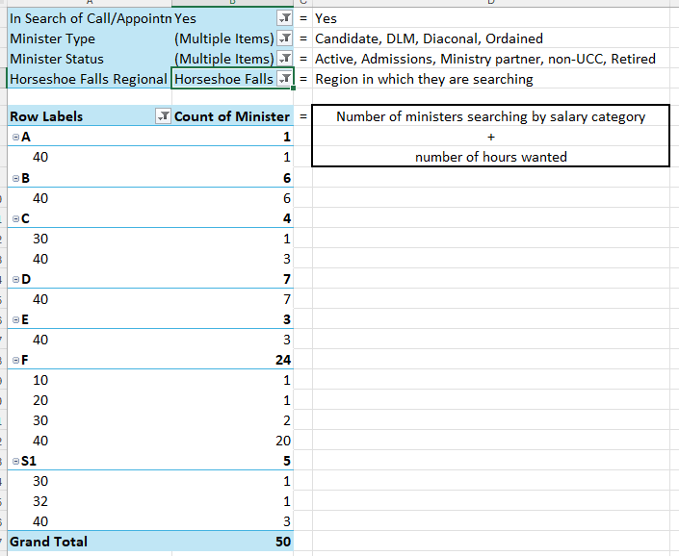

Positions available in HFRC: (as of July 15, 2025)
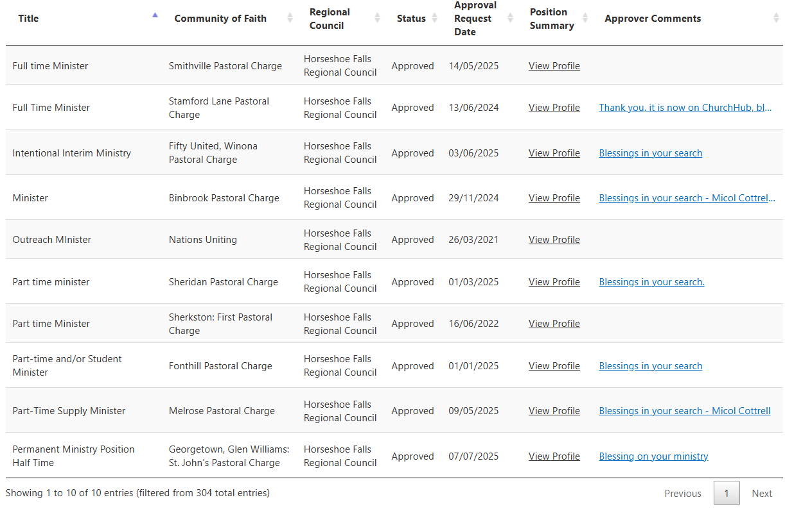

Next Meeting:
Date/Time: August - No Meeting
September 9th 3:00 pm Hybrid at Westdale UC and Zoom TBC – Jane Capstick
September 9th 7:00 pm in-person at New Vision TBC – Jane Capstick
Territorial Acknowledgement: Shawn Bausch
Worship by: Shawn Bausch

REMINDERS:
Affirm Initiatives
Section A: Encourage communities of faith to make use of available resources, including the Affirm Network, to discuss issues of inclusion and diversity
Section B: Encourage conversations with ecumenical and interfaith groups and community partners, especially with our full-communion partners regarding best practices
Section E: Encourage communities of faith to engage in conversations about making safer spaces within the church and community for people of any sexual orientation or gender identity.

Conflicts of Interest:
Confidential information may include, but is not limited to:

- Personal or pastoral matters shared in confidence
- Financial records and community of faith information
- Internal communications and meeting discussions
- Counselling or spiritual guidance sessions
- Any information designated as private by leadership or appointed members

