Congregational Support Commission
Horseshoe Falls Regional Council
of The United Church of Canada

HFRC Purpose: Supports, Connects, Empowers Communities of Faith
HFRC Commitment to be: Affirming, Anti-Racist

Tuesday March 10, 2026 – 10:00 AM
Roster: (8) Jane Capstick (co-chair), Shawn Bausch (co-chair), Steven Lowden, Ross Gowan, Karen Tobey, Barb McGill, Alison Nicholson, Kate Young
Staff Support: Beverly Tyhurst, Minister, Congregational Support.
Michele Petick, Communications & Administrative Assistant
Regrets: None

Minutes

Welcome and Constitute Meeting – Shawn Bausch
I constitute this meeting in the name of Jesus Christ, the one true head of the Church and by the authority invested in me by this meeting of the Horseshoe Falls Regional Council for whatever business may properly come before it. The bounds of the meeting will be the Zoom call.
Land Acknowledgement: Kate Young - TUCC
Opening Worship: Kate Young – Wales meeting opening prayer

Opening Agreements:

Approval of Agenda:
  - The Congregational Support Commission of Horseshoe Falls Regional Council agree on the agenda as circulated.
  - MOTION: Moved by: Jane Capstick Seconded by: Barb McGill, That the Congregational Support Commission of Horseshoe Falls Regional Council agrees on the agenda as circulated.
CARRIED

Consent Docket:

Approval of Previous minutes:
    - The Congregational Support Commission of Horseshoe Falls Regional Council approves the minutes of February 10, 2026, as circulated.

PCS Appointments
    - Rev. Irene Ty as a PCS for Applewood Untied Church (Mississauga) – February 10, 2026.

PCS Reports Received
    - Palermo United Church Pastoral Charge Supervision Report

Annual Reports Received
i.St. John’s United Church, Georgetown ON
ii.Jarvis Community Church, Jarvis, ON
iii.Munn’s United Church, Oakville, ON
iv.Delta United Church, Hamilton, ON
v.Grace United Church, Niagara on the Lake, ON
- Exit Interviews Received
    - None received

Congregational Support Minister (CSM) Report
i.Congregational Support Minister CSM March 10, 2026 Report

The Congregational Support Commission of Horseshoe Falls Regional Council agrees by consensus to receive all items in the Consent Docket for information.

New Business

a. Report from Rep to the Executive – Jane Capstick
- Executive has not met, no report
- Executive will meet at the end of this month

b. Collaborative Agreements
    - St. Paul’s United Church (Hamilton) & Emanual United Church (Hamilton)
Documents:
Living Faith Worksheet – St. Paul’s United (Hamilton)
Real Property Worksheet – St. Paul’s Untied (Hamilton)
Demographics Worksheet – St. Paul’s United (Hamilton)
Financial Viability Worksheet – St. Paul’s United (Hamilton)
November 30, 2024 Year End Disbursements - St. Paul’s United (Hamilton)
November 30, 2024 Year End Receipts – St. Paul’s United (Hamilton)
Emmanuel Community of Faith Profile
Emmanuel Real Property Worksheet
Emmanuel Financial Viability Worksheet
Collaborative Agreement between Emmanuel United and St. Paul’s United
Emmanuel Demographics Worksheet
Emmanuel Living Faith Story
MOTION: Moved by: Kate Young Seconded by: Ross Gowan, That the Congregational Support Commission of Horseshoe Falls Regional Council approved the collaborative of agreement by St. Paul’s United (Hamilton) and Emmanuel United.

CARRIED

c. Marshall Memorial Untied Church (Ancaster):
Marshall Memorial is looking to renew their appointment from Sunday April 15, 2026, to May 31, 2026, as a short-term appointment (there was a reduction in hours).
MOTION: Steve Lowden / Karen Tobey
that the Congregational Support Commission of Horseshoe Falls Regional Council receives the CoF Profile from Marshall Memorial United Church and agrees with the recommendation that Marshall Memorial United Church is viable to call/appoint a minister for up to 30 hrs at category F or equivalent.

CARRIED

Documents:
Marshall Memorial UC Living Faith Story
Marshall Memorial UC Preliminary 2025 Year End Draft Financial Statement
Marshall Memorial UC Preliminary 2025 Year End Highlights
Marshall Memorial UC Financial Viability form

d. Trinity United Church (Oakville):
Trinity United in Oakville minister’s contract comes to an end in mid September 2026. They are looking for a short-term supply minister as they are in discussions about amalgamation with three other churches in Oakville.

Documents:
Trinity United Financial Audit 2024
Trinity United Financial Viability Form

MOTION: Kate Young / Ross Gowan
That the Congregational Support Commission of Horseshoe Falls Regional Council receives the CoF Profile from Trinity United (Oakville) and agrees with the recommendation that Trinity United (Oakville) UC is viable to call/appoint a minister for up to 30 hrs at category F or equivalent.

CARRIED

e. Freelton Strabane and Rockton Amalgamation
    - Final Constitution – Freelton, Strabane and Rockton
      - Working Final Amalgamation Agreement - received for information and review (not approval)

Possible MOTION _____ / _____ MOTION:
that the Congregational Support Commission of Horseshoe Falls Regional Council approves the amalgamation of Freelton Strabane United and Rockton United pending congregational approvals from their respective congregational meetings with an official amalgamation date of May 31, 2026.
DEFERRED

ACTION ITEM: Beverly Tyhurst, HF Congregational Support Minister will circulate the feedback to the Commission by March 13th, 2026.

f. Wording Change in the Sale of Congregational Property Basic Steps, The Manual and
Trustee Handbook – Jane Capstick

It has come up that perhaps the works in Section G.2. of the Manual and the Board of Trustees handbook should be updated from “consults” to “seek approval” (item 2).

Original Wording:
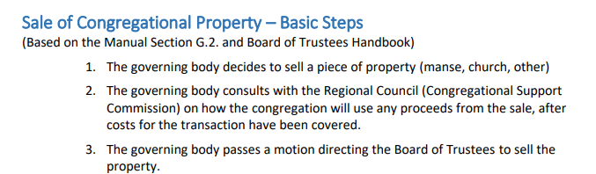

Proposed Wording:
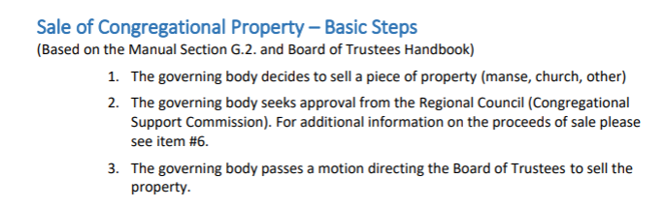
The Congregational Support Commission of Horseshoe Falls Regional Council request wording change in the Manual Section G.2 by proposal to General Council Executive.

ACTION ITEM: Co-chair Jane Capstick will draft a proposal to GCE on this issue and bring it to our next meeting to review.
Agreed by Consensus

g. Vetting Indwell
There was some discussion about putting developers through to UPRC to be vetted proactively for possible redevelopment of church properties.
MOTION Kate Young / Barb McGill
That the Congregational Support Commission of Horseshoe Falls Regional Council asks that UPRC vet Indwell and Pathways as approved developers.
CARRIED

ACTION ITEM: Co-chair Shawn Bausch will draft the correspondence to UPRC.

Kindred Works Article in Broadview

h. Recruiting for the HF CSC Commission – Jane Capstick
- Think about recruitment and succession planning and who we might know within our communities of faith that would be interested in this work
- Look for folks with skill sets helpful to the work of this commission
- Suggestion of a preparing a 30 second video of what the commission does
ACTION ITEM: Beverly Tyhurst, Congregational Support Minister will prepare a communication for the eNewsletter for recruitment to the Congregational Support Commission.
i. From the field:
-Shawn Bausch, Co-Chair attended Faith United’s I Hamilton Affirming Celebration.
-Meeting with the Oakville quartet of churches, discerned responsibilities and communications and meeting schedule. All lay people two from each congregation for a total of nine members.

4. Adjournment: 11:16am

Next Meeting: April 14, 2026 - 7:00 pm via Zoom
Worship by: Alison Chisholm
Land Acknowledgement: Alison Chisholm

May 12th Meeting at Westdale UC with lunch locally

Blank Motions
Possible MOTION _____ / _____
that the Congregational Support Commission of Horseshoe Falls Regional Council …
Possible MOTION _____ / _____
that the Congregational Support Commission of Horseshoe Falls Regional Council receives the CoF Profile from ___ and agrees with the recommendation that ___ UC is viable to call/appoint a minister for up to __ hrs at category __ or equivalent.

