Hi Congregational Support Commission
Horseshoe Falls Regional Council
of The United Church of Canada

HFRC Purpose: Supports, Connects, Empowers Communities of Faith
HFRC Commitment to be: Affirming, Anti-Racist

Tuesday April 14, 2026 – 7:00 PM
Roster: (8) Jane Capstick (co-chair), Shawn Bausch (co-chair), Steven Lowden, Ross Gowan, Karen Tobey, Barb McGill, Alison Nicholson, Kate Young
Staff Support: Beverly Tyhurst, Minister, Congregational Support.
Michele Petick, Communications & Administrative Assistant
Regrets:

MINUTES

Welcome and Constitute Meeting – Jane Capstick
I constitute this meeting in the name of Jesus Christ, the one true head of the Church and by the authority invested in me by this meeting of the Horseshoe Falls Regional Council for whatever business may properly come before it. The bounds of the meeting will be the Zoom call.
Land Acknowledgement: Alison Chisholm
Opening Worship: Alison Chisholm

Opening Agreements:

Approval of Agenda:
  - The Congregational Support Commission of Horseshoe Falls Regional Council agree on the agenda.
  - MOTION: Moved by: Kate Young, Seconded by: Ross Gowan That the Congregational Support Commission of Horseshoe Falls Regional Council agrees on the agenda as circulated.

Consent Docket:

Approval of Previous minutes:
    - The Congregational Support Commission of Horseshoe Falls Regional Council approves the minutes of March 10, 2026, as circulated.
    - Previous Minutes (March 10, 2026)

Emails Motions: None

PCS Appointments
  - Gordon Crossfield as a PCS for May 1, 2026 – Wesley United Church, Welland.
  - West Plains – PCS for August 1, 2026.

PCS Reports Received
  - Sheridan United Church (Mississauga, ON)
Annual Reports Received
- St. Andrew’s United Church, Georgetown, ON
- Sheffield United Church
- Selkirk Faith Centennial United Church, ON
- Smithville United Church, Smithville, ON
- Glen Abbey United Church, Oakville, ON
- Melrose United Church, Hamilton, ON
- Port Dover Woodhouse
- Sheridan United Church, Mississauga, ON

UPRC Vitality Reports
Munns United Church Vitality Report from UPRC (received for information)

Living Faith Story’s Received
Millgrove United Church will be embarking on a search for a new minister, and they have sent their living faith story (for information). We are still waiting on their additional paperwork.
Millgrove United Church Living Faith Story

UCRMN (United Church Rural Ministry Network) Annual Report
Report from UCRMN (Received for information)
The Congregational Support Commission of Horseshoe Falls Regional Council agrees by consensus to receive all items for information.

END CONSENT DOCKET ……………………………………………………………………………………………………………………..
MOTION: Moved by Alison Chisholm, seconded by Barb McGill, That the Congregational Support Commission of Horseshoe Falls Regional Council approve the Consent Docket of April 14th, 2026 as submitted.
CARRIED

New Business

Corresponding Member: Kristopher Tavella, Kindred Works

Binkley United Church & Kindred Works Agreement
There is an existing agreement between the former Binkley UC (now St. Mark’s UC) and Kindred Works (formerly UPRC). The original binding agreement involved the church contributing their land to a limited partnership at the start of construction in exchange for an equity interest equal to the land's fair market value. Following the amalgamation with St. Mark’s, the congregation requested to transition from a partnership interest to annual payments.

Kindred Works has now finalized this new structure and are ready for execution and Regional Council approval. Effectively, the church is selling the property to the limited partnership. To date, Kindred Works has invested $1.2M in municipal approvals. Additionally, the congregation is seeking cash payments of approximately $1.35M prior to construction—a departure from Kindred’s traditional project model with other United Church developments. To account for both the capital already invested and this upfront payment, which has a time value of money associated with it, we agreed with the congregation on a total property value of $3.5M. To provide security for future payments, the congregation requested security through a mortgage structure. In the event of a default, the congregation can accrue interest; however, the total purchase price remains fixed at $3.5M.

The initial Principal Terms of the Partnership Agreement included in original agreement (Schedule “J”) of the Binkley Report.

Binkley Report
Binkley Agreement of Purchase of Sale
Binkley Appraisal Report
Binkley Property Trustee Resolution Form

Possible MOTION _____ / _____
that the Congregational Support Commission of Horseshoe Falls Regional Council approve:
(1) the sale of certain Real Property, the legal description of which is 1570 Main Street West (the former Binkley United Church), pursuant to an agreement between the Trustees of St. Mark’s United Church, Dundas, Ontario, a congregation of The United Church of Canada and Binkley Communities LP and subject to regional council approval, the terms consistent with the April 6 Draft of an Agreement of Purchase and Sale summarized as a sale price of $2,806,478 with a payment of $500,000 within a closing period of 90 days. The terms also include a vendor take-back mortgage of $2,306,478 at an interest rate of 6.45% per annum yielding a payment of $500,000 on the first anniversary of closing, payments of $350,000 on each of the second, third, fourth, fifth, sixth, and seventh anniversaries of the closing date and a final payment of $400,000 on the eight anniversary of the closing date. The Purchaser has the privilege of prepaying the whole or any part of the principal at any time. An adjustment will be made for any costs of remediation due to environmental issues given that St. Mark’s is notified of these adjustments by the Purchaser within one year of closing and the cost is verified by a third-party assessor selected by the Purchaser and approved by the Vendor acting reasonably. That adjustment, should it be necessary, will be no more the first $200,000 and 50% of the next $300,000 verified costs of remediation and will be applied equally to each installment of the VTB after the installment payable on the first anniversary of closing.
(2) That the proceeds will be held by the Trustees of St. Mark’s United Church, Dundas, Ontario in trust for the use and benefit of the congregation of St. Mark’s United Church, Dundas, Ontario as a part of The United Church of Canada.

DEFERRED more documentation required: identify purchasing partners, provide current agreement, projection analysis, meet on Friday April 17th at 1:15 pm

Report from Rep to the Executive – Jane Capstick
- Discipleship and Justice Commission without chair and not attaining quorum to pass motions.
- The Collective 2026 being held at Brock University this summer, a joint venture between United Church/Presbyterian Church event.
- New Vision requested and were approved funds for a healing retreat at Five Oaks.
- York is moving forward with their plans.
- Elcho church is being demolished, there is a cemetery on the property.
- Capital Fund request from Fairview United.

c. Congregational Support Minister (CSM) Report
    - Congregational Support Minister CSM April 14, 2026 Report

d. Jerseyville United Church Disbandment
At the Annual Congregational Meeting held on February 15th, 2026, the Congregation of Jerseyville United Church voted to disband under administration and close on July 26th 2026. Further to this motion, the congregation had an additional meeting on March 15, 2026 at which it voted to accept the resignation of the congregation’s trustees effective July 31st or sooner if Regional Trustees are appointed earlier. Certificates of membership for all their members were prepared and their roll is up to date. They have also ended their pastoral relationship with their minister as of July 26, 2026.
Jerseyville disbandment notice and motion
MOTION Shawn Bausch / Kate Young
That the Congregational Support Commission of Horseshoe Falls Regional Council receives the intent to disband fromJerseyville United Church, with the final date of worship to be July 26, 2026. The Congregational Support Commission (CSC) will disband Jerseyville United Church once the finance team has received all the necessary documentation.
CARRIED

e. Collaborative Agreement – Westminster United Church (St. Catharines) and Elm Street United (St. Catharines)
Westminster United Church and Elm Street United Church are wanting to set up collaborative ministry together.
Financial Viability – Westminster United Church
Financial Viability – Elm Street United Church
Collaborative Agreement – Westminster and Elm Street United Churches

MOTION Barb McGill / Karen Tobey
That the Congregational Support Commission of Horseshoe Falls Regional Council approves the
Collaborative agreement between Westminster United Church (St. Catharines) and Elm Street United (St. Catharines).

CARRIED

f. Melrose United Church (Hamilton, ON) Repair Work:
Melrose United Church is proposing to complete the gutter repairs on one side of the building this year (2026), with further work on the other side to be completed in 2027. They also plan to make repairs to the chapel roof and flat roof immediately adjacent to the chapel). They have been planning this work for some time, and it has taken considerable time to find a willing contractor with necessary expertise to do this work. The work on the gutters is necessary because the current gutters in some cases have large holes in them and have shifted position so that they are no longer in the right position to capture rainfall and direct it away from the walls of the building. This has led to infiltration of water into the walls of the sanctuary, and damage to the wall tiles and plaster, particularly in the transepts.

Melrose United has also experienced seepage into the chapel along one wall, which we believe is related to the weight of the A/C unit on the adjacent flat roof, and possibly also leakage through the roof under the A/C unit. Separately, some ice falls from the Sanctuary roof have cracked a few slates, leading to new leaks in a different location. We need to have buckets set up in several spots in the chapel to try to keep water off the floor. The slates can be repaired by our custodian but require the scaffolding from the main project to be fixed safely. After that preparatory work is done, we will have the flat roof fixed so that it does not leak, and that will be done by the AIMED group.
Their plan is to use various trustees' funds to pay for most of this work (the Memorial Fund, and the Sustaining Fund), we are also actively fundraising to try to reduce the draw on these funds. The required votes at the Board and Congregation to access these funds have taken place, so the last piece in the approval process rests with the Regional Council.
In accordance with Manual Section C.2.6(a)ii, Horseshoe Falls Regional Council defines “major renovations” as any repair, work, addition, upgrade or capital improvement or like project to the real property of a congregation or pastoral charge estimated or expected to cost the lower of 50% of net revenue used for assessment purposes for the prior calendar year or $250,000.00 or more, with all costs in, including without limitation applicable taxes, design, permits, project management and commissions. Net revenue for assessment purposes for Melrose United Church is: $175,072.00
Documents:
Annual Report 2025 – Melrose United Church
AIMED Group – Quote for Melrose United Church
Melrose United – Financial Viability

MOTION Kate Young / Alison Chisholm
That the Congregational Support Commission of Horseshoe Falls Regional Council to approve Melrose United Church’s roof and gutter repairs.

CARRIED

g. Rockton United & Freelton Strabane United Church Amalgamation:
The agreement of amalgamation (below) was presented to the Rockton Board on Monday March 30th, and a motion was made to accept the document as presented. It passed unanimously. This agreement of amalgamation (below) was also presented to the Freelton Strabane Council on Tuesday March 31st, and a motion was made to accept the document as presented. It passed unanimously. The Freelton Strabane Council and Rockton Board would petition the Commission to give its approval prior to the Congregational meetings called for April 19th following worship.

We understand that the United Church does not work on presidency as we believe that there must be room for the Action of the Holy Spirit in making our decisions. However, When the Amalgamation happened between Freelton United Church and Strabane United Church the Region had approved the Amalgamation Document and the Amalgamation before the congregational vote. The decision of the Region was not shared until after the congregations had voted.
Documents:
Final Amalgamation Agreement – Rockton United & Freelton Strabane United Churches
MOTION Karen Tobey / Ross Lawford
That the Congregational Support Commission of Horseshoe Falls Regional Council approve the final amalgamation agreement for Freelton Strabane and Rockton United Churches.
CARRIED

h. Covenanting Service – Waterford United Church (Waterford, ON):
Kellie McComb - April 26, 2026 - at 2pm 135 Main Street South, Waterford, Ontario N0E 1Y0 – any volunteers that could possibly attend? Karen Tobey will attend.

i. St. Paul’s United Church Oakville
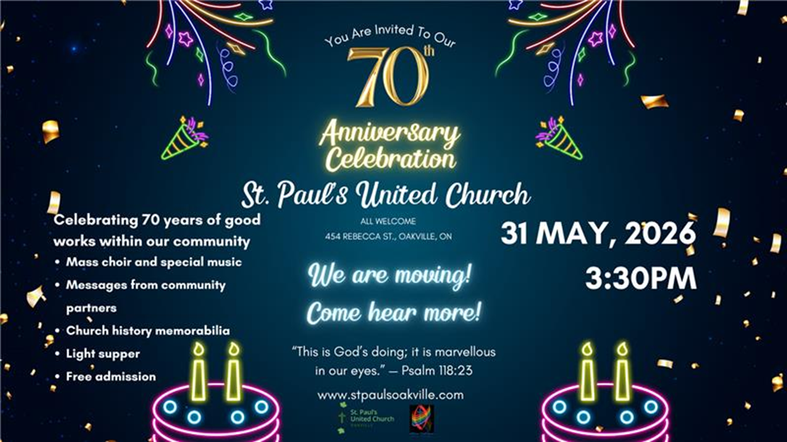
Shawn Bausch, Jane Capstick, Beverly Tyhurst, and Barb McGill will attend.

j. Oakville Quartet – Shawn Bausch
- 4th meeting
- lay folks, total of 8 members with lots of energy
- discussing mission, governance and communication plans
- They have named themselves ANTa = a new thing
Next Meetings: April 17, 2026 at 1pm – Binkley/St. Mark’s, May 12, 2026 - 10:00 am via in person (Westdale United Church, Hamilton ON) and via Zoom
- Worship by: Kate Young
- Land Acknowledgement: Kate Young
- Menu Snooty Fox Lunch Board

Adjournment

Blank Motions
Possible MOTION _____ / _____
that the Congregational Support Commission of Horseshoe Falls Regional Council …
Possible MOTION _____ / _____
that the Congregational Support Commission of Horseshoe Falls Regional Council receives the CoF Profile from ___ and agrees with the recommendation that ___ UC is viable to call/appoint a minister for up to __ hrs at category __ or equivalent.

Motion Examples Template.docx

