Horseshoe Falls
Regional Council Spring Meeting

Friday, June 26 – Sunday, June 28, 2026
Meeting Workbook
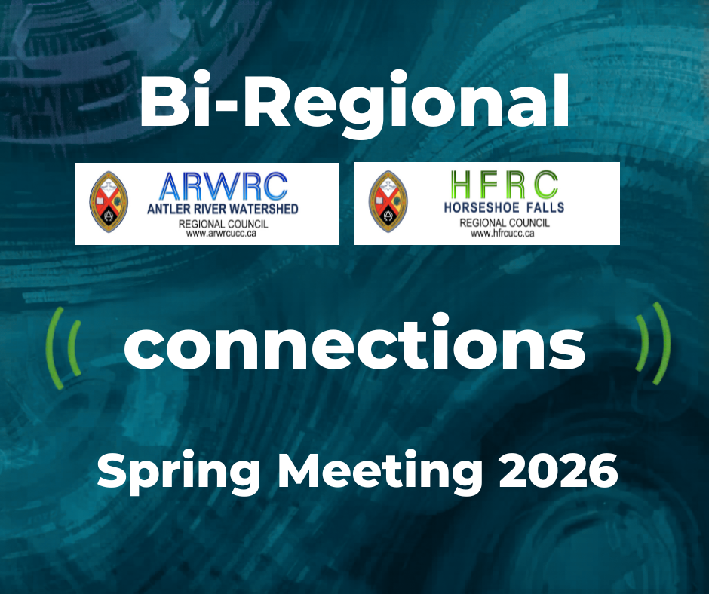

Contents
Workbook Introduction 4
HFRC Spring Meeting Support Team 5
Commitment to Community Safety 6
Participation in a Virtual Meeting 7
Zoom Link for Plenary: https://united-church.zoom.us/j/88357616179 7
Chaplains and Equity Support 9
Equity Support Team Member Position Description 10
Map of Lamplighter Inn 12
Section One:
Meeting Agenda 13
President Sula Anne Kosacky’s Message 15
Workshops Descriptions for HFRC Spring Meeting 16
Kids and Youth 17
Celebrants: 20
LLWL Recognition: 20
Retirees 21
Leaving Us 22
Retiree Message: Keith Hagerman 23
Retiree Message: Carolyn Smith 24
Retiree Message: Joanne Hedge 25
Retiree Message: Paul Miller 26
Retiree Message: Jeffrey Chalmers 27
Order of Ministry Jubilands 28
Community of Faith Life Cycle Changes: 31
Section Two: Meeting Materials
Proposal #1 – Opening and Procedural Motion 32
Proposal #2 – Recruitment Slate 34
Proposal #4 – Funding for Camps 35
Proposal #4 – Closing Motions 37
Section Three: Reports
2025 Apology to 2S and LGBTQIA+ People and Communities 38
Affirming Ministries Plan of Action 40
Report from the Chair of the Planning Committee for GC46 43
Atlantic School of Theology Report to the Region 44
Centre for Christian Studies Report to the Region 46
Emmanuel College Report to the Region 49
St. Andrew’s College 52
United Church Rural Ministry Network Report to the Region 53

Workbook Introduction

Theme: Connections

Purpose: Supports, Connects, Empowers Communities of Faith

Priorities:

Assessment | Mission & Support
Communities of Faith Support/Pastoral Relations | Children and Youth
Communications and Resources Support | Chaplaincy
Connecting/Meeting | Social Justice

Format and Process: Decision Making
The format for General Council proposals is being used for the regional meeting. The General Council approach involves three distinct stages in the decision-making process:
- Listening/Learning;
- Discussion;
- Decision.
In our regional council meeting we do not have the space or time to mirror these stages in the same way the General Council practices them.
In our proceedings, the steps will be:
- The Presenter will outline:
  - What is the issue? And,
  - The suggested way in which the regional council might respond to the issue.
- The President will inquire if there are questions for clarification.
Please note this is for clarification only.
- The President will then ask if there are changes or additions being suggested for the proposal.
- Once there is significant agreement, the President will invite the Presenter to move the motion at which point the regional council enters the formal debate process.

HFRC Spring Meeting Support Team

Agenda & Business – Wanda Backus-Kelly (Chair), Doug Caldwell (Parliamentarian), Sula Anne Kosacky (President), Mark Laird (Executive Minister), Max Watkinson (Plenary Recording Secretary)

Please contact Executive Minister, Mark Laird at mlaird@united-church.ca with any Agenda & Business items.
Chaplain – Laurie Stevenson
email: LStevenson@united-church.ca

Equity Support – Tessica Hackshaw

Note: Contact information for Equity Support persons will be shared at the meeting.
Those wanting to be in touch with equity support prior to the meeting are asked to contact:
Equity Support Staff: Thérèse Samuel– tsamuel@united-church.ca / call 226-407-4310 or
John Egger – jegger@united-church.ca / call 226-407-4309
Community Building – Pam Wilcox
Hospitality – Louise Hall and Krista Ford
Parliamentarian – Doug Caldwell
Tech Team – Greg Smith-Young, John Neff and Michele Petick
Worship Team – Greg Simpson and Gabrielle Heidinger

Commitment to Community Safety

Participation in a Virtual Meeting

Zoom Link for Plenary: https://united-church.zoom.us/j/88357616179

If joining by Zoom, please review the following. How Zoom presents depends upon the device being used. Every participant is expected to know:
- How to mute and unmute themselves;
- How to turn their video on and off;
- How to rename themselves;
- How to raise their hand.
If you are not familiar with these options, there are zoom information tips at: Zoom Resources

Please ensure you have updated to the latest version of Zoom. Otherwise, some meeting options might not work for you.
Waiting Room
When you first log into the meeting, you will be placed in a waiting room. As soon as the meeting is ready to start, you will be admitted automatically.

Participants
When you are admitted to the meeting, please go immediately to the Participants List. You will see your name listed BUT sometimes you are identified by the type of device you are using. The President will be recognizing people on the basis of the name that is shown. So, please change your name to read First Name/Surname by hovering over the mic and camera icons, click on More, then Rename.
For example, Executive Minister, Mark’s iPhone might read: Mark’s iPhone. Mark would need to go to the Participant List and change his name to: Mark Laird (he/him). All participants are encouraged to add their pronouns after their name.
Those who are at the meeting as a guest (not a voting participant) please add an x in front of your name. THIS IS IMPORTANT IF YOU ARE A NON-VOTING GUEST.
For example, if Mark was a guest, he would write his name as:
x-Mark Laird. This helps us with vote counting.

Mute
All participants will be automatically muted when they enter the meeting. Please ensure your microphone remains off. This reduces background noise and feedback and improves the quality of sound for everyone.
You will need to click on the Mute button to turn on your microphone if you are recognized by the President to speak in debate and when you move into breakout rooms.

Video
Please have your video on as you join the meeting! It is lovely to see everyone as we gather. Once the meeting begins, please turn off your video. That way, you have some privacy if you move around and are not in danger of sharing unintentionally. This also helps with the stability of the Zoom call especially in places with unstable internet.

Thumbs Up/Thumbs Down
There may be times when the President wishes to informally poll the regional council concerning a proposed change. The President may ask for a thumbs up or thumbs down. These two icons are found under reactions.

Being recognized to speak
To be recognized to speak in the discussion time, first please raise your hand by clicking on the button labeled Raise Hand. Your digital hand will then be raised. The Zoom host will draw the President’s attention to your hand. The hand will be lowered by the meeting hosts after you have spoken.

Remember when the President calls you by name to:
- Unmute your microphone
- Turn on video
- State your name; and
- Your community of faith – be sure to add the location as we have a few Trinity United
Churches, Emmanuel United Churches, St. John’s United Churches …

Voting
This will be explained in the meeting. If you are a guest, please remember you do not vote.

Chat Box
We are asking participants not to use the chat function during this meeting unless specifically instructed to do so as the chat box is disruptive for those using screen readers and can be distracting to the flow of the meeting.
Please use the private message feature in the chat to speak directly to the Zoom Community Host for the following:
- Questions of clarification;
- Procedural concerns and questions;
- Matters of privilege (for example someone uses a term that is insulting to another who then wishes to bring that to the President’s attention re the conduct of the council).
If you see a friend among the participants with whom you wish to chat, please feel free to send a private message to them. Go to Participants, enter their name or scroll to their name and click on it and then you can send them a private note! Alternatively, select “New chat” in the chat feature and select their name.

Breakout Rooms
Participants will be invited to move into a breakout room at various times during the meeting.
To join the breakout room, participants must accept the join invitation. Once you enter the breakout room, unmute your microphone and turn on your video.

Chaplains and Equity Support
IF YOU HAVE CONCERNS DURING THE MEETING:
The Chaplains and the Equity Support Team will be there (in person and online) to assist.
Contact information will be posted during the meeting.

CHAPLAINS
The chaplains are available throughout our meeting time to offer pastoral and spiritual support to participants. The chaplain provides a compassionate, confidential listening presence for anyone who may be feeling overwhelmed, anxious, emotionally affected by discussions, carrying personal concerns, or simply in need of conversation, prayer, or quiet support during the gathering.

The chaplains are present to care for the well-being of participants, not to address procedural or policy concerns.

Please note that during meeting sessions, the chaplain may not be able to respond immediately to phone calls or emails. Your message is important, and they will respond as soon as they are able. We thank you for your patience and understanding.

EQUITY SUPPORT TEAM
The Equity Support Team focuses on the health of the communal space and group dynamics, especially around justice and inclusion, throughout the planning, registration and meeting.

Equity Support Team members are here to
- Notice barriers and social and ecological injustices, as well as steps taken toward justice and equity
- Receive concerns and kudos from participants
- Report/convey/communicate concerns and kudos
  - After the meeting: with a written report to the Executive
  - During the meeting: with immediate communication to the business table, only when the team deems it necessary

Equity Support Team members can be reached by email or phone during or after the meeting.

TO CONTACT A CHAPLAIN OR EQUITY TEAM MEMBER-
The names, email and phone contact information for Chaplains and Equity Teams will be readily available during the meeting.

If you have any questions or concerns, before the meeting you may contact regional council staff:
Pastoral Support: Laurie Stevenson- Minister, Pastoral Support lstevenson@united-church.ca
Equity Support: John Egger- Minister, Social Justice jegger@united-church.ca

Thérèse Samuel- Minister, Right Relations and Social Justice tsamuel@united-church.ca

Equity Support Team Member Position Description

The members of the Equity Support Team are two or more individuals who might volunteer to be active participants at a United Church meeting or event. The Equity Support Team members are part of the leadership of a meeting or an event, and have responsibilities before, during, and after a gathering.

Equity realizes that in order to ensure fair treatment, access, opportunity, and advancement for all peoples, we need to identify and eliminate barriers that have prevented the full participation of some people and groups. Equity moves closer to justice, and it is part of the work of the church.

While working toward equity is a collective responsibility of everyone, the members of the Equity Support Team have a particular role in helping to name equity issues at gatherings.

Responsibilities
Before the meeting
- Attend planning team meetings, when possible, to help offer advice about equity- related issues and to help shape the planning process for the event or meeting.
- Receive background education and training on equity and receive an orientation to the Equity Support Team role.
- Offer advice about Web content, meetings, workshops, or events so that they follow established protocols for equity, accessibility, and communication-related issues; and that PowerPoint slides comply with an established font size protocol (as suggested by the 43rd General Council) and communicate a set of best practices for online and in-person meetings.
- Along with the planning team, clarify that the role of the Equity Support Team is different from the role of theological reflectors, chaplains, Elders, and other leadership roles that are present at a meeting or event.
- Share a contact phone number or equity email with participants so they can be in touch with the Equity Support Members during the gathering.
- Be introduced to participants of the meeting in advance (by short video and/or by email with a bio) so participants at the meeting might get to know the team members before the gathering takes place.

During the meeting
- At the beginning of the meeting, offer a covenant, equity agreements, intercultural lens questions, or other related protocols that can help work toward equity at the gathering.
- Be available (by phone or email) to participants at the meeting who would like to share about any equity-related issues over the course of the meeting (including affirmation of processes, or hearing particular challenges that people are experiencing).
- Help work toward the full participation of peoples of all identities.
- Be attentive to microaggressions, unhelpful power dynamics, harm, intercultural conflicts, oppressive practices, and/or other inequities.
- If hurt or harm has been done in the course of a meeting, in most cases do not offer a direct intervention or interjection in the moment, but rather be in touch with the moderator or chair of the meeting and ask them to address the issue at another point during the gathering.
- Partway through the gathering and/or at the end of the gathering, offer advice and feedback on how the meeting has been functioning in terms of equity. It is helpful to offer some affirmation about what has been going well, and suggestions for a subsequent gathering.
- When reporting back to the meeting, point out any issues in a general way, and not specifically target individual people.

After the meeting
- Meet with staff and/or the planning team to offer feedback about equity for a subsequent meeting. These could name what has worked well and what should continue, as well as suggestions for improvement at a subsequent meeting.
- If possible, offer a written report of their insights and recommendations for a future meeting.

Background
The United Church of Canada, through its General Council, has made several commitments around equity in recent years. These commitments include the following:
- adopting the United Nations Declaration on the Rights of Indigenous Peoples as the framework for reconciliation between Indigenous and non-Indigenous peoples
- adopting the Calls to the Church as the basis for a new relationship
- welcoming people of all sexual orientations and gender identities into full membership and ministry in the church
- committing to becoming an intercultural church
- committing to becoming an open, accessible, and barrier-free church, where there is full participation of people with disabilities
- working toward functional bilingualism and ensuring that francophone ministries are an integral part of the church’s identity, mission, and vision
- opposing discrimination of any kind on the basis of identity, and
- developing an anti-racism policy and committing to becoming an anti-racist denomination.

All of these commitments are part of ongoing and sustained efforts for the United Church to continue to work toward equity, creating better places of belonging for people of all identities, to challenging power and privilege, and to live into God’s call to be the church.

Map of Lamplighter Inn

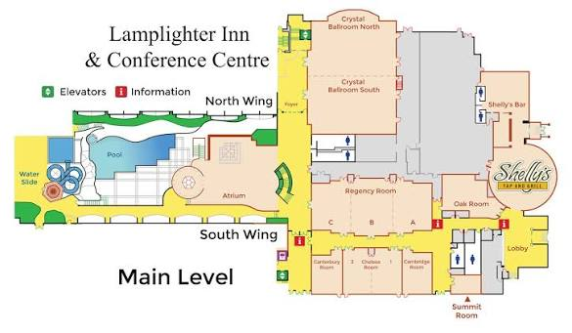

Section One:

Meeting Agenda

Friday, June 26th | 1:30 p.m. – 8:30 p.m.
 | Welcome, Land Acknowledgement
 | Introduction of Meeting Leadership, BRAVE + Affirming Statements
Opening Worship
Covenanting with New Staff
 | Community Building
Commissions Presentation
Hear from Candidates

 | BREAK
 | Hear from Candidates
 | Presentation from TUCC
Presentation from the Moderator
United Church of Canada Foundation Presentation
Emmanuel College Presentation
 | Dinner
 | Workshops

Saturday, June 27th | 9:00 a.m. – 8:30 p.m.
 | Welcome back
 | Worship
 | Presentation from the Moderator
 | M&S Recipients
BREAK (RCs will meet individually following the break)

Welcome
Time with President
Time with the Congregational Support Commission
 | President Elect Speeches
 | Time with the Moderator
 | Covenanting with LLWLs
 | Elections
 | Covenanting with newly elected
 | New Business: Proposal #3 Camp Ministry
 | LUNCH (RCs rejoin following lunch)
 | Celebration of Ministry Service
 | Dinner
 | Retirees / Jubilands
 | CoF Lifecycle Changes / In Memoriam
 | Ecumenical Guest
 | Community Building
 | Closing Prayer

Sunday June 28th | 9:00 a.m. – 12:15 p.m.
Welcome
Worship
Youth Presentation
 | Presentation from the Moderator
 | BREAK (RCs will meet individually following the break)
 | Welcome back
 | 2SLGBTQIA+ Apology
 | Thank Yous
 | Closing motion

President Sula Anne Kosacky’s Message


Dear Horseshoe Falls Regional Council,
Happy Summer/Happy Pride!

Welcome to our HFRC Spring gathering where our theme for the weekend will be Connections. We chose this theme with
intention because the church, if boiled down to a couple of words might be community, or maybe relationship.

My hope, as the president of Horseshoe Falls region is that we might strengthen and nourish our connections. From the grass roots of connection and relationships within a single community of faith, to the relationships between different communities of faith, there is a spirit moving us to be stronger together. Between the first third, second third and third third, (the children and youth, the young and middle-aged adults, and our elders) we need to establish and support the creation of relationship and connection. Between the communities of faith, and our regional leadership, we need to reconnect and build trust and relationship. ALL of us are stronger together than any of us are alone.

"Though one may be overpowered, two can defend themselves. A cord of three strands is not quickly broken." Ecclesiastes 4:12

Church, we are living in troubled times. I read an article recently that says research shows that people are more connected to their phones and computers now than ever before, because they feel so alone.
Loneliness is now recognized by the World Health Organization as a threat to global wellbeing. Everyone is broadcasting – songs, poems, books, blogs, YouTube, TikTok, chatrooms, Facebook – everyone is broadcasting the message “I’m here. Please notice me.” But no one is really on the other end paying attention. For the younger generation, when asked the question “what do you want to do for work when you grow up?” the most often stated response is “Influencer”.

Surely the Spirit must be calling us into the wilderness of this loneliness. Surely, this Jesus whom we follow is walking even now into the places where people long to be seen, listened to, understood, valued, included and loved. Surely the God in whom we are adopted as sons and daughters wants their children to be a family. And surely a church that is meant to share God’s love with the world should be a United Church.
Just like every family, we have conflict sometimes and that’s fine! Conflict teaches us how to learn and grow; how to listen and compromise and understand one another. In doing this, we as church might set an example for our communities about how to find our own belonging and to offer relationship, care and belonging to others.

Let us meet with joy, let us connect with one another in fellowship, and in God’s work for our world.
Amen.
Rev. Sula Kosacky - HFRC President

Workshops Descriptions for HFRC Spring Meeting
Time: 7 p.m. on Friday June 26th, 2026

"We're More Than a Holding Operation!" (it'll make sense in the presentation!) - In Person Only
Join Kyle Pugh, the Ontario Regional Councils Archivist, as he talks about The United Church of Canada Archives, its holdings, the services they offer, and how they can help you and your congregation!
From Coffee to Collaboration: Shared Ministry in Southwest London - In Person Only
Come and hear from Michelle Owens, Kerry Stover and Rob Apgar Taylor about a collaboration that is happening in London- 4 churches-3 Ministers- One Spirit!
Simple Practices for Spiritual Connection - In Person Only
Presented by Minister Pastoral Support Laurie Stevenson. In the midst of busy lives, learning to "stop and listen" is both a challenge and a gift. This workshop offers an introduction to a range of spiritual practices that invite deeper awareness of self, others and God. Through guided experiences and gentle reflection, participants will be encouraged to notice how the Spirit speaks through body, mind and soul. Come with curiosity, and leave with practices you can carry into daily life.
Faithful Conversations for Amalgamation Discernment - In Person Only
This workshop offers a guided introduction to Exploring Amalgamation Faithfully, led by Congregational Support Minister, John Neff, a resource designed to help congregations slow down, listen deeply, and approach amalgamation as a spiritual and relational journey. Participants will explore practical tools and facilitated exercises that emphasize story-sharing, trust, pastoral care, and discernment before outcomes. Ideal for those supporting congregations navigating uncertainty, change, and shared decision-making.
Connecting with Rural Churches - Hybrid https://united-church.zoom.us/j/87032209155
Eric Skillings has a passion for Rural Ministry. Eric will share practical ways to connect with your neighbouring Rural Churches. Why bother connecting with your neighbour Churches? Where do you start? How to get connected? Connecting with your neighbour can give you both new life! Over the past three years, South Kent United Churches have connected and supported each other through changes that no one could have predicted. Synergy; one + one = three.
Budgeting on Purpose: How to make your budgeting process faithful, collaborative, and even enjoyable - Hybrid https://united-church.zoom.us/j/88357616179
Discover how to transform your church budget from a necessary task into a meaningful expression of your ministry and calling. In this workshop, you’ll learn how to align financial decisions with your community of faith’s purpose while building a process that is collaborative, transparent, and life-giving. Whether you dread budgeting or simply want to improve it, you’ll leave with practical tools and fresh perspective. You will leave this workshop with…
- Greater hope and clarity about your next budget cycle, grounded in your church’s “why”
- Practical ideas and tools to make your budgeting process more collaborative, flexible, and forward-looking
- Confidence in connecting finances to ministry impact—telling a compelling story with your budget
CHOOSE ONE!
Register for workshops here: ARW/HF Bi-Regional Council Spring Workshops 2026 – Fill out form

Kids and Youth

Yay! You are coming to the HF & ARW Spring Meeting
Now what?

Soon we will be gathering at the joint ARW & HF Regional Gathering in London on June 26-28. This is an information package for our children and youth program to help you prepare and know what to expect.

Arrival (1-1:30PM) **Optional early drop-in**
The registration team will happily greet you at our welcome table in the lobby. We will guide you to the Chelsea room where you can leave your luggage if checking in later. We can show you the Chelsea room, as well as the main meeting space. This drop-in time is optional to ease your familiarity with our space, team and other participants.

Please eat before you arrive or bring along a lunch to eat in our space.

Sign In/Out

It is expected that caregivers will sign-in with each child/youth when they are starting the program each day and sign them out when they will not be returning for the evening.

Reminder that they will be sharing accommodation with their caregiver or as otherwise assigned. They will not be supervised outside of program hours.

No need to come and get them for meals. Meals will be with the adults (except for Saturday pizza lunch if at the church). We will bring children to you and have you initial our sign in/out sheet. They are welcome to eat with you or us until our next activity begins. We will provide snacks during the day for those not bringing their own (including vegan options).

Packing List
What should you bring? We hope to go outside for a walk. So, here’s what we think:

- Pajamas (will be a PJ party both nights for children who stay after dinner)
- Comfort Item (books, stuffy, blanket, fidgets, etc.)
- Shirts, pants, sweatshirts, underwear, socks, etc.
- Face cloth & toiletries (toothbrush, toothpaste, deodorant etc.)
- Weather appropriate coat and comfortable indoor & outdoor footwear
- Sunscreen and hat
- Refillable water bottle
- Personal snacks for breaks/room
- Medicine (as needed)

Meet Our Leaders

A superstar team that has been preparing for this moment! It takes a village 😊

- Chris Lindsay – Children's & Youth Program Coordinator at First-St. Andrews United Church in London
- Seann Laforet (Divinity student) – HUB Community Network staff for youth and young adults; member at St. Paul's United Church, Oakville
- Meghan Gilholm (Divinity student)– First Third Minister at Grace United Church, Burlington
- Laura Black (Master of Education) – Tri-Regional Council Staff, First Third Ministry Faith Formation

Group Covenant for Health, Safety, and Respect

In Antler River Watershed and Horseshoe Falls Regions, we seek to serve by holding, encouraging, connecting, supporting, and empowering communities of faith. To prioritize a safer and meaningful experience for all involved, we ask participants to align with the following covenant, informed by Faithful Community: A Duty of Care Approach for Programs.

- Because I want to serve others, I will bring an open and curious attitude. I will come ready to build relationships, help the community, and learn from the people I meet.
- Because I understand my actions affect others, I will follow all local laws, Lamplighter Inn and United Church of Canada policies. This means:
- I will not bring or use illegal substances, alcohol, cannabis, or tobacco products while participating in the program.
- I will maintain personal boundaries and follow laws of consent. There are no secrets around touch. I will listen when someone says stop with their words or body.
- I commit to using electronic devices respectfully (moderate usage – putting them away during program time) to focus on building relationships and limit distractions. I will not take or post content (videos, photos, etc.) about others unless I have consent from caregiver and participant.
- Because I value community, I will treat everyone - leaders, staff, other participants, and community members - with kindness, respect, and understanding. I will consider how I am showing up, who hasn’t had an opportunity to contribute, and not repeat personal stories without permission. I honour that people learn, process, and communicate differently.
- Because my well-being and the well-being of others is important, I will follow safety guidelines, stay within designated boundaries in groups of three or more when required, be wise about my choices, and communicate regularly with my leaders.
- Because I know how I treat others and their belongings matters, I will respect the property of others, and the spaces where we gather, work, and stay. I will remember that I represent the wider church community. I will act in a way that reflects care and humility.

Health & Safety Note: First Aid Kit will be present at the event. Group activities are led by a minimum of two volunteers and a roving volunteer who can offer support and assist in an emergency. Children under 12 will always have supervision.

Program
An overview of our evolving weekend schedule – without revealing all the “Connections” magic.

FRIDAY @ Lamplighter
1 PM – Welcome & Drop In as you arrive (Chelsea Room)
1:30 PM – New Connections: Icebreaker & Group Activities (Chelsea Room)
2:30 PM – Community Connections (Plenary)
3:00 PM – Nature Connections: Guided Walk to Mitches Park & play (weather permitting)
4:00 PM – Theme Connections: Stories & Music
5:30 PM – Supper & Break (with adults; sign out)
- In case you are interested, from 5-7pm there is a Family Community Campfire at Camp Kee-Mo-Kee in Komoka (~25 minutes).
7:00 PM – Optional: PJ Movie Night (Chelsea Room) or family time (swimming, games room, etc.) while workshops happen
8:30 PM – Complete sign-out for those remaining

SATURDAY @ First-St. Andrew’s Church for the daytime
8:30 AM – Drop off at First St. Andrew’s Church (FSA parking lot at back or pull in drop off area)
9:00 AM – Reconnecting: Group Activities (Fireside Room)
10:30 AM – Connecting through Art: Crafts, Theater, Music
12:00 PM – Pizza Lunch at FSA
1:00 PM – Connecting with the Plenary: Creating for Sunday's Worship & Youth Presentation
2:30 PM – Connecting with our Bodies: Sports, Mindfulness and Somatic Exercises
5:00 PM – Supper & Break (Return with adults at Lamplighter; sign out)
7:00 PM – Optional: PJ Video & Board Games Party (Chelsea Room) or family time
8:30 PM – Complete sign-out for those remaining

SUNDAY @ Lamplighter
9:00 AM – Connecting with God: Spiritual Practices & Worship; Youth Presentation (Plenary)
10:00 AM – Connecting with our voice and choice: Games and Craft Stations (Chelsea Room)
11:30 AM – Closing Connections: Circle & Communion (Chelsea Room)
12:30 PM – Final Sign Out

Questions or Concerns

Before Event Contact: Laura Black, Lblack@united-church.ca or 1-226-407-4308

During Event Contacts:
Laura Black @ 519-635-8235; Seann Laforet @ 905-580-6563; Chris Lindsay @ 519-872-5441

Celebrants:

Caitlin Mackenzie
Ordained Ministry

Previously Recognized as a Designated Lay Minister who has now met the requirements of The United Church of Canada to enter into Ordered Ministry:
Janice Pow
Ordained Ministry

Celebration of Ministry Service attendance will be in-person at Lamplighter Inn and livestreamed on YouTube at this link on Saturday June 27th at 2:30pm:
https://www.youtube.com/live/iNagjG-ZDtM?si=GbeR_vgFSFsWDvz9

LLWL Recognition:
Brian Takayesu, member of Erin Mills United Church – 11/26/2025
Andrew Harris, Member of Burford United Church – 11/26/2025


Retirees

Carolyn Smith, OM
July 1, 2025

Keith Hagerman, OM
Marshall Memorial P.C.
June 1, 2026

Joanne Hedge, OM
Mississauga Applewood P.C.
June 30, 2026

Philip Gardner, OM
West Plains Pastoral Charge, Burlington
August 1, 2026

Jeffrey Chalmers, OM
Bethesda United Church, Ancaster
August 1, 2026

Retirees continued

Paul Miller, OM
Westminster United Church, St. Catharines
August 31, 2026

Leaving Us
Tanya Cameron
Office of Vocation, The United Church of Canada
June 30, 2026

Retiree Message: Keith Hagerman
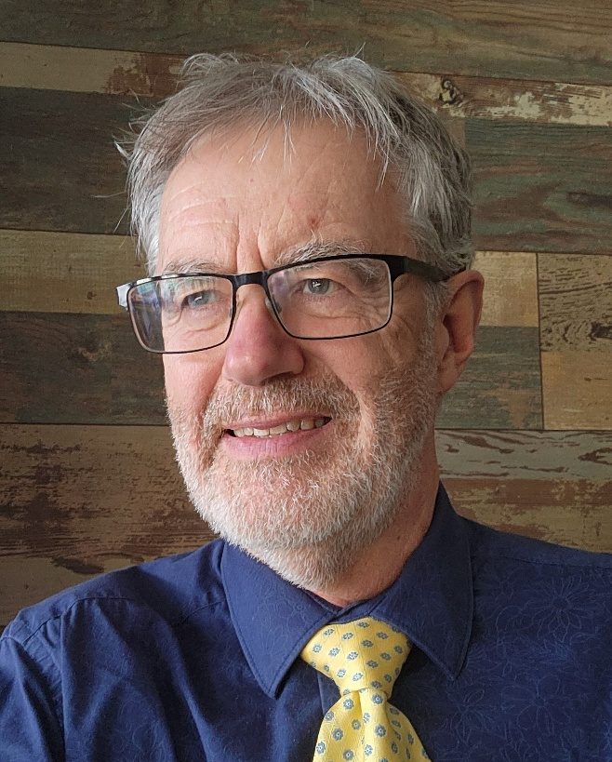
Ministry Reflection from Keith Hagerman
Keith Hagerman was ordained by Maritime Conference on May 15, 1988 – a candidate for ministry from Wesley Methodist Church in Hamilton, Bermuda (Bermuda Synod, UCC Maritime Conference). He went on to serve churches in London Conference: Kintore and Brooksdale (Oxford Presbytery) and St. Johns, Stratford (Huron-Perth Presbytery), before returning to Maritime Conference: St. James, Antigonish (Pictou Presbytery). Later he served St. Andrews-Westminster and Littlewood (Middlesex Presbytery, London Conference), Parkminster (Waterloo Presbytery, Hamilton Conference), First, Cambridge and then Wesley, Cambridge (Western Ontario Waterways RC), and finally Marshall Memorial, Ancaster (Horseshoe Falls RC).

Along the way, Keith was involved in university chaplaincy (Westminster College at University of Western Ontario and St. Francis Xavier University), countless workshops on worship and music, leading both music and worship at Conference Annual Meetings and at General Council, directing musicals, leading small group discussions on progressive theology, leading worship at UCC Berwick (family) Camp, and involvement with the Guatemala-Canada Solidarity Network (including composing and directing a musical, Solidarity: The Musical).

After receiving both a BA and BMus from Mount Allison University, Keith went on to complete both MDiv and MSM degrees at Boston University School of Theology and School of Fine Arts. Later, he was awarded a post-graduate Merrill Fellowship to Harvard Divinity School where he focused on the interface of the arts and spirituality.

Throughout his ministry career, Keith developed a pattern of weekly writing, both to the local congregation and to the wider public. This became an opportunity to make connections with spirituality, often acting as a spiritual guide and companion on the journey.

Keith is retiring from 38 years as an ordained minister in the United Church of Canada. He is a progressive theologian, skilled at making new connections between the world and evolving spirituality, encouraging others to live authentically and courageously in this time. He is a musician who uses music in prayer and praise, connecting people to one another in community and to the sacredness at the heart of life. He is a minister who proclaims justice and hope, grief and lament, expressing what is deepest within us. In retirement, he looks forward to the possibility of future work with the church. His prayer is for the thriving of the progressive United Church. The community and the world need us more than ever.

Retiree Message: Carolyn Smith


It's a different view for me this summer, enjoying the sun in our new home with a pool, and in a busy new season with my partner and our shared work. The rhythms of ministry remain very close to the surface. Twenty years in these circles, and a lifetime shaped by church life run deep, while I'm allowing new rhythms to make themselves known.

I've championed this United Church of ours as flourishing community, widening the welcome before it was comfortable. It has been a rare space of mingling ages and stages together, and it chooses public, intentional and explicit witness in social arenas, leading past safe and crowded spaces where 'faithful' too often hides.

What brings it to life every time, is the Spirit in and among people.

People striving to lead well, discovering gifts they didn't know they had. Young people with more to teach than they know. Marginalized voices finding expression in a needed space. Folks walking through the door carrying courage, hopes, grief, and possibility, despite the headlines. New and old, challenging and championing each other for something better. It's stewardship at its best: making room for and nourishing the gifts already present among us, helping one another become more fully ourselves, and knowing all the time that God creates new things — more than the sum of our parts.

It has been good to serve and lead together. In this season, my calling stretches now to developing leaders; coaching for resilient integrity in hard times and hard work; gathered at tables with people seeking to lead wisely in civic life and in the church too.

The 2035 numbers weigh heavily, but they are no surprise after forty years of watching. And yet, people still come. Not at the altitude of cross-country statistics, but that doesn’t diminish what’s good. When something we do touches deeply the world around us, it meets a need people don't even know they have. When someone bothers to show up on a Sunday morning, join a call at seven, or drop in for a games night - that is not nothing. It's sacred space for them and us. It's a miracle.

Meet them well. They are not problems to manage; they are the purpose. Champion them. Let them change you. The Church has always moved forward on the courage of people who were trusted just enough, just in time. Be that trust for someone. Make it matter.

Over many seasons, I've been honoured to be called and reaffirmed in my ministry. In other seasons, I’ve been sustained by cherished mentors and rejuvenated by daring voices who call us forward.

For this turning season, I step back. I entrust these people, this work, and this church I love, to all of you. With deep gratitude and abiding hope, Carolyn

Retiree Message: Joanne Hedge

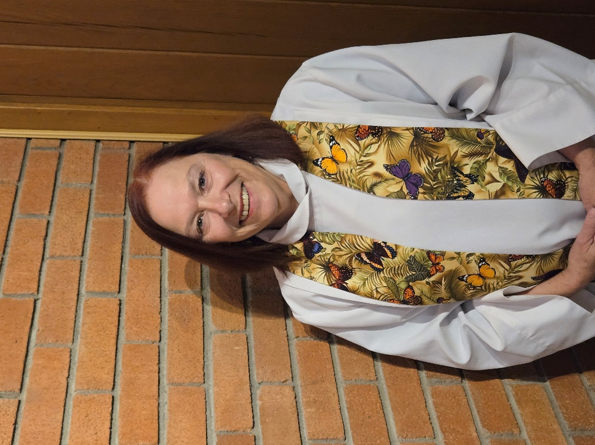
I am grateful to be retiring from pastoral ministry with so many wonderful memories and supportive relationships to sustain me. There has always been a new adventure around the corner as I have served, and I anticipate more grandma escapades, more travel and quests to visit new places, and more time and adventures with family, friends and my garden in retirement!
Thanks to those who have journeyed with me or crossed my path over the last fifteen years – it has been a great honour to walk with you and share a bit of this vocation with you as colleagues and friends. May we all continue to be wrapped in God’s love, nourished by the love Jesus gives, and inspired by the love expressed in the Spirit.

Retiree Message: Paul Miller

Reflections on Retiring Paul Miller
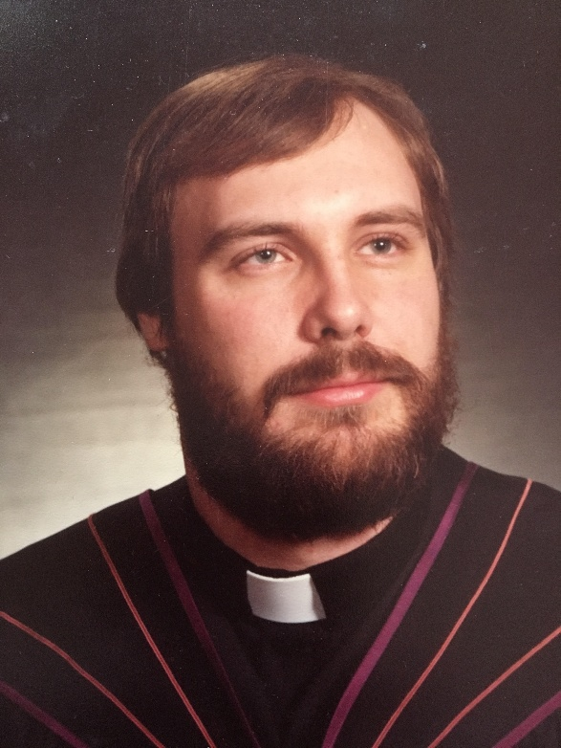
I was ordained on a blistering hot June night in 1981 at First United Church in Waterloo. There were nineteen – nineteen – of us being ordained and commissioned. In some ways it seems like yesterday. In other ways, it’s like another lifetime – if not another planet!
I consider myself amazingly blessed to have been able to serve in ministry for 45 years. I spent the first 33 in wonderful congregations in Emsdale, Vankleek Hill, Norwich and St. Catharines, Ontario. From 2014 to 2018, I worked as a full-time support minister for Waterloo Presbytery, giving me the opportunity to be involved with a whole range of congregations in a whole range of different ways.
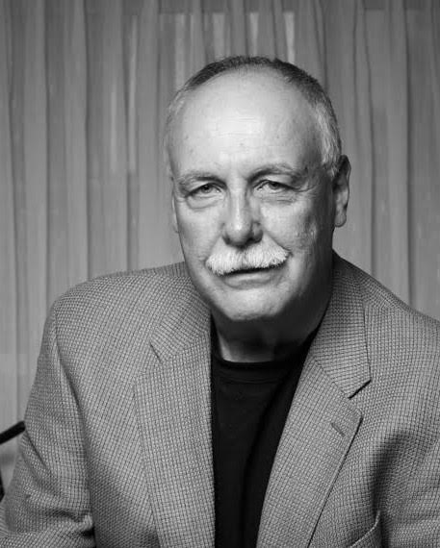
This is my second stab at retirement. The first one didn’t stick. When the church restructured, my Presbytery job disappeared. I took my pension and did a whole lot of things as a volunteer. I vowed I would never take a retired supply appointment. Then I led a couple of workshops at Westminster United in St. Catharines, a church who had been without a minister for over a year. I agreed to come and help them – for six months. Here I am, six years later. Profoundly grateful, but ready to give retirement another try. Westminster is fortunate to have been able to enter into a collaborative ministry agreement with a neighbouring congregation, so I leave them in good hands. Which has made my decision easier.
I could not have predicted in 1981 what the church of 2026 would be like. And I do not know what the church will be 10 or 20 years from now. But I face retirement with a profound sense of gratitude for this United Church of ours and for the privilege of serving God’s people. I will keep on contributing in whatever ways I am able for as long as I am able, trusting that God will continue to be at work in and through us, and that the Good News of Jesus Christ will continue to be heard, received and lived out in ways beyond our imagining.

Retiree Message: Jeffrey Chalmers



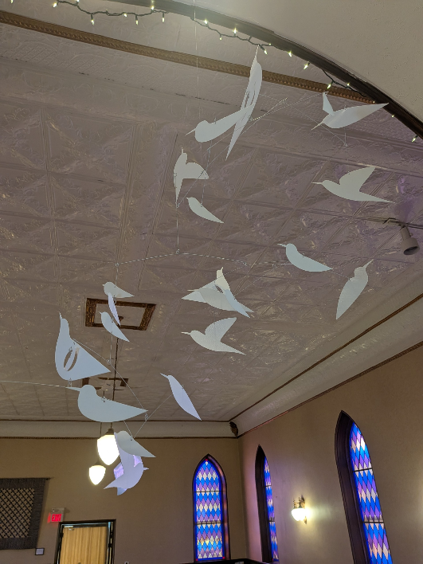

Pictured here … Sanctuary Spirit Mobil , Call to Worship quilt, and The welcoming Christ, the Bethesda Ent, the worship table and circle for outdoor baptisms, communion and occasional Sunday worship, part of 12 Bethesda Link spaces including a healing garden, Labyrinth, medicine wheel garden, community vegetable garden and truth and reconciliation plaza for faith and the common good concerts and protests.

Taken together, these have been the thrust of my Bethesda ministry focus points and the forward missional justice and evangelism efforts of this congregation. It has been a joy and a privilege to enter ministry in the United Church of Canada from the Presbyterian Church of Canada and to return to the rhythms, joys and challenges of parish ministry for 14 years at Bethesda after 20 years in corrections Chaplaincy.

Sincerely,
Rev. Jeffrey Chalmers.

Order of Ministry Jubilands

*** = entered through Admissions
5 Years:
Janice Pow, DLM

10 Years:
Barbara Creelman, OM
Brenna Baker, OM - Ordained in 2011 by the Presbyterian Church in the U.S.A.
Douglas Neufeld, OM
James Grunden, OM
Kevin Taylor, OM
Tessica Hackshaw, OM ***admitted from the Methodist Church in the Caribbean and the Americas

15 Years:
Deb Kigar, DM
Joanne Hedge, OM
Karen Williams, OM
Victoria Aldersley, DM
William Smith, OM

20 Years:
Candance Harvey, OM
Heather Gilmour, OM ** ordained in 1987 by the Baptist Convention of Ontario and Quebec.
Paul Ivany, OM

25 Years:
Alison Nicholson, OM
Jessica McCrae, OM
Kellie McComb, OM
Lee Claus, OM
Stephen Iverson, OM

30 Years:
Daryl Webber, OM
Dwayne Ratzlaff, OM
Eleanor Scarlett, OM
Lark Kim, OM **admitted in June, 1996 from United Methodist Church
Mary Rabjohn, OM
Ronald Pritchard, OM ** ordained in 1966 by Presbyterian Church in the US

35 Years:
Ann Stratford, OM
Consorcio Estoesta, OM **admitted in 1991 from UCC in the Philippines
Glenn Baker, OM
Mary Bish, OM
Robert Winger, OM

40 Years:
C. George White, OM
Donald Glennie, OM
Gayle Lucas-Roth, OM
Neil Young, OM
Ross Leckie, OM

45 Years:
Diane Walker, OM
Jessie Jansen, OM
Paul Miller, OM
Richard Burgess, OM
Seiichi Ariga, OM

50 Years:
Brian Elder, OM
David Love, OM
John Matthew, OM
Mark Gibson, OM
Randall MacKenzie, OM

60 Years:
Brian Brown, OM
George Peck, OM
Harold Wells, OM
John Nield, OM
Michael Beacom, OM

65 Years:
Johannes Huntjens, OM
William Bell, OM

70 Years:
Phillip Cline, OM

In Memoriam

Rev. Jeffrey Learmonth, OM
Rev. Roberta Pocklington, DM
Rev. John Ross Routliffe, OM
Dr. Ross L. Judd
Rev. Ian Kirby-Smith, OM

Community of Faith Life Cycle Changes:

Amalgamations
Freelton-Strabane and Rockton Amalgamation (became Heritage United on May 31, 2026)

Collaborative Agreements

Linden Park United Church & Binbrook United Church, January 1, 2026

St. John’s United Church & St. Andrew’s United Church (Georgetown) (January 1, 2026-June 30, 2026)

St. Paul’s United Church (Hamilton) & Emmanuel United Church (Hamilton), March 1, 2026

Section Two
Meeting Materials

Proposal #1 – Opening and Procedural Motion

Title: Opening and Procedural Motion
Origin: Executive Minister

What is the issue?
The regional council must establish the procedures by which it will conduct business.

Why is this issue important?
This clarifies and confirms the way in which decision-making will happen.

How might the regional council respond to the issue?
The regional council might adopt the following as a consent docket:
- Adopt the agenda as circulated and authorize the Agenda and Business Committee to make any changes as necessary;
- Approve the minutes of the meeting of 2025-11-21/22;
- Receive the minutes of the following meetings of the

  - Executive
25-09-24
25-11-26
26-01-28

- Congregational Support Commission
25-11-04
25-12-09
26-01-13
26-02-10
26-03-10

- Human Resources Commission
25-10-22
25-11-10
25-11-26
26-01-28
26-02-25

- Discipleship and Justice Commission
25-09-25
25-10-23
25-11-20
26-01-15

Note: Minutes are posted on the website www.hfrcucc.ca “About” page

- Confirm the appointment of Jessica McMillan to the HFRC Discipleship & Justice Commission;
- Appoint Doug Caldwell as Parliamentarian;
- Appoint Wanda Bakus-Kelly as Chair, Agenda and Business Committee;
- Name Tessica Hackshaw to serve as Equity Support Team Member;
- Name Laurie Stevenson as Chaplain;
- Name Sula Kosaky, Chair Agenda and Business Committee Wanda Bakus-Kelly, Executive Minister Mark Laird and Executive Assistant Max Watkinson as the Agenda and Business Committee;
- Set the bounds of the meeting as the Best Western Plus Lamplighter Inn, 591 Wellington Road, London, ON, N6C 4R3, and the Zoom call
- Make the designated representative from any United Church ministry, other than a congregation, which has been invited to become a community of faith by entering into a covenant with the regional council, a member of the regional council for this meeting (Section C.1.2 c);
- Make all guests corresponding members;
- Set the deadline for new business to be submitted to the Agenda and Business Committee as 9:00 a.m., Saturday, June 27th, 2026
- Adopt the following method for dealing with proposals for action by the regional council

Step One:
The Presenter will outline:
- What is the issue? and
- The suggested way in which the regional council might respond to the issue.
Step Two:
The President will inquire if there are questions for clarification. Please note this is for clarification only.
Step Three:
The President will then ask if there are changes or additions being suggested for the proposal. Using warm and cool signals, the regional council will seek to come closer to agreement on how to respond to the issue.
Step Four:
Once there is significant agreement, the President will invite the Presenter to move the motion at which point the regional council enters the formal debate process.

Proposal #2 – Recruitment Slate

Proposal
What is the issue?
The regional council can best fulfill its decision-making responsibilities if it has a full slate of diverse members in decision-making roles.
What might the regional council do?
The regional council might agree to: Accept the slate discerned by the Recruitment Team as presented on the floor of the court of Horseshoe Falls Regional Council Spring Meeting June 26-28, 2026:
That Horseshoe Falls Regional Council approve the slate prepared by the Volunteer Recruitment Committee as presented (additional names to be added at the spring meeting):

Volunteer Recruitment Committee
Proposed Slate for Horseshoe Falls Regional Council
Spring Meeting June 26 to 28, 2026
as of June 19, 2026
Executive (5)
John Hurst (lay) ⁽²⁷⁾  __________________ ⁽²⁹⁾ | __________________⁽²⁹⁾ __________________ ⁽²⁹⁾  __________________ ⁽²⁹⁾
Congregational Support Commission (6)
Alison Playfair (OM) ⁽²⁹⁾  Scott Martin (lay) ⁽²⁹⁾  Cheryl Dillon(lay) ⁽²⁹⁾ | __________________ ⁽²⁹⁾  __________________ ⁽²⁹⁾  __________________ ⁽²⁹⁾
Discipleship and Justice Commission (7)
Sue Starling (lay)⁽²⁹⁾  Lance Wright (lay) ⁽²⁹⁾  Keith Rutherford (lay) ⁽²⁹⁾ | Olivia Van Ravensway ⁽²⁹⁾  __________________ ⁽²⁹⁾  __________________ ⁽²⁹⁾ | __________________ ⁽²⁹⁾
Pastoral Relations Commission (2)
Michael Veall (second term) ⁽²⁹⁾
__________________ ⁽²⁹⁾

Proposal #3 – Funding for Camps

Origin: Cave Springs Camp, Board of Directors

- What is the issue? Why is it important?
Congregations have supported United Church camps for decades as they provide outdoor ministry for faith development, especially in the first third of life. With the decline in Sunday Schools and youth weekly programs, camping is a means for our children and youth to experience faith-based activities.

- What is happening now?
As congregations diminish in size, there is less funding for camps. Camps have strained operating budgets, due to fewer donations from congregations.

When congregations disband, they may designate up to 32% of net proceeds from sale of buildings to United Church Charities such as camps. Some are very supportive of camps.
Others have limited energy to designate funds, or may even lack trustee energy to manage the congregation disbanding and selling property.

- What is the recommendation?
That Horseshoe Falls Regions establish a policy that 20% of net proceeds from disbanding congregations, be directed to the camps in Horseshoe Falls Region.
(ie. Ryerson Camp in Vittoria (Norfolk) and Cave Springs Camp in Beamsville (Lincoln))

- Background information:
The United Church of Canada has called for an increased emphasis on the faith formation in the first third of life.
General Council 45, in August 2025, resolution COM09
A Call for Strengthening Camping Ministries as Central to Faith Formation within The United Church of Canada…………
“As camping ministry enthusiasts, we believe God/Jesus/The Holy Spirit is calling on The United Church of Canada to help change the mindset and engagement of the whole Church to invest in Camping Ministries as central to our collective work of faith format”
per webpage https://generalcouncil.ca/search?search_api_fulltext=COM09

- How does this proposal help us to live into our church’s commitments on equity?
The principal of equity is supported by Christian Camps, who offer access for all.

The current procedure reads

that in accordance with Manual Section C.2.6(a), Horseshoe Falls Regional Council adopts the policy that funds received from the property of a disbanding congregation be disbursed in the following manner:
- Reimbursement of holding/maintenance/disposal costs
- Covering unpaid past assessments and current year assessment
- Repaying any congregational indebtedness
- 33% to the United Church ministry(ies) of the community of faith’s choosing (provided a registered charity)
- 2% to Archives
- 15% to Indigenous Ministries in response to the Calls to the Church (received GC43) to support Indigenous Ministries and to upgrade Indigenous real property
- 10% to current year Mission and Service
- 15% to Mission and Service Endowment Fund to provide for the future
- 25% to the regional council to enable it to provide ongoing support and resources to communities of faith.
Be changed to read

that in accordance with Manual Section C.2.6(a), Horseshoe Falls Regional Council adopts the policy that funds received from the property of a disbanding congregation be disbursed in the following manner:
- Reimbursement of holding/maintenance/disposal costs
- Covering unpaid past assessments and current year assessment
- Repaying any congregational indebtedness
- 33% to the United Church ministry(ies) of the community of faith’s choosing (provided a registered charity)
- 2% to Archives
- 15% to Indigenous Ministries in response to the Calls to the Church (received GC43) to support Indigenous Ministries and to upgrade Indigenous real property
- 10% to current year Mission and Service
- 5% to Mission and Service Endowment Fund to provide for the future
- 15% to the regional council to enable it to provide ongoing support and resources to communities of faith.
- 20% to the operating budgets of camps within Horseshoe Falls Region.

Proposal #4 – Closing Motions

Title: Closing Motion
Origin: Executive Minister
What is the issue?
The work of the regional council continues between regional council meetings.

Why is this issue important?
The regional council must be clear how the work will continue.

What might the regional council do?
The regional council might
1. Entrust any unfinished business from its June 26-28, 2026 meeting to the Executive;
2. Authorize the Executive to fill any vacancies on the understanding that appointments will be confirmed at the next spring regional council meeting;
3. Direct the Executive to plan to convene a meeting of the regional council in the fall of 2026;
4. Entrust the Executive and Commissions with the responsibilities and authority of Horseshoe Falls Regional Council in accordance with The Manual of The United Church of Canada and the Governance Handbook of the Horseshoe Falls Regional Council.
5. Close the June 26-28, 2026 meeting of the Horseshoe Falls Regional Council.

Section Three: Reports

2025 Apology to 2S and LGBTQIA+ People and Communities
Spoken by the Moderator and General Secretary
at General Council 45 in Calgary
during a service of worship on August 8, 2025
Words from the Task Group
As the authors who were tasked with writing this apology, we have held the deep challenges and complexities of speaking on behalf of the church. We know that each of you carry your own stories and experiences; you have come to understand the United Church through relationships with communities of faith, clergy, staff, and fellow United Church members.
We recognize that each person has their unique needs when it comes to healing and that for some, this apology arrives too late and for others, this apology arrives ahead of healing actions by the church that have been longed for.
We offer this apology not because we’re convinced we have everything figured out but because we refuse to let fear keep us silent, nor do we wish for perfectionism to overtake the necessary task of publicly and explicitly addressing the legacy of 2S and LGBTQIA+ oppression and discrimination in The United Church of Canada.
We hope that where the apology feels inadequate, that these further resources may provide more depth, nuance, and healing as you process this apology.
Sincerely,
The Apology Task Group:
Rev. Michiko Bown-Kai (acting Chair), Rev. Aaron Miechkota, Christine Dolson, Frederick Monteith and Rev. Tricia Gerhard
February 2025
Apology to 2S and LGBTQIA+ People and Communities
Recognizing the need for apologies to be lived into with action, The United Church of Canada offers the following statement in response to the findings of Iridesce: The Living Apology Project and the 2011 National LGBT Consultation.
God tends the universe,
mending the broken and reconciling the estranged.
God enlivens the universe,
guiding all things toward harmony with their Source.
The church has not always lived up to its vision. It requires the Spirit to reorient it,
helping it to live an emerging faith while honouring tradition,
challenging it to live by grace rather than entitlement,
for we are called to be a blessing to the earth.
— A Song of Faith

Apology to 2S and LGBTQIA+ People and Communities
To all 2S and LGBTQIA+ individuals who currently are, or have previously been connected with The United Church of Canada,
We, The United Church of Canada, express our deepest apologies to all those who have experienced homophobia, transphobia, and biphobia within The United Church of Canada. This has at times looked like overt actions such as: loss of income, harassment, being denied access to church leadership, and threats to personal safety. The church should be a place of sanctuary and belonging for all people. You deserve a church that reflects God’s unconditional and abiding love.
Homophobia, biphobia, and transphobia have also been present in the times when we remained silent or ignorant instead of actively ensuring policies of inclusion and welcome were being lived out in communities of faith, conferences, presbyteries, regions, other forms of ministry, and at the national level of the church. We recognize that 2S and LGBTQIA+ members of The United Church of Canada have experienced feelings of abandonment when feeling unsafe or unable to access support and care, navigating homophobic, biphobic, and transphobic church environments.
We lament the ways in which the church has failed you, and that homophobia, biphobia, and transphobia have hurt not only individuals but loved ones as well, including friends, families, and fellow siblings in Christ. The cost of 2S and LGBTQIA+ oppression in our churches is not just personal; having harmed, excluded, and denied 2S and LGBTQIA+ people, it has been to the detriment
of the church. We acknowledge that homophobia, biphobia, and transphobia continue to impact people in the United Church today and we offer this apology with an awareness of both past and present harms and failings.
Moving forward, we recognize that change is required in the hearts and minds throughout The United Church of Canada and also through actions taken at an institutional level. We offer this apology with awareness of the many ways in which healing from homophobia, biphobia, and transphobia is needed within our church. We hope that you will receive this apology as only one part in a larger story of the work of the church and that you will turn to prayer, worship, and fellowship as you receive these words.
Accountability
In response to all that we have learned, and are continuing to learn, we humbly commit ourselves to upholding and fulfilling the recommendations of the “Living Apology into Action” statement issued by the Iridesce Working Group to the General Secretary of the UCC in February of 2023.

Affirming Ministries Plan of Action

In June 2019 at our general meetings, Antler River Watershed, Western Ontario Waterways, and Horseshoe Falls Regional Councils each approved the following Vision Statement:

SAFETY. SANCTUARY. UNCONDITIONAL LOVE
Striving to be faithful followers of Jesus in our time and place, Horseshoe Falls / Antler River Watershed / Western Ontario Waterways regional council will continue to remove barriers to participation in the life and work of the regional council and society, committing ourselves to be open to the Spirit. Resisting all forms of oppression, we welcome and celebrate people of any sexual orientation and gender identity, and all others who are marginalized.

That was step one. The next step was to approve a plan for how this intention will be implemented. This plan was approved by Affirm United, then approved by the three regional councils when each of them voted to become an Affirming Ministry. They officially became Affirming at the Tri-Regional Affirming Ministries Service of Celebration on June 6th, 2021.

Affirming Ministries are specifically focused on being open and welcoming to people of all sexual orientations and gender identities and also pay attention to those who are marginalized in other ways. Some resources for this conversation have come from Affirm United.

In 2020, the Affirm Network was a self-established joint committee of members of Western Ontario Waterways, Horseshoe Falls and Antler River Watershed Regional Councils and was accountable to the regional councils. The Affirm Network at that time promoted the mission of Affirm United / S’affirmer Ensemble through education, by encouraging communities of faith to become Affirming Ministries, and by offering support for those that were.

In 2020 the Affirm Network encouraged these practices to enact the Vision Statement:

- Intentionally engage guest speakers/preachers at events who reflect diversity
- Have introductions/name tags that indicate gender pronoun preferences and explain why we do so
- Review all policies and decisions through an affirming lens
- Encourage diversity in nominations procedures
- Identify, challenge and eliminate barriers in hiring and pastoral relations
- Make use of United Church of Christ resources, particularly “Stretching Beyond: Diversity in the Search and Call Process”: https://vimeo.com/showcase/5604408 and other appropriate resources from our partner denominations
- Brand the Regional Council as an Affirming Ministry on signage, website, letterhead, and in other ways and places
- Hold Regional Council events and meetings in locations that are accessible
- Work toward accessible properties, facilities, resources and systems
The Regional Council, Staff, Executive, Commissions, Committees, Networks, and members commit to working toward fulfilling the vision statement by:

A. Continuing to remove barriers to participation in the life and work of Western Ontario Waterways / Horseshoe Falls / Antler River Watershed regional council
- Commit ourselves to relationship building in our business and activities
- Educate continually on the value, importance and ways of inclusion of the LGBTQIA2S+ community
- Through the Executive, review all policies and actions with a view to removing barriers and to ensure barrier-free policies and actions moving forward
- Ensure that regional council staffing includes a portfolio with responsibility for LGBTQIA2S+ ministries
- Provide Affirming Ministries orientation including an opportunity for conversation and an information package to all new regional council members
- Include Affirming issues in the training of those serving in Pastoral Relations processes and on M&P Committees
- Encourage communities of faith to make use of available resources, including the Affirm Network, to discuss issues of inclusion and diversity

B. Continuing to remove barriers to participation in society:
- Advocate for municipal, provincial and federal government policies and laws that reflect a diverse and inclusive society
- Speak out on current events that demean, stigmatize or incite violence against others
- Encourage conversations with ecumenical and interfaith groups and community partners, especially with our full-communion partners regarding best practices
- Create physical and emotional spaces that are welcoming, encouraging and supportive for individuals to explore their own queerness and to explore queer spirituality
- Actively advocate for justice for all who are oppressed and who face discrimination within our geographical region

C. Committing to be open to the Spirit:
- Listen together for God's on-going revelation
- Discern new voices and seek them out
- Listen to and engage the diverse voices of the LGBTQIA2S+ community within the regional council
  - Recognize the unique gifts and spirituality of the LGBTQIA2S+ community, by embracing, welcoming and inviting the community to share their traditions, experiences and expressions, seeking to weave them into the full tapestry of the faith, liturgy and polity of United Church within our regional councils

D. Resisting oppression:
  - Conduct business and activities in a respectful manner that allows for open communication and discussion and differences of opinion
- Be conscious of 'safer space' practices at all regional council events, providing visible signs of inclusion (i.e. gender-neutral bathrooms, signage, nametags indicating preferred pronouns along with an explanation of their use)
  - Acknowledge the intersection of privilege and oppression
  - Be mindful of the disgraceful relationship of the church with the LGBTQIA2S+ community and seek reparation and reconciliation
  - Recognize the need for us to be held accountable, beginning with the development of a position description for the role of equity monitor and then the appointment of an equity monitor for meetings of the executive
  - As more are equipped to be equity monitors, they will be added to commissions.
  - Seek to provide accompaniment for those who are travelling a difficult path

E. Welcoming and celebrating people of any sexual orientation and gender identity:
  - Provide opportunities for the celebration of our diversity
  - Encourage communities of faith to engage in conversations about making safer spaces within the church and community for people of any sexual orientation or gender identity
  - Provide education and information on evolving gender identity language and the diversity of sexual orientations and gender identities
  - Visibly support LGBTQIA2S+ activities
  - Provide support for the Affirm Network, particularly through the Mission and Discipleship Commission, as it offers education, encourages communities of faith to become Affirming Ministries, and offers support for those that are.

The Vision Statement will be included in each annual meeting and compliance with the Action Plan will be assessed annually as part of the annual reporting to Affirm United / S'affirmer Ensemble.

Report from the Chair of the Planning Committee for GC46

General Council 46 is being hosted by Horseshoe Falls Region in 2028. This is very exciting news. This gives our Region the opportunity to host people from across Canada - representatives from other regions, General Council and Regional staff, youth and children - as well as United Church partners from across the world.
The gathering will happen at Brock University in St. Catharine’s, from Monday, July 31 to Friday, August 4. Several from the planning committee visited last December and were graciously given a tour. It’s a great location for hosting such a large meeting and for housing several hundred people. St. Catharine’s is also a great location for offering our guests opportunities to explore the area, from Niagara Falls, to wine country, as well as the experiencing the justice work done by many of the churches in our Region.
The planning committee meets once a month. From our Region, we have Mark Laird, our Executive Minister, Laura Black, our First Third Ministry Faith Formation Minister, who will lead the planning for youth, and Rev. Martha Lockwood, a longtime resident of the Niagara Region, who has taken on the responsibility of local arrangements. We are currently looking for someone to represent the indigenous people of our region. Of course, each of these people will be looking for support in their work, so if you have interest in being on the local arrangements team or Youth Forum team, or would like to help during the event, you can talk to me, or any of the others I have mentioned.
I don’t have much more than that to report for now. We’ll soon be able to announce a theme, and we’ll send information to regions before the end of the year on voting for commissioners.
It’s exciting to have General Council in our Region and I hope many of you will join me in supporting this event and warmly welcoming all those who journey to St. Catharine’s. Mark your calendars for July 31-August 4, 2028 and I hope to see you there!

Deborah Laforet, Diaconal Minister
Leading the congregation of St. Paul’s, Oakville

Atlantic School of Theology Report to the Region

Atlantic School of Theology serves Christ’s mission by shaping effective and faithful ordained and lay leaders and understanding among communities of faith. We did this in a variety of ways in 2025. With students and alumni in almost every United Church of Canada Region, we bring together a community with an extensive understanding of the varied needs of the church. The Summer Distance MDiv continues to be the degree with the highest enrollment. This form of the MDiv is normally 5 years and integrates the 2-year SME required for ordination into the program of study. This program brings students together for 6 weeks of intensive learning on campus in the summer and online, synchronous, and asynchronous classes are taken in the fall and winter. This integrated MDiv, suitable for those who have been approved as candidates and deemed eligible for a pastoral appointment outside of SME, enables candidates to being working in a ministry site at the start of their degree, or at any point within it, integrating the study of theology with the practice of ministry, allowing them to earn an income, serve the church and experience 6 weeks each year of in person community, formation and learning. Many of our graduates will be ordained at spring meetings of their regions and we rejoice in their success and the ministry they will continue to share with the church.
In addition to the MDiv degree, we have United Church of Canada Students enrolled in the MA as well as 3 diplomas and a wide range of continuing education options. The Diploma in Theological Studies and the Diploma in Intergenerational Faith Formation are lovely steppingstones for those interested in theological education but not sure if they want to commit to a degree. AST is also beginning to offer micro credentials for those looking to develop recognized skills in practical aspects of pastoral ministry. We believe these short term, specifically focused areas of learning, will provide people with credentials that will be valuable for the wider church.
The Bachelor of Theology degree, which includes a “Ministry Specialization” stream, is proving popular with UCC students. We anticipate our first UCC graduates in this stream in May 2027. This degree reduces the barrier for those without an undergraduate degree who feel called to serve the church and want academic excellence at a bachelor's level combined with opportunities for practical experience serving the church. Students who complete the degree and all the requirements for Testamur can be approved for SME as the final requirement for ordination. We are excited about the ways this may meet the identified needs of our founding parties. We value our relationship with the Office of Vocation and Candidacy Boards across the country as we seek to respond to the educational needs of the church for shaping effective and faithful leaders. We are grateful to Pine Hill Divinity Hall who offer all United Church of Canada Candidates for ministry with a full tuition bursary, allowing them to follow their calling without incurring huge debt.
Our President, the Rev. Dr. Heather McCance works closely with the other heads of UCC colleges and schools as we seek to find ways of sharing ideas and resources. As part of that consortium, AST is pleased to be part of the large-scale Lilly Grant, Reimagining Theological Education Across the United Church of Canada Affiliated Schools. In addition to this grant, AST is the lead school in a second large-scale Lilly grant given to work with schools from other denominations and the Canadian Council of Churches on Ecumenical Shared Ministries.
We are excited to move this initiative forward and help congregations, students and judicatories develop and work successfully in these ecumenical partnerships.

AST is involved in various accreditation processes to ensure that we maintain the highest standards of theological education.
Like all educational institutions, we face challenges and the road ahead is not always clear, however, there is a spirit of optimism and a sense of renewal within our school community as we chart a path for the future.
It is a joy to work with United Church of Canada students as well as those who support them within the administrative structure of the church and individual communities of faith. We welcome your input as we seek to serve the ever-changing needs of the church. It has been a pleasure to serve as Dean at AST for these past 3 years.

With the Deepest Respect and Gratitude,

Susan MacAlpine-Gillis

Rev. Dr. Susan MacAlpine-Gillis
Academic Dean
Atlantic School of Theology

Centre for Christian Studies Report to the Region
The Centre for Christian Studies is a national theological school grounded in the tradition of diakonia. We prepare people for ministries in the United Church of Canada and the Anglican Church of Canada, and offer lifelong learning for anyone who wants to deepen their faith-in-action

2025 Students and Programming
Central to the preparation of diaconal ministers and lay leaders are the learning circles, the vessels through which learning, growth and development occurred. In addition to the regular circles, a 2-week Learning on Purpose circle was held in Winnipeg in June 2025. The Theme circles offered in 2025 included
Ministry as Community Building, Worship,
Grief and Loss, Ministry as Listening,
Power and Privilege, and
Health, Pain and Trauma, as well as the three Integration Year Circles.
Learning on Purpose and all Theme circles are open to lay people, candidates for all ministry streams, and ministry personnel for Continuing Education. More information is available online about upcoming learning circles, for both online and in-person 6-day intensives and 6-week circles.

In Winter, 2025, we also offered a course on Intercultural Leadership for Educational Ministry, in collaboration with Emmanuel College and St. Andrews College.
Two students and one programme staff person were able to be part of the meeting of the Diakonia World Federation (DWF) in Tanzania, in July 2025, and that formed their Global Perspective Experience.
In other programming news, we continued our free, monthly, ‘lunchtime’ Zoom CCS
Fridays on topics such as
Punching Up or Punching Down: Comedy, Politics, and Social Justice Unbounded Stories from Palestine,
Our Daily Bread: Resisting the Lie of ‘Diet Culture’, Decolonizing Diakonia,
God and Money, and Microaggressions

2025 Milestones and Celebrations
The 2025 graduates were Hyerim Park, Letitia Berger, Lisa Byer-de Wever, Lisa Leffler, and Lynda Dickson.

Ann Naylor was recognized as a beloved and honoured Companion of the Centre. Ann’s commitment to diaconal ministry and to the Centre for Christian Studies is unquestioned, as was evidenced by the number of former students who spoke of the profound influence Ann had on their personal formation and ministry identity. Her service to the General Council Office of the United Church of Canada as staff and then as Acting General Secretary in the Division of Ministry Personnel and Education was acknowledged.
It was with a deep sense of gratitude that CCS accepted and acknowledged the retirement of Cheryl Thiessen. Cheryl served faithfully as the Office Administrator for 10 years and was also celebrated at the graduation event.
Later in the calendar year the contract period of Gwen McAllister came to an end. Gwen held the role of Interim Development Coordinator for 2 years.

The Centre welcomed two new members of staff: Robyn Cruz and Marlene Britton.
Robyn assumed the role of Finance and Administration Coordinator, having previously worked as a manager with the Manitoba Aboriginal Sports and Recreation Council. She has brought to CCS her love for administration and her deep understanding of her own roots as an Indigenous person.
Marlene assumed the role of Principal for Leadership and Development, having previously served at the General Council Office of the United Church of Canada, as the Director of the Office of Vocation.

2025 Strategic Planning and Deeper Partnerships
The recommendations in the areas of governance simplification and staffing restructuring have been put into place. New staff was hired as detailed above, and significant, deep conversations were held with potential partners in theological education. While those conversations were taking place, town hall meetings were also held with the various constituencies of CCS in order to share the progress of the conversations, as well as to garner helpful contributions and to have concerns aired.

2025 Sustainability and Partnerships
Amidst the shifting sands of theological education, funding challenges, and volatile investment markets, we continue to be sustained by generous donors, creative collaboration, dedicated and visionary volunteers, Council members, and staff, a diaconal imagination of what church can be in the world, and God’s grace. We are thankful for the mutual partnerships with which we engage in this sacred ministry of education, spiritual care, and justice. Particularly with; Sandy-Saulteaux Spiritual Centre, St Stephen's College, St Andrew's College / Saskatoon Theological Union, associate schools in the United and Anglican Churches of Canada, and the national staff who support them, Diakonia of the United Church of Canada, Anglican Deacons Canada, Diakonia of the Americas and Caribbean (DOTAC), and all who support CCS and its students (particularly, diaconal Mentors, Field Placement organizations & communities of faith, Learning Facilitators, Local Committee members).

Curious about which CCS Diaconal Diploma and Certificate students live in your region or relate to your candidacy board?
Vanessa Benoit and Lauri Greenwood Ladd (’26 Grad)

In addition…
The 2026 Learning on Purpose course will be held in June at Five Oaks, in Paris, Ontario. Come deepen your self-awareness as a leader in these changing times, discern your next steps in ministry or formation, learn practical tools like the Spiral model of theological reflection, and engage liberative perspectives of the bible, theologies, and social analysis. And it’s fun! From puppets to Paulo Freire to prayer, music to Miriam to social movements, come learn together.

To know more…
- Subscribe to our monthly e-newsletter Common Threads: http://ccsonline.ca/blog/common-threads/
- Follow us on Facebook or Instagram to hear about happenings and upcoming events.
- For information about the program and studying with us: http://ccsonline.ca/about-ccs/
For more details and numbers, 2025 Yearbook, 2025 Annual Report, and financial statements: http://ccsonline.ca/event/ccs-annual-general-meeting-2025/

Respectfully submitted by Marlene Britton, Interim Principal, April 2026.


Emmanuel College Report to the Region
Emmanuel College – Principal’s Report to United Church of Canada Regional Councils, Spring 2026
Dear friends in the United Church of Canada,
Greetings from Emmanuel College at Victoria University in the University of Toronto. We give thanks for your ongoing partnership in theological education, leadership formation, and the shared work of nurturing ministry across the Church. It is a privilege to share a brief update on the life and work of the College.
Lilly Endowment Grants: Pathways for Tomorrow
Emmanuel College is deeply engaged in the Pathways for Tomorrow initiative, supported by the Lilly Endowment. This includes:
• $1M USD awarded directly to Emmanuel College
• $10M USD awarded to the United Church of Canada (Collaborative Grant)
• $6.5M USD awarded to the Toronto School of Theology (Collaborative Grant)
These grants are enabling us to strengthen leadership pathways, expand continuing education, and deepen collaboration with the United Church of Canada.
As part of this work:
• We will be hiring a Manager for the Emmanuel Professional Advancement and Continuing Training Centre (EMPACT Centre) this spring. This role will help coordinate Emmanuel’s work within the Lilly initiative and support collaboration with United Church partners.
• We are also launching a pilot Artist-in-Residence program, supporting creativity, worship life, and experiential learning within theological education.
New Centre for Buddhist Spiritual Care and Counselling
We are pleased to share that Emmanuel College has secured $750,000 in funding over 10 years to establish the:
Tung Lin Kok Yuen (TLKY), Canada Society Research and Education Centre for Buddhist Spiritual Care and Counselling.
This groundbreaking Centre will:
• Launch a new academic journal in Buddhist Spiritual Care and Practical Theology
• Host academic conferences and scholarly gatherings
• Offer psychospiritual continuing education for healthcare professionals
• Serve and support Buddhist communities in Canada and beyond
This initiative reflects Emmanuel’s growing leadership in multifaith theological education and its commitment to equipping leaders for diverse spiritual care contexts.

Faculty Updates
We celebrate important milestones among our faculty:
• Dr. Glenn McCullough – Interim review: Successfully completed his interim (pre-tenure) review.
• Dr. Henry Shiu – Tenure and promotion: Approved for tenure and promotion to Associate Professor, effective July 1, 2026, along with a year of research leave.
• The Very Reverend Dr. Carmen Lansdowne – New appointment: We were pleased to welcome Dr. Lansdowne to Emmanuel College on December 1, 2025, following the completion of her term as Moderator of the United Church of Canada. She serves as Assistant Professor of United Church Studies—the first appointment of its kind at Emmanuel—and will serve as the Director of the Master of Divinity program, as of July 1, 2026. We are deeply grateful for the leadership and insight she brings from across the national Church, enriching the formation of our students and strengthening our shared work of preparing future ministry leaders.
Student Admissions
• Continued growth in applications: Emmanuel is experiencing another year of strong application growth, with sustained and increasing interest in our multi-faith Master of Psychospiritual Studies program.
• Steady MDiv enrolment with renewed focus: Applications to the Master of Divinity program remain steady. Through our participation in the Lilly Endowment Pathways for Tomorrow initiative, we are intentionally deepening engagement with United Church communities—supporting vocational discernment and encouraging potential leaders for ministry.
• Strong doctoral interest: Emmanuel has received a growing pool of applicants, including 26 PhD applications in the first round, among the highest in recent years.
• TST-wide doctoral trends: Across the Toronto School of Theology, there were 54 PhD applications (32 international, 22 domestic).
We continue to discern ways to strengthen financial support for students, ensuring accessibility and competitiveness within the broader University of Toronto context.
Psychospiritual Continuing Education Initiative
Supported by a generous gift from Ms. and Mr. Price, Emmanuel has launched a three-year pilot in Psychospiritual Continuing Education:
• A dedicated program coordinator has been hired
• A soft launch will take place online on April 24, 2026
• Initial instructors include Prof. Jenny Bright and Dr. Agnes Wong (SickKids Hospital)
• A formal public launch is anticipated in 2026–2027
This initiative aligns closely with Emmanuel’s commitment to equipping leaders for spiritual care, counselling, and ministry in complex contexts.
Alumni Update: Centennial 2028
As Emmanuel College prepares for its Centennial in 2028, we are updating our alumni records and reconnecting with graduates across generations. If you are an Emmanuel College alum, please reach out to emmanuel.admissions@utoronto.ca to ensure we have your current contact information and can keep you connected to the celebrations ahead.
We are also delighted to invite alumni to our annual Alumni Day on May 11, 2026, a special opportunity to return to Emmanuel, reconnect with the community, and celebrate the life of the College as we begin this journey toward our Centennial. Two of our faculty members, Prof. Natalie Wigg-Stevenson and Prof. Nazila Isgandarova will be workshop leaders for the Day.
Closing
We remain deeply grateful for the United Church of Canada’s ongoing partnership in theological education and leadership formation. Your communities continue to shape and send students to Emmanuel, and we are committed to forming leaders who embody deep spirituality, bold discipleship, and daring justice.
With gratitude and every blessing,
HyeRan Kim-Cragg
Principal and Professor of Preaching
Emmanuel College

St. Andrew’s College

Dear Kin in Christ of the Antler River Watershed Regional Council,

I am grateful for the continued support and encouragement of the Regional Councils, and I am pleased to share an update on the life and work of St. Andrew’s College. There is much to be thankful for, and a strong sense that we are building on solid foundations while responding faithfully to the needs of the church today.

The Oliver & Gruchy Learning Centre continues to emerge as a central platform for accessible theological learning. It is serving both congregations and the wider church with programmes that are flexible, grounded and responsive. The Centre has become a trusted space for ongoing formation, supporting lay leaders, ministry personnel and those exploring new questions of faith and practice. Its reach and impact continue to grow, and it reflects our shared commitment to learning that is open, hospitable and connected to the realities of ministry.

Our collaboration through the Saskatoon Theological Union remains a significant strength. Working alongside our partner colleges, we are expanding learning opportunities through shared faculty, joint programmes and a spirit of genuine collegiality. This collaboration allows us to steward resources wisely while also enriching our students’ academic and formational experience. The current alignment with the STU is strong and life-giving, and it continues to shape our teaching and community in constructive ways.

The College continues to welcome a strong cohort of students preparing for leadership in the church. Our students bring diverse experiences, cultural backgrounds and vocational stories, alongside a deep commitment to ministry and service. Their presence enriches classroom learning and community life, and their engagement gives us confidence in the future leadership of the United Church. We remain attentive to the changing patterns of ministry and are committed to preparing leaders who are adaptable, reflective and grounded in faith.

Alongside this, important work is underway to strengthen pathways of leadership development and vocational discernment within the United Church. We are paying close attention to how people are invited, accompanied and supported as they explore calls to ministry and other forms of leadership. This work is relational and collaborative, and it reflects a shared desire to nurture gifts with care, clarity and integrity.

We also continue to value and deepen our local and international partnerships. These relationships broaden our perspective and root our work in the global church. We are especially pleased to name our new relationship with Murray Theological College in Zimbabwe. This partnership is already opening opportunities for mutual learning, shared reflection and deeper solidarity, and we look forward to where it may lead.

Overall, there is a strong sense of momentum and hope. We remain committed to serving the church with humility, imagination and faithfulness, and we are thankful for the ongoing relationship with the Regional Councils as partners in this shared ministry.

In Christ,

Dea. Dr. Richard Manley-Tannis

Dea. Dr. Richard Manley-Tannis

United Church Rural Ministry Network Report to the Region
The United Church Rural Ministry Network (UCRMN) is a national network, connecting 515 subscribers from all of the Regions in Canada, an electronic network sharing stories and news of rural communities across Canada (and around the world), and bringing together leaders of rural communities of faith – lay and clergy. In 2020, we received a one-time start up grant of $5,000 from United Church Foundation and got going. UCRMN is a charitable organization that receipts donations from Regional Councils, Congregations or interested people. At UCRMN.ca, there is a link for online donations, and information for emailing e-Transfers or mailing cheques. UCRMN has requested that all Regional Councils (or tri-Region groupings) put UCRMN in their annual budgets; 70% of United Church congregations across the country are in rural or small towns, therefore this support is a relevant cost to each Regional Council.
Our primary ways of connecting with people are e-Newsletters (10 times a year), quarterly Zoom workshops and the ongoing presence of our website, https://ucrmn.ca, online. Peter Chynoweth of Cochrane, AB, has been our Web Minder since October 2022.
The e-Newsletters are always available for sharing worship ideas and hopeful stories from rural congregations. Regularly, there is excellent tech advice and challenges from Martin Dawson in PEI and from Peter Chynoweth in Cochrane, AB, who write the regular ‘Tech Corner’. In addition, the e-Newsletters publicize events happening throughout the Church which are of interest to rural folks, advertising from Regions and committees like Affirming Connections, Learning on the Way, etc. Rural Routes Through the Holy conference held in the Maritimes for a number of years receives good coverage through the UCRMN newsletter and website as Catherine Smith is a partner of the UCRMN Board. Chinook Winds has also held rural ministry conferences publicized by UCRMN. If other Regional Councils would like to connect with the wider rural constituency, let us know through editor@ucrmn.ca. We invite all rural congregations to connect and receive e-newsletters through registering on the website (www.ucrmn.ca ).
Our Zoom workshops this year:
- Jan. 20 “LLWL Check in” (continuation of conversation with Licensed Lay Worship Leaders across the country. So interesting and helpful finding out the different practices within Regions and supporting each other. Continued in June.)
- May 15, “How to Save your Computer” (as Windows 10 reached the end of its life and Windows made demands for new systems, Martin and Peter, our tech gurus, talked about open-source software as a secure, ethical and economic option for churches).
- Nov. 20, “The gifts of Rural Culture” (Shawn Sanford-Beck led some thinking about the gifts rural communities offer the wider church shaped by Joyce Sasse’s observations on rural culture).
- Jan. 22, 2026, Christine Jerrett who is leading the ChurchX Lenten Study on book, Bless, Break and Share, led a discussion to hear a rural perspective on the theme.
- Feb, 19, 2026, Lay-Led Congregational Leadership.
These workshops are advertised in the e-Newsletters and offered free of charge. Registration is done through Eventbrite. Reports on a number of the workshops that were held are found on the UCRMN website.
IRCA (International Rural Churches Association) Day of Prayer will be hosted by UCRMN folks again this year, on April 16, with some stories of local ministries and opportunity to pray for them. You can check last year’s program out on the IRCA website (https://irca.online/24-hour-prayer-zoom - the Americas).
UCRMN members take part regularly in the “Rural Townhalls” by United in Learning to hear peoples’ thoughts about what is going on in rural churches, and how rural ministries can be supported.
Finally, UCRMN always is looking for members to serve on our national Board, as e-Newsletter Editor, Workshop Coordinator, or on the Finance Committee.
Respectfully Submitted
Catherine Christie - President, UCRMN (Abbey, SK)

Notes:

